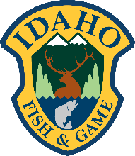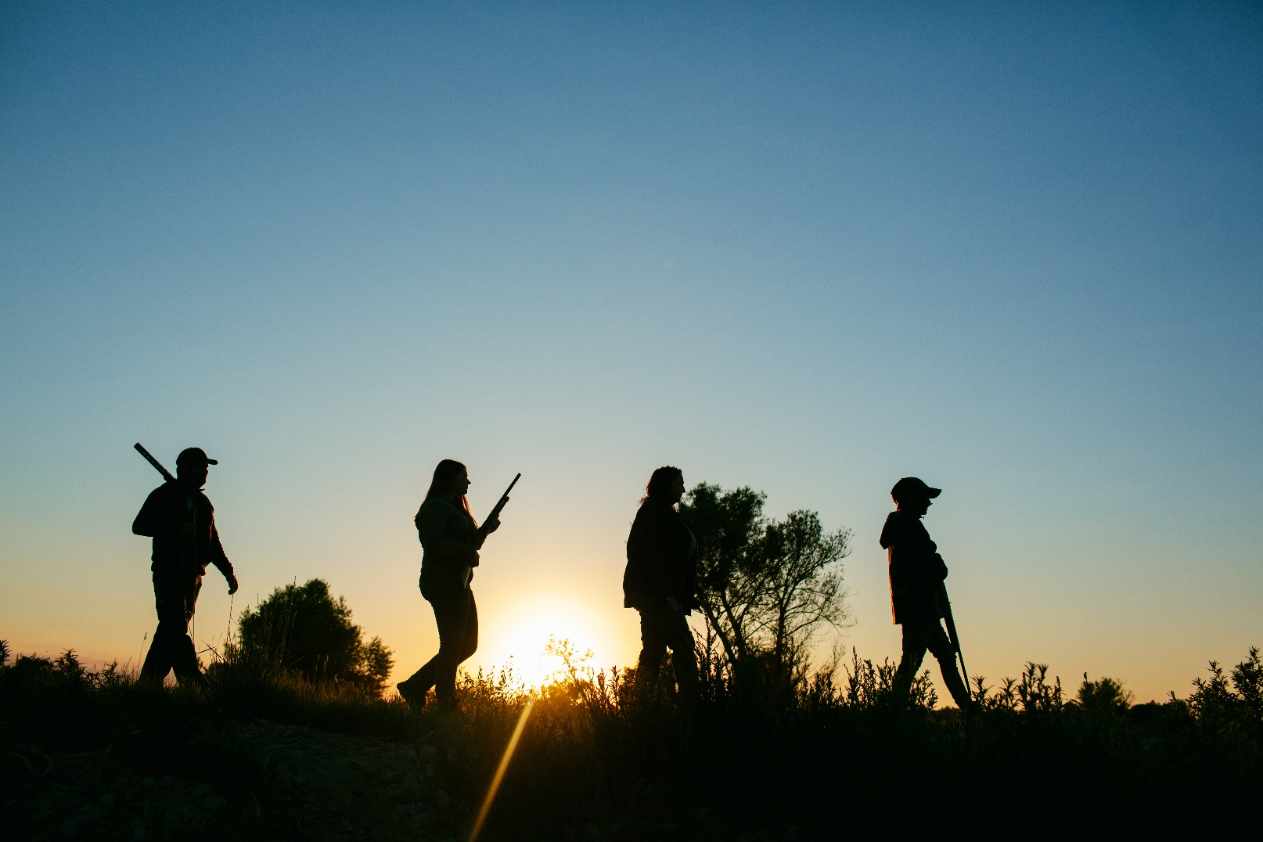

**Idaho 2022 Hunting Campaign**

**ACI R3 2021 MSCG Marketing Campaigns Report**

**Idaho Department of Fish and Game**

**February 14, 2022**

Ian Malepeai   
ian.malepeai@idfg.idaho.gov

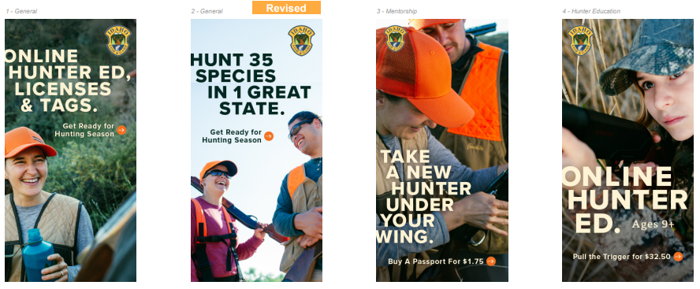

## Campaign Overview

With the unprecedented increase in license sales in 2020, Idaho Fish & Game hoped to establish 2020 participation level as the new baseline and improve past R3 success. Idaho’s hunting campaign focusing on the retention of current resident hunters and the continued recruitment of new resident hunters through a multilayered digital advertising on social media, display, and email. The campaign was supported by developing assets to aid the recruitment and retention of hunters which included developing new content, the gohunidaho.org website, encouraging mentorship among our current hunters, and launching “field to fork” wild game recipes.

When the marketing team created the metrics for this campaign, we set goals to exceed 2020’s record setting year. In retrospect, and after looking at national trends reflecting the “covid-bump” was difficult to maintain – our goals to exceed total participation and year-over-year license retention now appear ambitious. That said, the campaign was still a success in that it maintained our pre-2020 participation rates, and provided an increase to pre-2020 revenue.

## Campaign Goal

Our goal was to utilize ACI grant funding to complete a digital advertising campaign to drive awareness and increased hunting participation to residents of Idaho. Ads paid for through the grant were live from September 9 – October 17, 2021, and a campaign to promote mentored license and hunter education enrollment was completed in the spring of 2021. The overall campaign goals were:

**Goal 1: Increase hunter recruitment and retention  
Goal 2: Provide additional tools & information to support recruitment and retention of hunters  
Goal 3: Reinforce an ethos of “Mentoring” in our current, resident hunters**

## Metrics

Idaho recently contracted with Brandt Licensing, and will soon have the ability to track advertising ROI with google tags. We were not able to implement this tracking into our 2021 hunting campaign, so our primary goal was an awareness campaign for reach and impressions.

The Display campaign reached a total of 362,670 unique users with an ad frequency of 4 ads. The 2021 campaign had a 270% increase in in conversions compared to 2020, and CPA decreased my more than half. (CPA was measured by clicks to the online license purchase site from the landing page)

Social performance resulted in 2,428,932 impressions, and conversion increased over 400% from the same period in 2020. CPA decreased by $53, we found that Facebook had twice the CTR as Instagram, and men and women engaged with the ads equally.

|  |  |  |  |
| --- | --- | --- | --- |
| **Tactic** | **Spend** | **Revenue** | **ROI** |
| Facebook & Instagram Awareness/Interest | $6,000 | $xx | X |
| Facebook Conversion/Intent | $10,000 | $xx | X |
| Programmatic Display | $9,000 | $xx | X |
| Hunter Ed Spring Ads | $5,000 |  |  |
| **TOTAL CAMPAIGN** | **$30,000** | **$xx** | **X** |

*** Between April and June of 2021, IDFG Marketing team lost an associate marketing manager and marketing data analyst to a retirement and the private sector. While IDFG partnered with Stoltz Marketing Group to complete the campaign, the agency loss of 2/3 in-house-capacity impacted our ability to fully implement our campaign to our planned level. The loss of the data analysts has also affected our ability to analyze all planned metrics for the campaign. As of the writing of this report, February 2022, both positions remain vacant. Below are the metrics we are able to provide at this time, with expectation of doing a full analysis when staff is replaced.

**Goal 1: Increase hunter recruitment and retention**

* Graduate 13,000 students from hunter education (7% increase over 5-year average)
  + 11,471 graduated from hunter education in 2021. In 2020 there was a 100% increase in hunter education graduates over the previous year. 2021 graduate numbers was second only 2020 in the past fifteen years. Given our educated guess on continuing momentum of 2020, this goal now seems to have been overly-ambitious.
* 50% of hunter education graduates purchase hunting or combination license in same license year (+6% from 2020)
  + Could not complete analysis. We have been working on integrating our hunter ed database from Kalkomey into the Brandt license system to better track hunter ed graduates and license purchase. The integration had been postponed but looking to have this completed by late 2022.
* 55% of 2020 hunter education graduates retained by purchasing a 2021 hunting or combination license (+5% from 2020)
  + Could not complete analysis. See above for integration of Kalkomey hunter education database with Brandt database.
* Retain 87% of annual and multiyear resident fishing, hunting and combination license holders (+1% from 2020)
  + 72% of annual adult resident fishing, hunting, and combination license holders were retained in 2021. This included 84% of hunting licenses, 58% of fishing licenses, 86% of combination licenses, and 96% of sportsman package license holder who retained. When this metric was created, it was unknown if the “covid” bump would continue. In retrospect, this metric was quite ambitious given that this target would have exceeded the all-time record year that we saw in 2020. This included record license sales, and record retention percentage from the previous year.
* Issue 6,200 passport (mentored hunting) licenses (+7% from 2020)
  + 3,807 mentored hunting license were issued in 2021.
* 2,000 hunters sign on to “Mentor Pledge” committing to mentor someone new to hunting in 2021
  + 34 hunters signed the “Mentor Pledge.” While we were able to create the pledge and develop the infrastructure to track sign ups, staffing capacity impacted our ability to promote this as planned. We look forward to continuing this in 2022.
* Develop and deploy social media and Google display network advertising
  + Completed.

**Goal 2: Provide additional tools & information to support recruitment and retention of hunters**

* Develop a minimum of 1 video tutorial on how to hunt an upland bird species
  + Completed.
* Complete 2 new “Maiden Hunt” videos following a new hunter’s first hunt with a mentor
  + One video was completed, and 1 video had to be scrapped due to lack of usable footage after COVID limited participants ability to continue filming
* Work with Brandt Information Systems to create marketing email automation to brand new hunters
  + Completed .
* Work with Brandt information Systems to create marketing email automation to hunter education graduates
  + Full integration of our Kalkomey license data into the Brandt system was not completed as planned. Emails continued to be delivered manually through GovDelivery.
* Improve “Field to Fork” promotion by creating wild game recipes section on our website and promote on social media
  + Completed and now available at idfg.idaho.gov/cooking
* Hunter Education Newsletter
  + Completed through GovDelivery

**Goal 3: Reinforce an ethos of “Mentoring” in our current, resident hunters**

* Create social media toolkit to inspire mentoring that will be shared with 23 hunting NGO’s within Idaho
  + Completed. The toolkit was made digitally available at [Partner Toolkit — Go Hunt Idaho](https://www.gohuntidaho.org/partner-toolkit), with password: GoHuntIdaho4Partners
* Work with First Hunt Foundation and other NGO’s to build their ranks of mentors
  + Completed.
* Work with Backcountry Hunters and Anglers to complete one “Hunting for sustainably” six-week course.
  + Completed. IDFG partnered with BHA-Idaho to deliver 5 classes to approximately 17 new hunters from August 11 – October 2, 2021. Staff also volunteered as hunting mentors on participant’s first hunts.
* Create Mentor Ambassador Pledge Community and provide ongoing communication and resources
  + Completed. Although the pledge was created, promotion of effort was diminished by lack of staffing capacity. A 2-month organic social media campaign was completed to highlight “Mentorship Monday” and encourage current hunters to bring someone new to the outdoors. This was in addition to our paid advertising promoting our mentored hunting license.

## Call to Action

A variety of call to actions (CTA) were used for awareness ads and re-targeting ads. CTA’s included “Learn More”, “Go Hunt Idaho”, “Everything you need to start”, “Get Licensed and Loaded”, “Buy a Passport”, “Get ready for Hunting Season”, “Pull the Trigger”, and “Online Hunter Ed, Licenses, and Tags.”

All link clicks directed customers to the landing page gohuntidaho.org where we had additional information and CTAs. CTAs on the landing page included:

* “BUY A LICENSE” to encourage license purchase
* “ONLINE COURSES” and “INSTRUCTOR LED” for enrollment to hunter education
* “TAKE THE PLEDGE” to support a new hunter through mentoring

## Future Efforts

This was the second year of implementing a hunting campaign for Idaho. We plan to continue running future hunting campaigns and taking lessons learned in continue improvement. In the future, we look forward to segmenting our markets into smaller targets with more specific metrics. We also plan to incorporate google tags to track ROI to the Brandt license system, an improve hunter education tracking with integrations between Kalkomey and Brandt.

## Target Audiences

Idaho residents age 18-40 with affinity to outdoor recreation, fishing and hunting.

Geo targeting Idaho metros: Boise/Meridian, Nampa, Idaho Falls, Pocatello, Caldwell, Coeur d’Alene, Twin Falls, Post Falls, Lewiston, Rexburg, Eagle, Moscow

Behavioral Targeting (Display only): Sports & Outdoors, Outdoor Enthusiasts, Active Lifestyle, Hunting & Fishing, Camping & Hiking, Recreational Stores, Weather PMP’s

Sample Segments (Social Awareness and Retargeting): Family, Family Activities, Outdoor Recreation, Camping, Adventure Travel, REI, Hunting, Hunting & Fishing, Bass Pro Shops, Cabela’s

## Images and Graphic Treatment

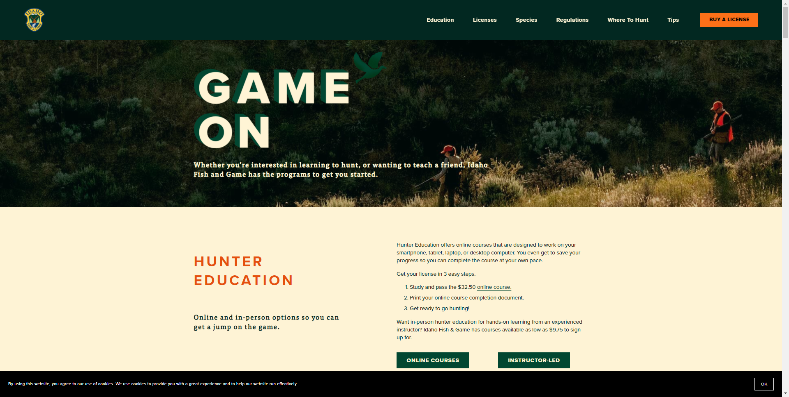

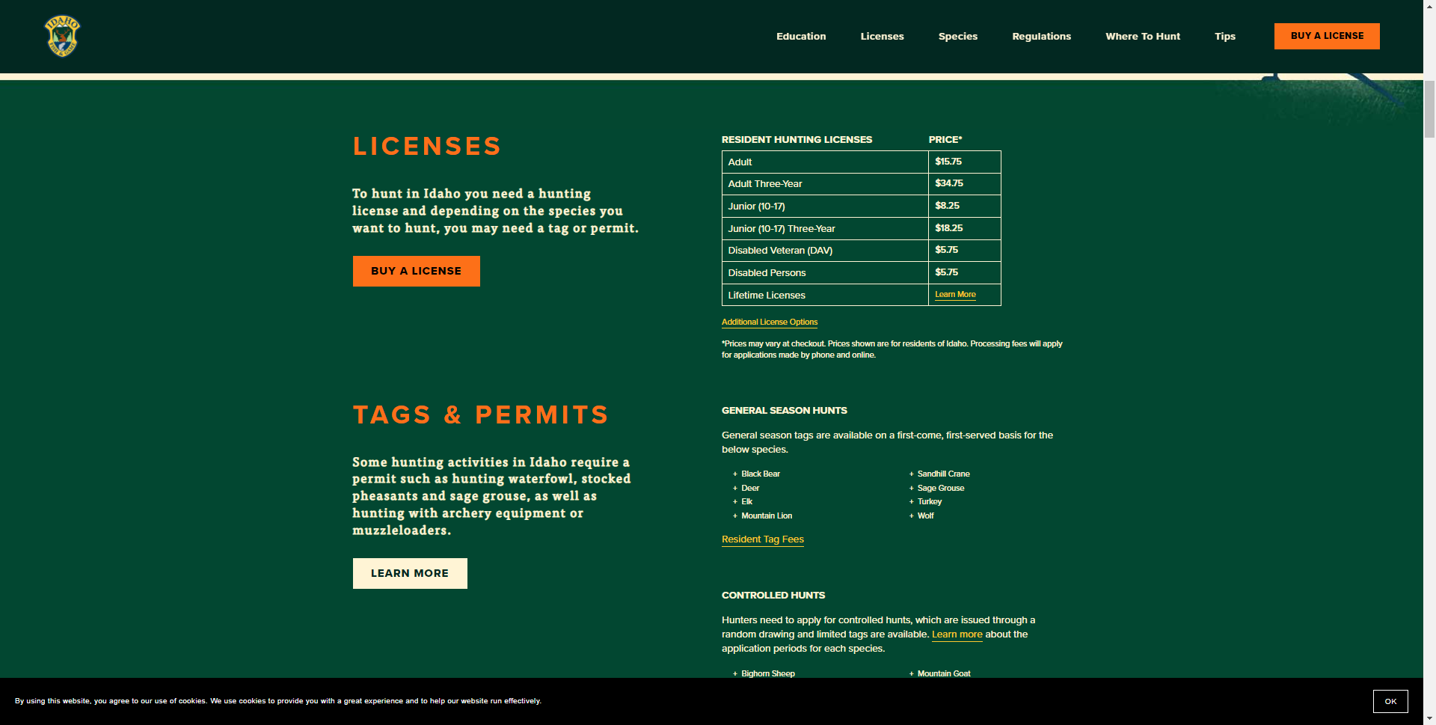

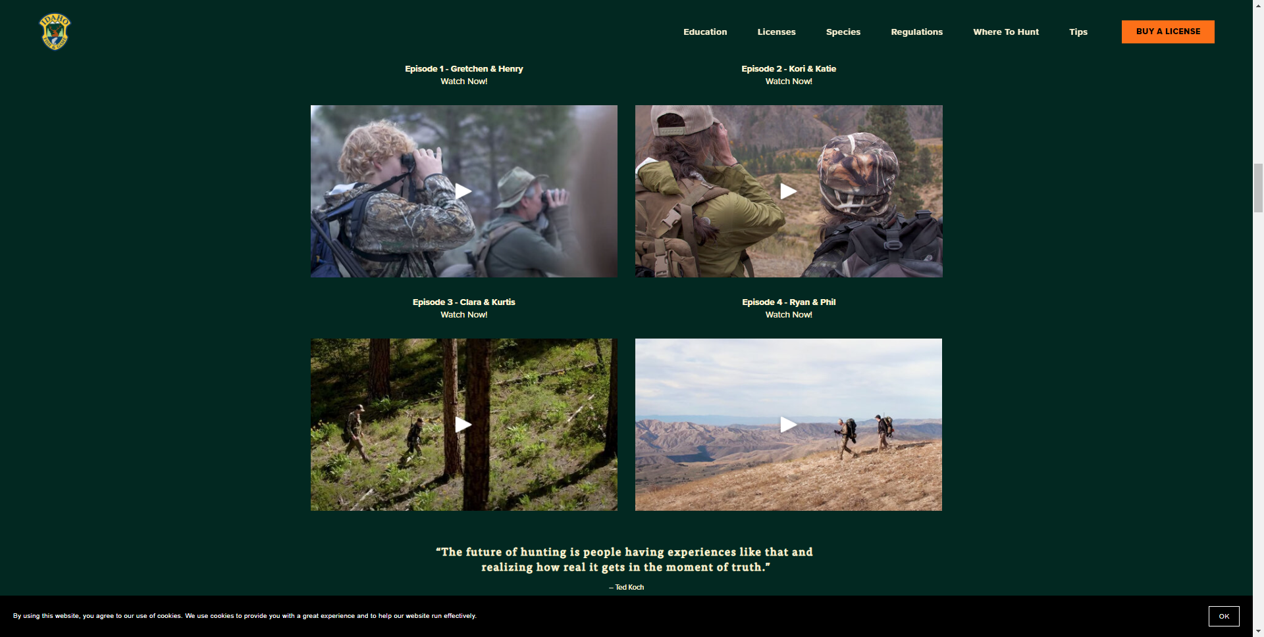

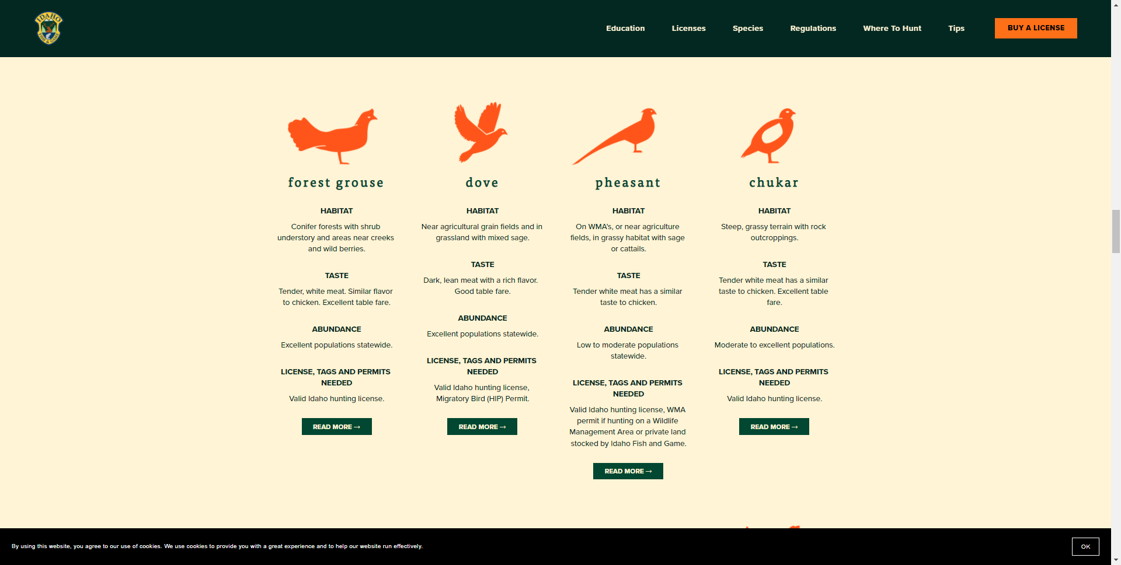

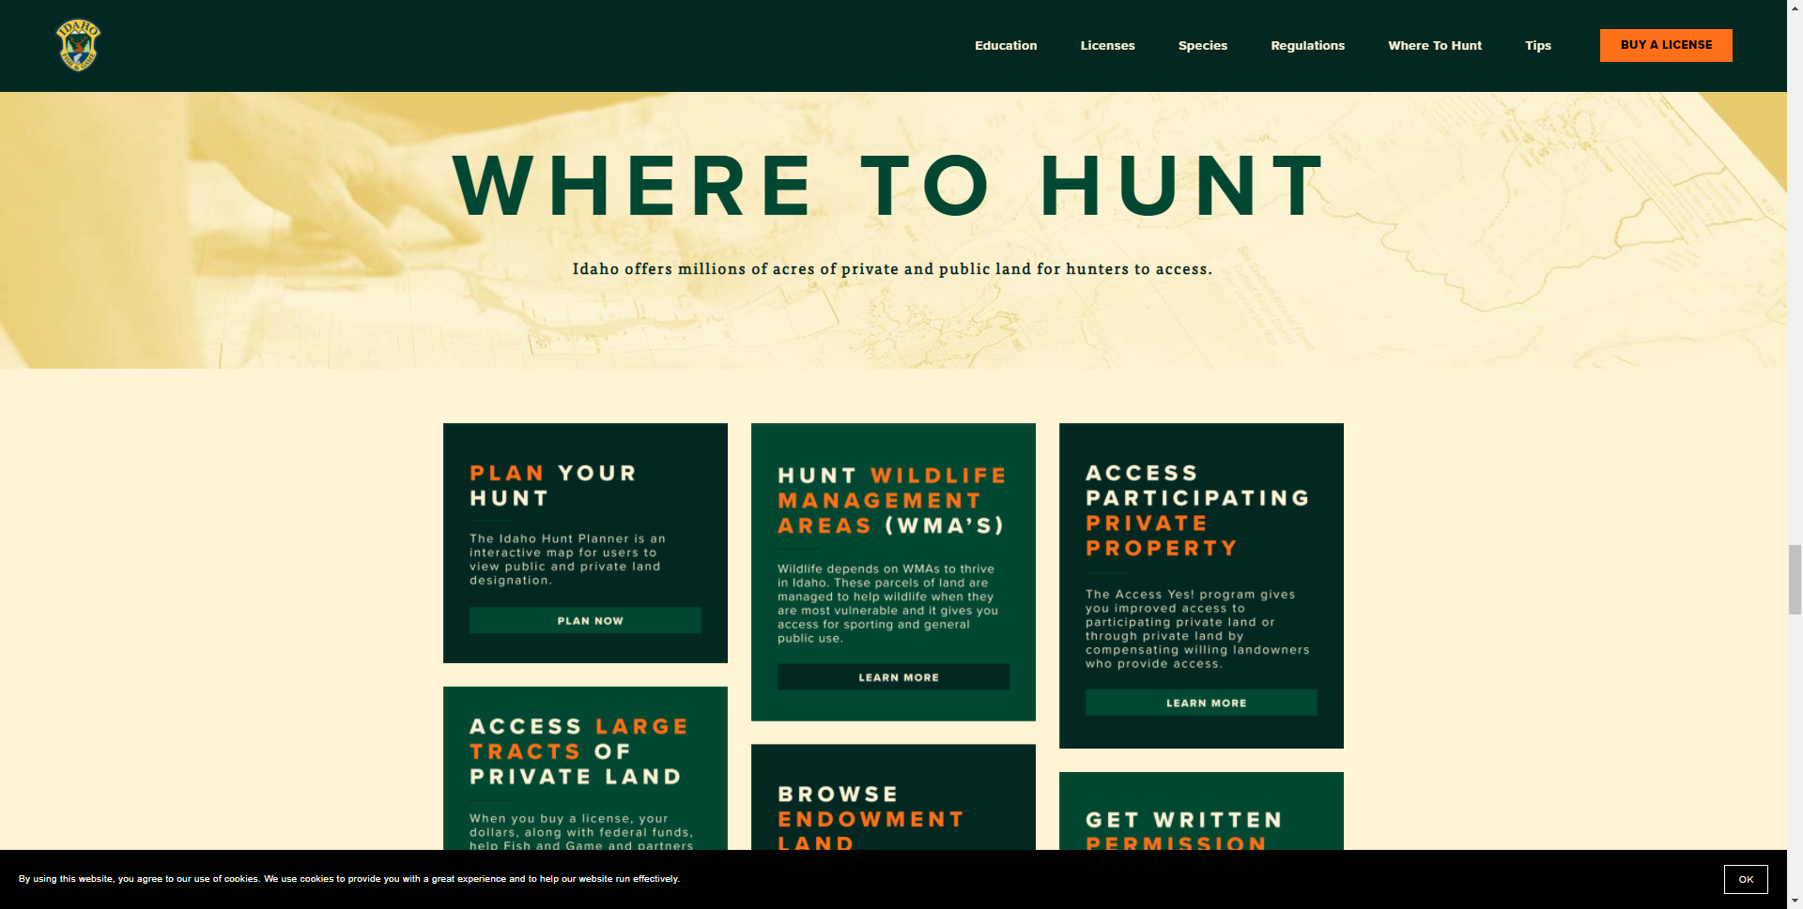

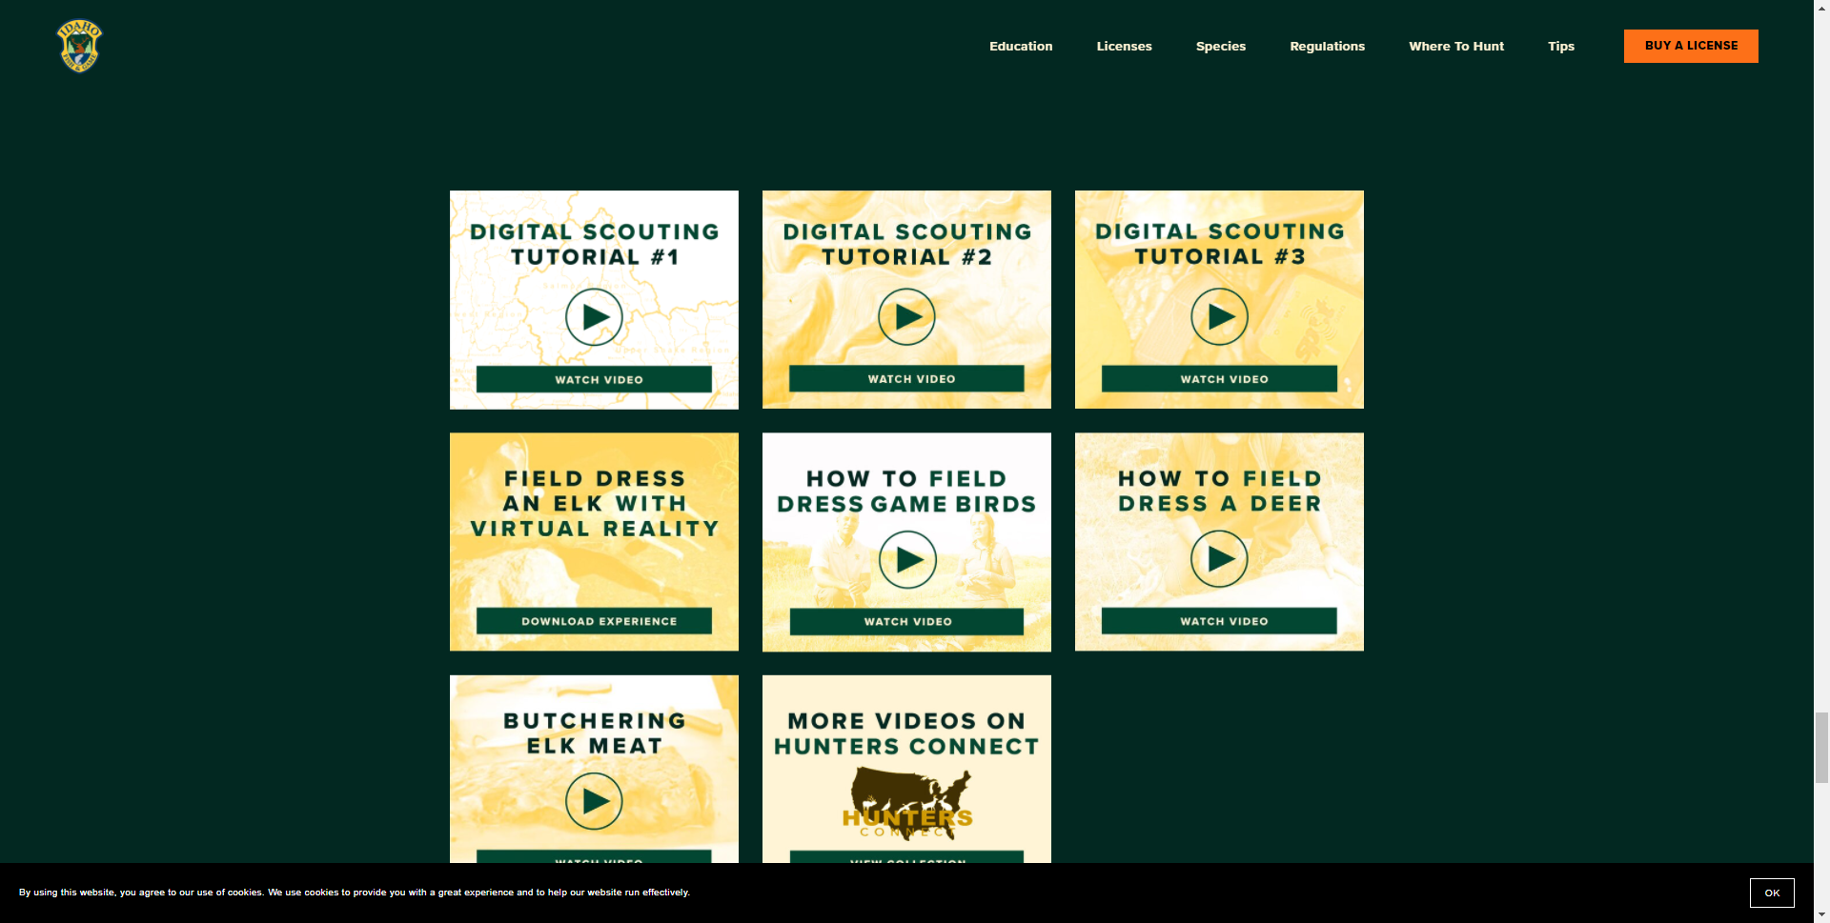

## Assets / Paid Placements

Insert text, if applicable

