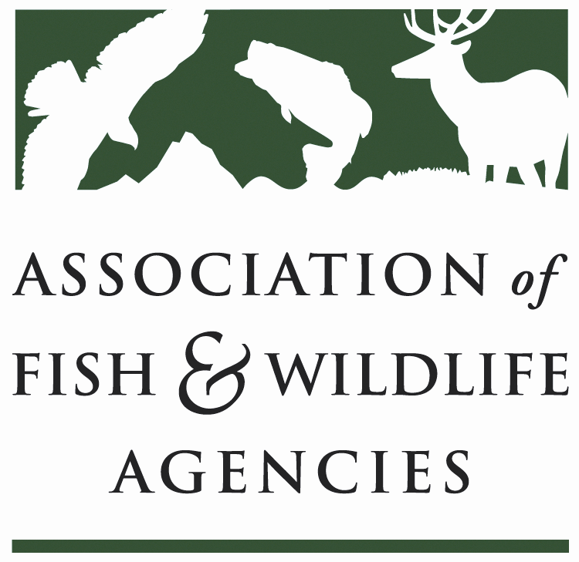

WILDLIFE RESOURCES POLICY COMMITTEE
Chair: Jim Douglas, (Nebraska)
Vice-Chair: Chuck Sykes (Alabama)

Friday March 30, 2018
8:00 AM – 10:00 AM

North American Wildlife and Natural Resources Conference
Room: Salon C
Hilton The Main | Norfolk, VA

Committee Charge
To discuss and develop recommendations on Association positions related to federal laws, regulations and policies concerning habitat conservation, wildlife resources and related funding for such programs as well as wildlife management practices including those concerned with problem or nuisance wildlife, and emerging issues (e.g., commercial trade). The committee also stays abreast of threatened and endangered species wildlife issues, state legislation pertaining to wildlife management and wildlife diversity funding initiatives.

Agenda

8:00 AM Welcome, Introductions & Review Agenda-Jim Douglas, NGPC

8:10 AM Wildlife Services Report-Martin Mendoza, USDA/APHIS

8:30 AM Human/Wildlife Conflicts Working Group Report-Brian Wakeling, NDOW

8:50 AM Landscape Conservation Working Group Report-Jim Douglas, NGPC

9:10 AM Update on the North American Bat Monitoring Program-Mylea Bayless, BCI

9:20 AM Update on the Alliance for America’s Fish and Wildlife-Sean Saville, AFWA

9:30 AM Multiagency MOU on Aircraft-Wildlife Strikes-TBD, USDA/APHIS

9:40 AM Update on Mid-America Monarch Conservation Strategy-Ed Boggess, FWS and Claire Beck, MAFWA

9:55 AM Adjourn

