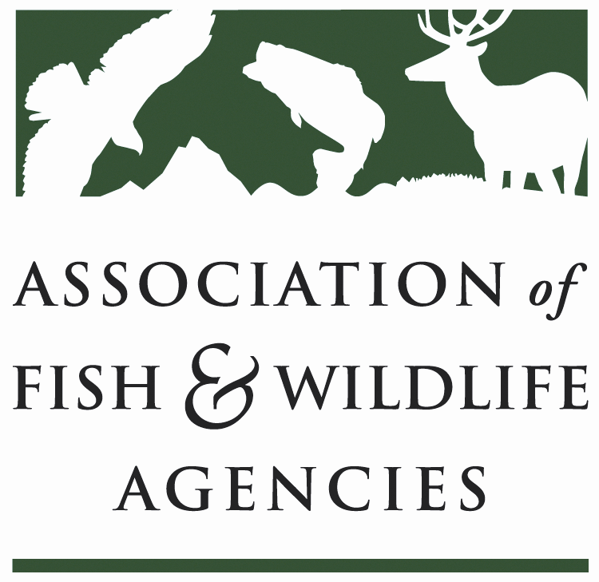

Leadership and Professional Development Committee

Chair: Scott Talbott, Director (WY)
Vice Chair: Alexandra Sandoval, Director (NM)

Friday, March 30, 2018 8:00 am – 10:00 am (LPD Committee)
Friday, March 30, 2018 10:15 am – 11:30 am (NCLI Business Meeting)

83rd North American Wildlife and Natural Resources Conference
Room: TBD / Davenport Grand Hotel – Norfolk, VA

Committee Charge: Related to this strategic priority of the Association, the Leadership and Professional Development Committee plays a primary role in guiding actions of the Association that develops tools and programs to help States develop new generations of agency leaders who are prepared to address current and future conservation needs in their state, region, and across the US. The Committee charge is to:
- Provide oversight and direction to the AFWA Management Assistance Team (MAT) Work with MAT to provide guidance from Agencies regarding identified issues and concerns about the [current and future] work force so that MAT is most effectively targeting the most important leadership development and agency management needs of state fish and wildlife agencies and AFWA members.

- Create and foster leadership development activities that may be used by State AFWA member agencies - Facilitate development, guidance, support, and ongoing continued improvement of a Leadership Development Initiative, based on identified Agency needs, to provide training and consulting services to States that will help them best address leadership development. Facilitate and lead development of a Leadership Institute that provides exceptional training and networking opportunities for the next generation of conservation organizations’ top-leaders.

- Communicate with AFWA members on trends related to current workforce issues, leadership development, and professional development – Communicate with AFWA members and disseminate state-of-the-art knowledge on workforce trends and issues, latest information, and “Best and Improved Practices” in leadership development. Provide resources so members may share their knowledge and experiences and a forum to share Agency experiences.

- Coordinate with the National Conservation Leadership Institute Board of Directors – Work with the National Conservation Leadership Board of Directors and Executive Director to facilitate state fish and wildlife agency involvement in the National Conservation Leadership Institute and provide continuity in leadership development programming.
Agenda

8:00 am
- Call to Order/Review Agenda/Approve Minutes
Scott Talbott
8:10 am
- Introductions
Committee
8:25 am
- Updates on the NCLI:
Gina Main
- NCLI Overview; New direction
- Cohort 12
- Cohort 13
- NCLI 2.0 Unleashing the Power
- Fundraising Updates
- Survey
- Targets
- Business Strategy

9:05 am
- Updates on the MAT Team:
Bettina Fiery
- MAT Overview
- State Leadership Development Program Review
- Products & Services—Mary Hughes
- Leadership Skill-builders
- Lunch & Learns
- R3 Training

9:35 am
- Updates from Committee members
Committee

9:45 am
- New Business
Committee

10:00 am Adjourn

10:00 – 10:15 Break
-----------------------------------------------------

NCLI Alumni / Board / Staff Business Meeting

Gina Main, Director Prof. Dev. / Exec. Dir. (AFWA/NCLI)

Friday, March 10, 2017 10:15 am – 11:30 am (NCLI Business Meeting)

82nd North American Wildlife and Natural Resources Conference
Room: TBD / Davenport Grand Hotel – Spokane, WA

Agenda

10:15 am – 11:30 am

- Cohort 13 Nomination Period
- Update on the Board
- NCLI Community – Self Organizing System – Mission – Objectives –Vision
- NCLI Continuing Education / 2.0 – Unleashing the Power
- Telling the NCLI Success Story – Snapshots of Success
- Meeting the Growing Demand

- NCLI Alumni Portal
- Alumni Fundraising
- NCLI Survey Update

