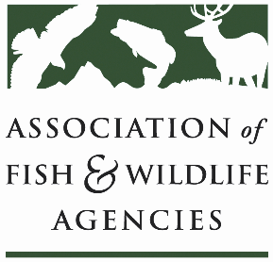

Energy & wildlife policy committee
Chair: Clay Crowder (AZ)
Vice-Chair: Vacant

1 April 2026
3:30 pm – 5:30 pm

91st North American Wildlife and Natural Resources Conference
Columbus, OH

Committee Charge: The energy and wildlife policy committee is focused on understanding and ameliorating the effects of energy development and generation in North America and its impacts on fish and wildlife resources and their landscape habitats at the state, province, territory, region, and international levels.

Agenda

3:30 pm Call to Order / Approval of Minutes from September 2025 AFWA Annual Meeting
Clay Crowder, AZGF

3:35 Ohio Spotlight
Becky Crowe, OH DNR & Lauren Devin, Savion

3:55 National Utility Scale Solar Wildlife Guidelines (NUSSWG) Update & Discussion
Clay Crowder, AZGF & Becky Crowe, OH DNR

4:15 Wind Wildlife Working Group Update
Laura Zebehazy, Texas Parks and Wildlife

4:30 Solar Wildlife Working Group Update
Emily Grabowsky, Washington Dept. Fish & Wildlife

4:45 Committee Priorities Discussion
Clay Crowder, AZGFD; ALL

5:00 Federal Agency and Partner Updates
- FWS (Michael Oetker, tentative)
- TNC (tbd)
- TCF (Nick Morgan)

5:15 State and Provincial Roundtable
One representative per state agency highlights a couple of legislative and policy initiatives, issues, or success stories. Non-state participants, please introduce self.

5:30 Wrap-up and Adjourn

