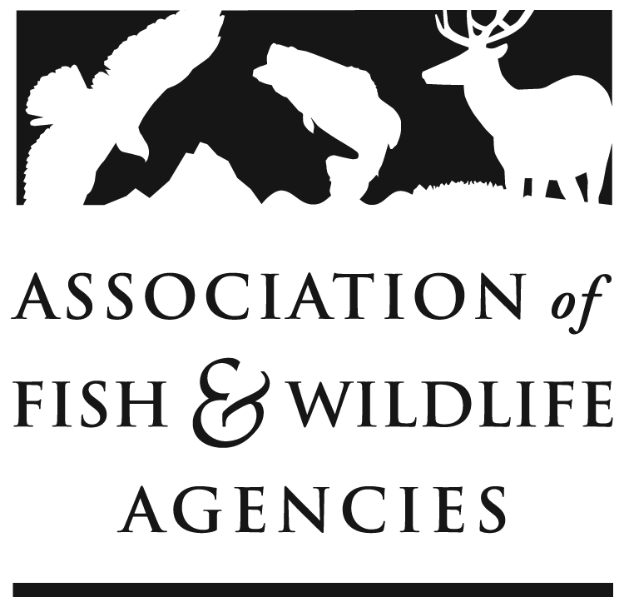
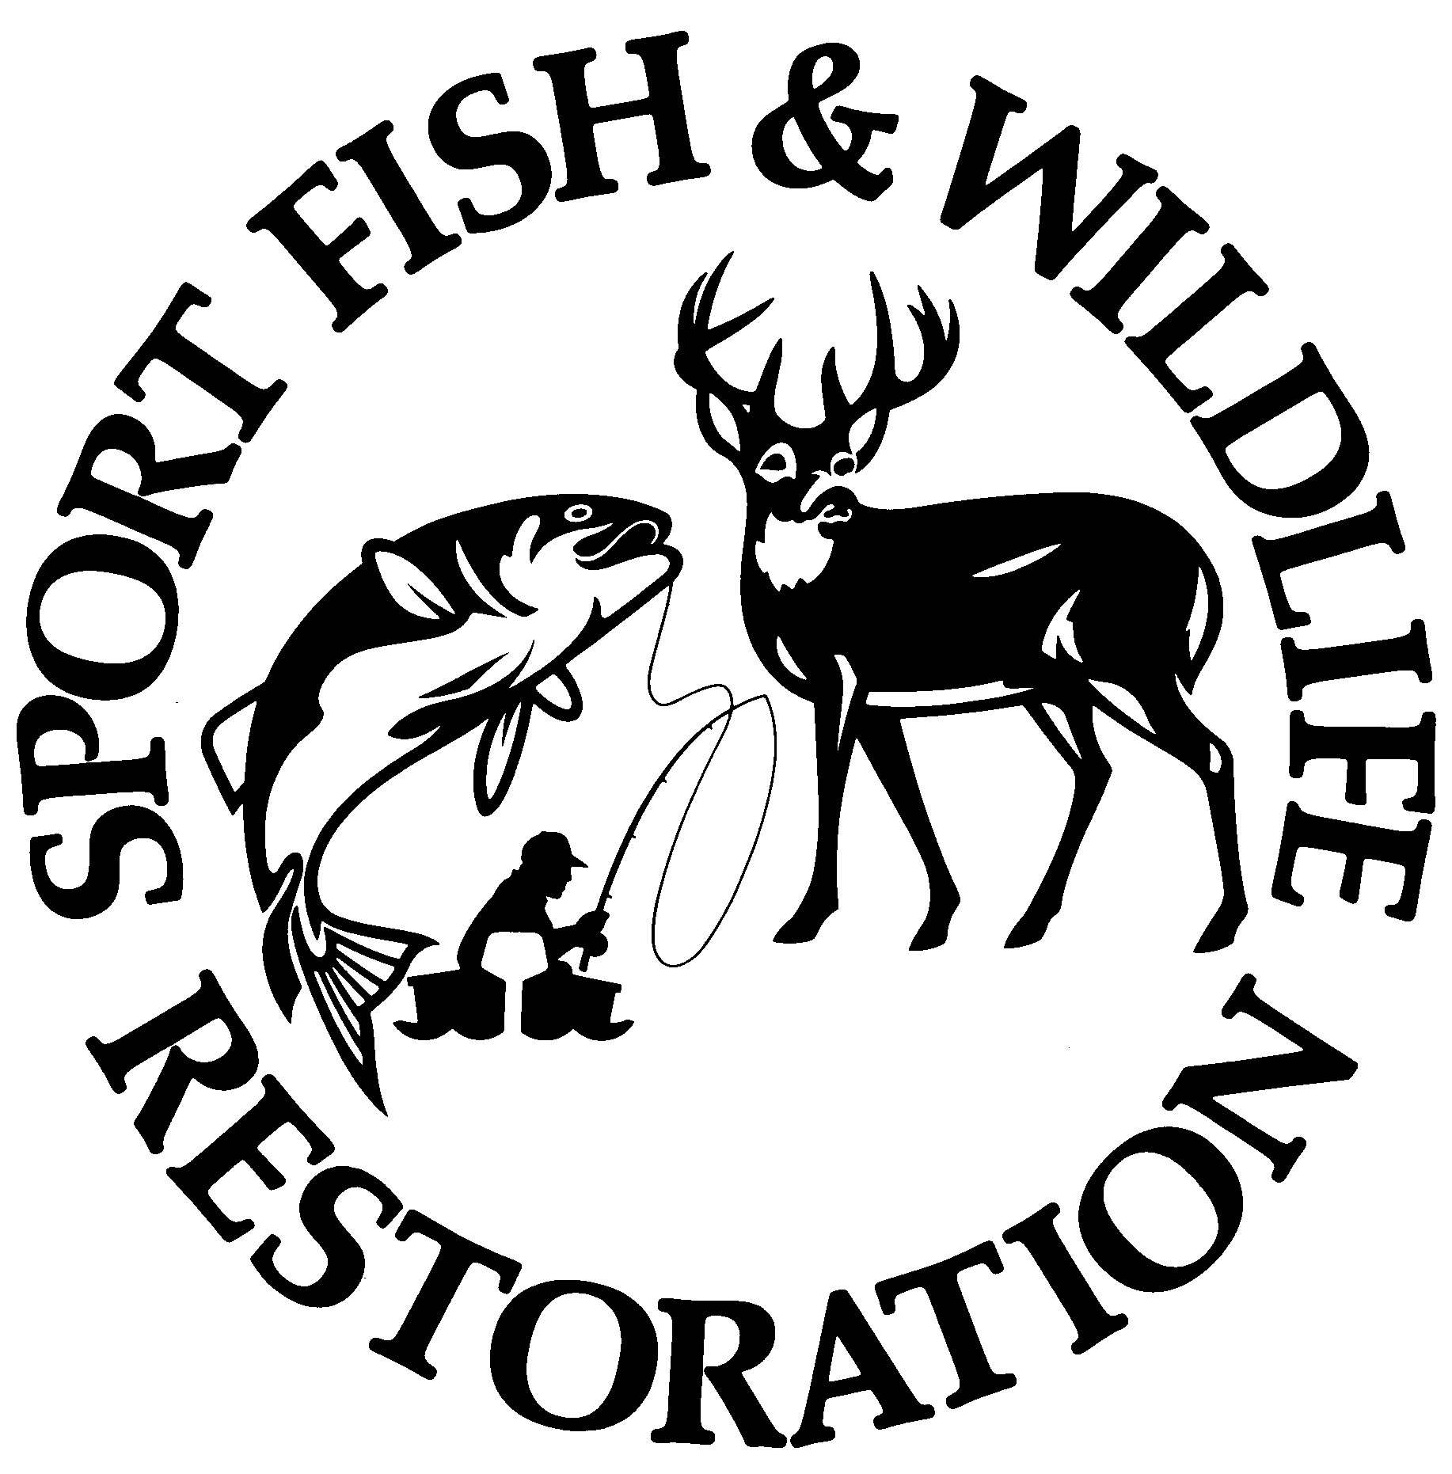
Multistate Conservation Grant Program

Frequently Asked Questions
_____________________________________________________________

Below is a list of questions frequently asked by MSCGP applicants. If your question is not addressed, or you require further clarification please contact Silvana Yaroschuk, Multistate Conservation Grant Program Manager, at syaroschuk@fishwildlife.org.
________________________________________________________________________
Program Information

What is the Multistate Conservation Grant Program (MSCGP)?

The Dingell-Johnson Sport Fish Restoration Act (16 U.S.C. 777 et seq.) and the Pittman-Robertson Wildlife Restoration Act (16 U.S.C. 669 et seq.) as amended by the Wildlife and Sport Fish Restoration Programs Improvement Act of 2000 (Pub. L. 106-408, 114 STAT. 1766 §113 and 114 STAT. 1722 §122) authorize the Secretary of the Interior to make up to $6,000,000 available annually to fund MSCGP projects. The U.S. Fish and Wildlife Service (Service) will cite this traditional program as the Traditional Multistate Conservation Grant Program (T-MSCGP). In addition, the Modernizing the Pittman-Robertson Fund for Tomorrow’s Needs Act (Modernizing PR Act, 16 U.S.C. 669) amended the Pittman-Robertson Wildlife Restoration Act to, among other measures, authorize the Service to make hunter recruitment and recreational target shooter recruitment grants that promote a national hunting and shooting sports recruitment program, including related communication and outreach activities. The Service will cite this program as the R3 Multistate Conservation Grant Program (R3-MSCGP). Up to $5,000,000 will be available specifically for the R3-MSCGP grants.

Who administers the MSCGP?

The Association of Fish and Wildlife Agencies (AFWA) and the U.S. Fish and Wildlife Service (USFWS) cooperatively administer the MSCG process.

- AFWA begins the annual grant cycle by developing a list of Strategic Priorities in consultation with state agencies, conservation partners, and industries.
- USFWS publishes the Notice of Funding Opportunity (NOFO) in the federal grant management system known as www.GrantSolutions.gov, which the USFWS uses to review federal grant applications. The NOFO provides application guidance for both types of projects (i.e., T-MSCG and R3-MSCG) under the competitive Multistate Conservation Grant program.
- AFWA solicits grant proposals that support Strategic Priorities and selects projects that best address the priorities.
- AFWA then submits a recommended list of priorities to the USFWS for approval.
- USFWS completes review and approval of MSCGP grant applications, issues awards, and manages and monitors the grant awards.

How can I apply for MSGP funding?

The application process involves submitting a proposal and budget information (i.e., budget narrative and budget table) first in the AFWA Portal for review by Technical Review Teams facilitated by AFWA. The Applicants may then be invited to submit a Complete Application Package to GrantSolutions, which the USFWS uses to review federal grant applications. The Complete Application Package includes the proposal, budget information, and other required federal forms. An information webinar is provided for applicants annually to update them on processes and any changes for the current application year. While this webinar is not mandatory to apply for a grant, it is recorded, and applicants are strongly advised to watch the recording if they cannot participate.

MSCGP grants are traditionally approved for one year of funding. Applicants whose projects are expected to last for more than one year are encouraged to let the Grants Committee know that they will apply for a subsequent year(s) of funding and will need to report on progress made in the first year as part of the justification for subsequent/supplemental funding. Subsequent funding is not guaranteed and will depend on the project’s merits, available funding, and progress. Under special circumstances, the Grants Committee will consider approving multiple years of funding (multiyear funding). The criteria for multiyear funding established by the National Grants Committee are included in the application package. Please note that there is a very high bar to justify multiyear funding, and most applicants will be requested to apply for one year of funding at a time. If applicants decide to apply for multiyear funding, they are required to break down the objectives, budget table, and budget narrative for each year of the proposed project. If awarded, funding for a multiyear proposal is approved for all years of the project, but funds are only obligated to the project one year at a time.

Can R3 programs related to sport fish still be funded, and if so, how?
Yes, R3 related to sport fish will be funded under Strategic Priority #3, although they will be funded through the Traditional MSCGP program using available Sport Fish Restoration funding.

What is the maximum length for the project narrative or supporting documents?
There is no strict page limit, but clarity and conciseness are encouraged. Supporting documentation must be relevant and necessary.

Can an organization submit more than one application?
Yes. There is no restriction on the number of applications submitted by a state or organization, as long as each application is eligible and distinct in its scope and objectives.

Where can I view examples of previously funded projects?

Please visit https://fishwildlife.org/mscgp and search under respective categories or using keywords.
Timeline

What does a typical timeline look like for MSCGP?

Post NOFO April
Proposals Due June
AFWA and OCI Review June
Technical Review Teams Review Grants July
National Grants Committee and CI Review August
Applicants asked for updates based on NGC/CI feedback September
Proposals Full Package due in AFWA Portal September
Approval of the Priority List of Projects September
Proposals Full Package due in GrantSolutions End of September
Priority List Sent to USFWS By October 1

The timeline for the 2026 MSCGP Cycle looks different.

2026 Multistate Conservation Grant Program Timeline
July 24, 2025 | U.S. Fish and Wildlife Service (USFWS) Posts Notice of Funding Opportunities (NOFO)
August 8-October 1, 2025 | Recruitment and training of the Technical Review Teams members
September 22, 2025 | Proposals due via AFWA Portal
September 23 – 29, 2025 | AFWA and the Office of Conservation Investments (CI) review proposals for eligibility and compliance
October 1-October 24, 2025 | Technical Review Teams (TRT) score and discuss eligible proposals. Preliminary recommendations sent to the National Grants Committee (NGC)
October 27 – November 10, 2025 | CI conducts detailed review of preliminary Priority List of Proposals
November 10, 2025 | AFWA Executive Committee reviews the preliminary Priority List of Proposals (summary)
October 27 – November 13, 2025 | NGC reviews recommendations and votes (virtually) on forwarding the Priority List to the State Directors
November 14, 2025 | State Directors convene virtually to vote on the Priority List of Proposals
November 14, 2025 | Applicants are notified of their Application Status (selected, not selected, revision required)
November 17, 2025 | Final Priority List of Proposals is submitted at USFWS
November 28, 2025 | Applicants submit their Proposals and the required Federal Forms via GrantSolutions
February 2026 | USFWS completes the final review and awards the 2026 MSCGP grants

Eligibility Criteria

Who can apply for MSCGP?

- State or group of States
- A nongovernmental organization.
- Public Institution of Higher Education
- The United States Fish and Wildlife Service, or a State or group of States, for the purpose of carrying out the National Survey of Fishing, Hunting, and Wildlife-Associated Recreation

Can you clarify whether my project meets the criteria for states benefiting? Does it need to involve 26 states?

There are three options for a project to meet the criteria for state involvement. A project must benefit states using ONE of these criteria:
- 26 states, or
- The majority (over 50%) of states in a U.S. Fish & Wildlife Service region or
- The majority (over 50%) of states in a regional association of fish and wildlife agencies
If a region has three states and the project benefits two states, then the project is eligible.

If the proposal does not benefit all states, please list the states (abbreviations) it does benefit. You must describe how the project will benefit the states or region selected.

What does it mean to be Species and Activities eligible?

To be eligible AND allowable, projects and activities must also follow all current laws, regulations, and guidance; cost principles under 2 CFR 200; and any other rules or standards set forth by the USFWS.

Projects proposed for Multistate Conservation Grant Program (MSCGP) funding must meet species and activity eligibility standards under the Wildlife Restoration Act and/or Sport Fish Restoration Act (collectively referred to as “the Acts”). Eligible species are wild birds, mammals, and sport fish. Wildlife means the indigenous or naturalized species of birds or mammals. Sport fish means aquatic, gill-breathing, vertebrate animals with paired fins, having material value for recreation in the marine and fresh waters of the United States.

Proposed project activities must carry out the purposes of the Acts. These purposes include conservation, restoration, management, and enhancement of wild birds, mammals, and sport fish, as well as providing for public use and benefit from these resources.

Can you give some examples of ineligible activities and species?

Any taxonomic group other than wild birds, mammals, or sport fish is ineligible.

Any proposals addressing species whose geographic range does not extend to the minimum required extent of geographic benefit (i.e., 26 or more states or 50% of a FWS region or AFWA region) will not be considered.

Ineligible activities include, but are not limited to:
- public relations to promote an agency.
- general conservation education or wildlife education that is not specifically related to sharing accomplishments supported by the Acts;
- law enforcement activities;
- establishment of regulations;
- producing revenue as the primary purpose, including all processes and procedures directly related to printing, distribution, issuance, or sale of licenses and permits;
- promoting opposition to regulated taking of fish or hunting or trapping wildlife;
- wildlife damage management.

What are Strategic Priorities, and how do I find them?

To be eligible, proposals must address one or more of the Strategic Priorities. These priorities are updated annually with input from the Association's Committees, Regional Associations, Nonprofits, and Federal partners. You can find the Strategic Priorities at AFWA Website under the Full Grant Proposals section.

Can an organization submit more than one application?

Yes. There is no restriction on the number of applications submitted by a state or organization, as long as each application is eligible and distinct in its scope and objectives.

Partnering and Letters of Engagement

Is there a preference for nonprofit vs. state agency lead applicants?

No. All eligible entities are treated equally and reviewed based on merit.

Is it allowable to pay partners (e.g., guides, instructors) for their services?

Yes. Partners can be paid for services as contractors or subrecipients, depending on the nature of their role with the grant-funded project.

Can a federal employee (e.g., university faculty affiliated with USGS) serve as a co-Principal Investigator?

Yes. Though federal agencies are not eligible applicants, federal employees may participate in a grant-funded project as a co-Principal Investigator or other key project participant as long as an eligible entity is the applicant. Identify the federal employee’s faculty role, describe the role of the federal employee in the project, and disclose any potential conflicts of interest in writing.
Do I need to submit Letters of Engagement?

Letters of engagement from participating states are required as documentation of planned collaboration. These should be included where applicable, particularly when states counted toward beneficiary eligibility. We do not consider Letters of Engagement from non-state agencies.

Examples:

Geographic scope: If your proposal will benefit 8 of 14 NEAFWA states, you will need to submit Letters of Engagement (a confirmation e-mail will suffice as well) from those 8 states.

Working with specific states: If your proposal benefits all 50 states, but identifies certain states for activities such as focus groups, you must submit Letters of Engagement from those states.

How do I determine if an agreement is a Contract or a Subaward?

The applicant must use case-by-case judgment based on the criteria provided in 2 CFR 200.331 . The nature of the relationship between the applicant and the 3rd party is critical in the determination, and no single factor determines the type of relationship.
Subawards are appropriate when the partner is involved in the grant-funded project, including but not limited to, helping to carry out the project’s objectives, leading or assisting with project decision-making, and reporting on project performance.
Contracts are generally used for goods or services that are provided by vendors within normal business operations in a competitive environment. See also for determination guidance.

Subaward Example:
- Scenario: A State Fish and Wildlife Agency partners with a university to conduct research on bat population trends for a regional species status assessment.
- Why it’s a subaward:
  - The university helps define the research scope and methodology.
  - Its results are used to inform management decisions under the agency’s federal grant.
  - The university's activities advance the primary objectives of the grant program.
Contract Example:
Scenario: A state agency uses grant funds to pay a web development company to build a data portal for public access to fish stocking information.
- Why it’s a contract:
  - The company is providing a technical service (website creation).
  - It does not have a responsibility for meeting the grant’s objectives.
  - The task supports the agency’s grant work, but is not integral for meeting the grant objectives, and any number of other vendors could fulfill the need for the service.
Can I request Multiyear Funding?

MSCGP grants are traditionally approved for one year of funding. Applicants whose projects are expected to last for more than one year are encouraged to explain in the proposal that they will apply for a subsequent year(s) of funding for the project and will need to report on progress made in the first year as part of the justification for subsequent/supplemental funding. Subsequent funding is not guaranteed and will depend on the project’s merits, available funding, and progress.

Under special circumstances, the Grants Committee will consider approving multiple years of funding (multiyear funding). The criteria for multiyear funding established by the National Grants Committee are included in the application package. Please note that there is a very high bar to justify multiyear funding, and most applicants will be requested to apply for one year of funding at a time.

If I apply for multiyear funding, is it okay not to specify each year’s objectives and budget?

If applicants decide to apply for multiyear funding, they are required to break down the objectives, budget table, and budget narrative for each year of the proposed project. If awarded, funding for a multiyear proposal is approved for all years of the project, but funds are only obligated/available to the project one year at a time.

Can federal agencies be contractors or subrecipients of MSCGP funds?

Federal agencies and personnel can often be involved in MSCGP projects (through contracts, sub-awards, etc.) Federal agencies cannot primarily receive MSCGP funds, except for the U.S. Fish and Wildlife Service, which coordinates the National Survey of Fishing, Hunting, and Wildlife-Associated Recreation.

Budget

How much funding is available for a typical Multistate Conservation Grant Program Cycle?

Annually, a total of $11,000,000 is allocated for the MSCGP.
- Traditional Multistate Conservation Grant Program - $ 6,000,000
Wildlife Restoration Funding: $3,000,000 and
Sport Fish Restoration Funding: $3,000,000
- R3 Multistate Conservation Grant Program – $ 5,000,000
The available funding changes annually as the amount allocated to the National Survey changes, previously approved multiyear grants, as well as recoveries from expired grants. The available funding will be updated as we get closer to approving the Priority List of Projects.
Is there a matching requirement?
No match is required.

How competitive is the MSCGP?

Below is a table of MSCGP Cycles and the number of proposals submitted and projects funded:

MSCGP Cycle | Initial Proposals Submitted | Proposals Submitted | Projects Funded
2025 |  | 109 | 45
2024 |  | 105 | 55
2023 | 103 | 65 | 55
2022 | 121 | 54 | 42
2021 | 85 | 52 | 38

What amount of funding can be requested?

Applicants should review the guidelines to determine the amount of funding available for the current MSCGP Cycle and consider whether the project will require funds from Sport Fish Restoration, Wildlife Restoration, or R3, or a combination of those.
The range of funding for projects has been up to $1,000,000, depending on the type of project, its scope, and duration. The average per grant is $350,000.

Are indirect costs allowed?

Yes. Applicants may:
- Use their organization’s Negotiated Indirect Cost Rate Agreement (NICRA) or a voluntary reduction in this rate
- Use the De minimis rate (up to 15%) as defined by 2 CFR 200.414(f)
- Propose not to include indirect costs
Applicants are encouraged to justify their approach clearly. available for demonstrating effective management of indirect costs.

Is there a cap on indirect costs?

No. There is no cap on indirect. Applicants may use their negotiated indirect cost rate or up to 15% of the de minimis rate but must justify the rate and explain how it supports project delivery. Bonus points are available for demonstrating effective management of indirect costs. See also 2 CFR 200.414 and the NOFO.

Can Multistate Conservation Grant funds be used to pay for state fish and wildlife agency personnel?

State agency personnel's salaries, benefits, and indirect costs are allowable as part of a Multistate Conservation Grant Program (MSCGP) application budget, as long as:
- Proposed activities are eligible under the grant program, are allocable under the specific Multistate award, and are necessary and reasonable for accomplishing the grant objectives (2 CFR 200).
- State agency personnel must document the time and effort spent on each grant-funded project assigned to them.
- A state agency cannot duplicate (“double dip”) time charged for an activity under both an MSCGP federal award and a state Wildlife Restoration (WR) and/or Sport Fish Restoration (SFR) apportionment grant or any other federal grant.
All states structure activities funded differently under their annual WR and SFR apportionments. It is possible that state personnel activities proposed under an MSCGP grant may not have been included in any of the state’s annual apportionment grants, thus making it reasonable for a state to request personnel expenses as part of an MSCGP application.

Lobbying

How is lobbying defined under this opportunity?

Lobbying is defined under 43 CFR 18 as influencing or attempting to influence an officer or employee of any agency, a Member of Congress, an officer or employee of Congress, or an employee of a Member of Congress. Applicants must report lobbying activities on Federal form SF-LLL. This form must be included with your application if you are requesting more than $100,000 and you or your organization has used or plans to use funds other than Federal funds for lobbying, as defined under 43 CFR 18, related to the proposed project. Using Federal funds to influence an action related to a Federal award is prohibited.

General Terms and Conditions

Where can applicants find the terms and conditions document for awarded projects?

General terms and conditions for the U.S. Fish and Wildlife Service can be found at FWS General Award Terms and Conditions. General terms and conditions for the Department of the Interior can be found at DOI General Terms and Conditions. These links are also provided in the NOFO. Project-specific terms and conditions may be added to a Notice of Award upon application review and approval.

Reviewing Process

Who is involved in reviewing and selecting proposals, and what are the selection criteria?

Technical Review Teams will score proposals using published criteria. Technical Review teams consist of subject matter experts (representing states, federal agencies, and all other partners).
There are 4 Technical Review Teams: Conservation and Science, Relevancy and Capacity Building, Recruiting, Retention and Reactivation (R3), and the AFWA Priorities.
To maintain impartiality and fairness in the review process, AFWA enforces the following:
- State Agency Representatives - Under the Pittman-Robertson and Dingell-Johnson Acts, state fish and wildlife agencies are legally designated cooperators and managers of conservation programs. Because of this:
- They are allowed to participate as reviewers for Multistate Conservation Grant Program (MSCGP) proposals, even if their state stands to benefit from a proposal.
- They must disclose any direct conflicts (e.g., if they are listed on a proposal or their staff are key personnel) and recuse themselves from scoring or discussing those proposals.
- This is justified by their statutory role as co-managers and decision-makers under the Acts
- Non-State Representatives are only eligible to participate as reviewers if:
  - Their organization is not submitting or listed on a proposal.
  - They are not contractors/subrecipients or are not listed as key personnel.
  - They did not contribute to the development of the proposal.
  - There is no other personal or professional conflict.
- Annual Disclosure: All reviewers must sign a COI disclosure annually.

Who prepares the List of Projects that is sent to the USFWS?

The National Grants Committee (NGC) approves a draft Priority List, which is adopted by the majority of Fish and Wildlife State Agencies' Directors.
The National Grants Committee is comprised of the following Association members:

Vice President of AFWA (Chair)
Chair of Executive Committee (Vice Chair)
Vice Chair of Executive Committee
Chair of Fish and Wildlife Trust Funds Committee
Western President (or designee)
Northeast President (or designee)
Midwest President (or designee)
Southeast President (or designee)

The Priority List is sent to the U.S. Fish and Wildlife Service by October 1 (for the 2026 Cycle, November 17, 2025).

How does AFWA handle the Conflict of Interest?
All individuals serving on Technical Review Teams (TRTs) or the National Grants Committee (NGC) who are involved in reviewing proposals for the MSCGP must complete a Conflict of Interest (COI) Certification Form on an annual basis.
This certification serves as a formal acknowledgment of each reviewer’s commitment to uphold the integrity and impartiality of the MSCGP review process. The form must confirm that the individual:
- Has reviewed and understands the MSCGP Conflict of Interest Policy.
- Does not knowingly have any conflicts of interest with any of the proposals submitted for the current cycle.
- Agrees to promptly disclose any conflict that may arise during the review period.
All signed certifications must be submitted prior to the start of each review cycle. AFWA is responsible for collecting, managing, and securely retaining these records in accordance with applicable records management policies.
Performance

What is the timeframe in which projects should be completed?

The performance period is one year from January 1st, 20XX, to December 31st, 20XX.

Do I send the reports and publication to AFWA after the project has closed?

Please submit your report to the U.S. Fish and Wildlife Service by uploading it under your award number in GrantSolutions. Send any questions regarding your report to karen_bennett@fws.gov . The U.S. Fish and Wildlife Service and the Association of Fish and Wildlife Agencies may use resources produced under this grant for reporting and publicity purposes.

If you produced publications under the grant, you should send copies (electronic) of the publications to AFWA Program Manager Silvana Yaroschuk at syaroschuk@fishwildlife.org

Where do I find more information about MSCGP?

Below are the resources to find more information and answer your questions:

MSCGP WebPage:
https://www.fishwildlife.org/afwa-informs/multi-state-conservation-grants-program

MSCGP Grants Database
www.fishwildlife.org/mscgp

GrantsSolution WebSite
www.grantsolutions.gov

U.S. Fish and Wildlife Service
https://www.fws.gov/program/multistate-conservation

Contact AFWA staff before and during the submission:
syaroschuk@fishwildlife.org

Contact OCI Staff after October 1st:
Karen_bennett@fws.gov

