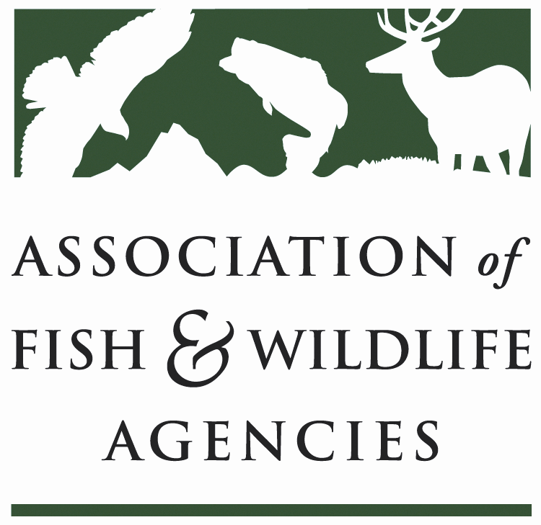

FISH AND WILDLIFE TRUST FUNDS COMMITTEE
Chair: Mark Tisa, MA
Vice Chair: Ted Will, GA

March 10, 2025

1:15 – 3:00 PM

​
- Call to Order, Introductions, Announcements, and Agenda Review – Mark Tisa, MA

The meeting was called to order at 1 PM.
- Approval of the September 2024 Meeting Minutes
The committee approved the meeting minutes from September 2024.

Scheduled Discussion Items

- 2027 National Survey Update – NORC (Presentation attached)

The 2027 National Survey of Fishing, Hunting, and Wildlife-Associated Recreation, conducted by NORC at the University of Chicago in collaboration with the U.S. ​ Fish & Wildlife Service, is a continuation of a long-standing effort to collect comprehensive data on outdoor recreational activities in the United States. ​ This survey, conducted approximately every five years since 1955, serves as the definitive source of data on fishing, hunting, and wildlife-associated recreation. ​ It also includes information on related activities such as target shooting, archery, and recreational boating. ​ The survey collects participation and expenditure data for adults and youth, as well as state-specific data for coastal and inland regions.

The 2022 survey introduced significant updates, including a redesigned questionnaire to reduce respondent burden and a multimode survey methodology to improve cost efficiency. Over 105,000 interviews were conducted, and 15 states purchased state-level data to support policy development, economic impact analysis, and conservation efforts. These state-level surveys used the same rigorous methods as the national survey, allowing for precise comparisons and tailored insights. ​ States also had the option to add custom questions to address specific needs, such as recruitment and retention strategies. ​

Looking ahead, the 2027 survey will expand its scope by increasing the number of interviews by 25% and incorporating cost-saving measures like reducing reliance on paper-and-pencil interviews. ​ It will also explore alternative sampling methods, such as using fishing and hunting license lists, to enhance data collection. ​ Additionally, the survey will include new estimates for activities like bow hunting and work toward piloting an interim survey to provide high-level participation data during off-years. ​ These efforts aim to improve data accuracy, reduce respondent burden, and enhance the survey’s utility for stakeholders. ​

States participating in the 2027 cycle will benefit from actionable data, in-depth analysis, and tailored reports to support their conservation and policy goals. NORC is actively engaging with states to finalize plans for state-level surveys by Fall 2025, offering flexible pricing and consultation services. ​ The survey’s enhancements and collaborative approach underscore its commitment to providing reliable, actionable insights for the outdoor recreation community.

Q&A

Dan F. – What did the (buy-in) states think of the quality of state data

States were pleased with the data, and they are coming back for 2027. NORC will work with the states and their base their data on their needs.

ASA wants to see more fishing questions

- Legislative Updates – Kurt Thiede, AFWA (Full Report attached)

Administrative Updates - AFWA is maintaining regular communication with the state agency members, federal agencies, congressional offices, and conservation partners to assess and document the ongoing effects and challenges associated with the implementation of Executive Orders, especially those related to funding and staffing. As part of this effort, we are actively communicating with agency leadership and Congress to raise awareness about the importance of these programs and the current and potential consequences of delays and disruptions associated with staffing cuts and funding delays.

Budget Updates - In January–February 2025, Congress remained at an impasse on FY25 appropriations, with little chance of passing all 12 spending bills before the current Continuing Resolution (CR) expires on March 14, making either a short-term or full-year CR almost certain. House Republicans are preparing a “clean” CR to extend funding through September, with a vote expected as early as March 11, while Democrats favor a shorter extension to allow time for negotiations on updated appropriations with detailed funding and policy provisions. The measure still faces hurdles in the Senate, and without agreement, a government shutdown could begin March 15. Meanwhile, the FY26 budget cycle has begun despite uncertainty around FY25, with the President’s budget proposal not expected until April. The House Appropriations Subcommittee on Interior, Environment, and Related Agencies has already issued testimony instructions for FY26, due April 4, while members continue to stress the importance of submitting requests through individual appropriations portals.

Sporting Goods Excise Tax Modernization Act (H.R. 1494) Introduced - On February 21, Representatives Panetta (D-CA) and Moore (R-UT) introduced the bipartisan Sporting Goods Excise Tax Modernization Act (H.R. 1494), a priority for AFWA and its partners, to close a major gap in funding for the Wildlife Restoration and Sport Fish Restoration Trust Funds. The bill would require online marketplaces to collect excise taxes on archery and angling equipment sold directly to U.S. consumers by foreign vendors, aligning with recent Government Accountability Office recommendations. With a favorable score anticipated, the measure is being considered as a potential addition to the final reconciliation bill, or alternatively, as part of the upcoming Sportfish Restoration and Boating Trust Fund reauthorization.

Upcoming Reauthorization of the Sport Fish Restoration and Boating Trust Fund - he excises taxes paid on angling equipment and the portion of the federal gasoline excise tax attributable to motorboats that are deposited into the Sport Fish Restoration and Boating Trust Fund (SFRBTF) must be reauthorized every five years and the current authorization expires at the end of FY26. AFWA has been working with the Angling and Boating Alliance, an informal coalition of organizations representing those who pay into the fund and those who administer and benefit from the fund, to develop legislation to reauthorize the SFRBTF. After a year of discussion, the Alliance has agreed on a platform and draft legislative text to reauthorize the fund. We are now sharing the platform with congressional offices, securing sponsors, and we expect the legislation will be introduced later this spring. Based on previous reauthorizations, the bill will eventually be incorporated into the larger surface transportation bill.

- Update on FET Slippage through Internet Marketplace Facilitators – Dan Forster, ATA

On February 21, the bipartisan Sporting Goods Excise Tax Modernization Act (H.R. 1494) was introduced. It has a high likelihood of being included in reconciliation, and if not, it might make it to the SFR Reauthorization.
- Joint Federal/State Task Force on Federal Assistance Policy (JTF) Update- Mark Tisa, MA

The JTF meeting was postponed, and it will be held virtually sometime in the spring.

- The Federal Aid Coordinators Working Group – Matthew Warriner, AR

The FACWG gave a presentation on the "Real Property Status Reporting Survey of States" (presentation attached), providing insights into the progress and challenges faced by agencies in completing real property status reporting. The survey, conducted between December 13, 2024, and January 10, 2025, gathered responses from 55 entities, representing an 87% response rate. ​ The survey covered 13 questions and included participation from 50 states, Washington D.C., five territories, and eight marine entities. ​

Key findings indicate that only 21.1% of respondents have completed their real property status reporting in TRACS, while 78.9% have not. ​ Regarding collaboration, 71.7% of respondents have met with their Conservation Investment Regional Office POC to discuss reporting needs, though 26.1% have not. ​ Written procedures for monitoring and documenting the status report are lacking, with only 19.1% having them in place, while 38.3% do not, and 25.5% acknowledge their procedures need updating. ​

Assistance remains a significant need, with 47.4% seeking help from others within their agency, 15.8% from Conservation Investment, and 36.8% requiring both. ​ For updating TRACS records, 40.9% plan to work with CI to ingest new data, 36.4% intend to update directly in TRACS, and 22.7% aim to replace all inventory records. ​ Confidence in meeting the April 30, 2026, deadline is mixed, with 48.9% feeling on track, 46.7% unsure, and a small percentage indicating they are not on track. ​

Currently, 10 respondents have completed their reporting, while 38 need to review and update TRACS records. ​ The highest demand for uploading records is expected in the next 3-4 months. ​ While 22 respondents are confident in meeting the deadline, 21 remain uncertain. ​

- New Business –Mark Tisa, MA

No new business

