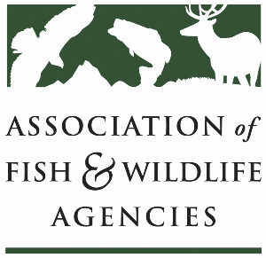

**Ocean resources policy committee**

Chair: Nate Pamplin (WA)

Vice-Chair: Dave Golden (NJ)

July 2

1:00 – 3:00 PM ET

Microsoft Teams

**Agenda**

1:00 pm Call to Order/Review Agenda/Approval of Minutes – *Nate Pamplin, WA*

* Do at Annual Meeting

1:05pm Introductions - *All*

1:15 pm Government Affairs Update - *Ali Schwaab, AFWA*

* Federal Budget
* AFWA Funding Priorities for NMFS, Grant Updates, and Check-In with States
* Sport Fish Restoration and Boating Trust Fund Reauthorization
* Other Legislation

1:35 pm Federal Partner Updates

2:00 pm Proposed transfer of NMFS OPR to USFWS – *All*

2:15 pm National Fish Habitat Partnership Update – *Ryan Roberts, AFWA*

2:30 pm State Roundtable – *All*

2:55 pm Wrap up and Adjourn – *Nate Pamplin, WA*