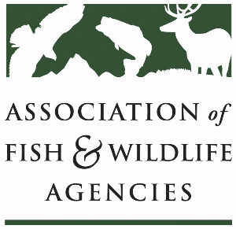

**Ocean resources policy committee**

Chair: Nate Pamplin (WA)

Vice-Chair: Dave Golden (NJ)

Wednesday, March 12

3:30 – 5:30 PM

90th North American Wildlife and Natural Resources Conference

Louisville, Kentucky

**Agenda**

3:30 pm Call to Order/Review Agenda/Approval of Minutes – *Nate Pamplin, WA*

3:40 pm Introductions - *All*

3:50 pm National Fish Habitat Partnership Update – *Ryan Roberts, AFWA*

4:10 pm Government Affairs Update - *Ali Schwaab, AFWA*

* Federal Budget
* NMFS Funding Priorities
* Sport Fish Restoration and Boating Trust Fund Reauthorization
* 75th Anniversary of Sport Fish Restoration Act
* Offshore Energy Development and Executive Orders
* Mitchell Act check-in

4:30 pm Open Roundtable on Marine Mammals- *All*

* Take reduction teams
* Stock assessments
* Bycatch reduction technologies

5:00 pm Other Partner Updates – *All*

5:20 pm Wrap up and Adjourn – *Nate Pamplin, WA*