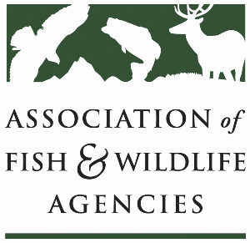

**Fisheries and WATER rESOURCES pOLICY COMMITTEE**

Chair: Jim Fredericks (ID)

Vice-Chair: Craig Bonds (TX)

Thursday, March 13

1:15pm – 3:15pm

90th North American Wildlife and Natural Resources Conference

Louisville, Kentucky

**Agenda**

1:15 pm Call to Order/Review Agenda/Approval of Minutes – *Jim Fredericks, ID*

1:20 pm Introductions - *All*

1:25 pm Subcommittee and Working Group Reports

* Subcommittee on Water – *Julie Carter, AZ*
* Drug Approval Working Group – *Alan Johnson, IA*
* Fish & Wildlife Coordination Act Working Group – *Jen Sheehan, AR*
* Aquatic Animal Health and Aquaculture Working Group – *Ali Schwaab, AFWA*
* Bird Fish Related Conflict Working Group – *TBD*

1:50 pm National Fish Habitat Partnership Update – *Ryan Roberts, AFWA*

2:05 pm Break

2:15 pm Government Affairs Update – *Ali Schwaab, AFWA*

* Budget
* Sportfish Restoration and Boating Trust Fund Reauthorization
* Executive Orders
* Other

2:30 pm Roundtable on Fisheries/Water Funding Issues and Priorities – *All*

2:50 pm American Fisheries Society Update *– Jeff Kopaska, AFS*

3:00 pm Federal Partner Updates *– TBD*

3:10 pm Wrap-up Discussion – *Jim Fredericks (ID)/All*

3:15 pm Adjourn