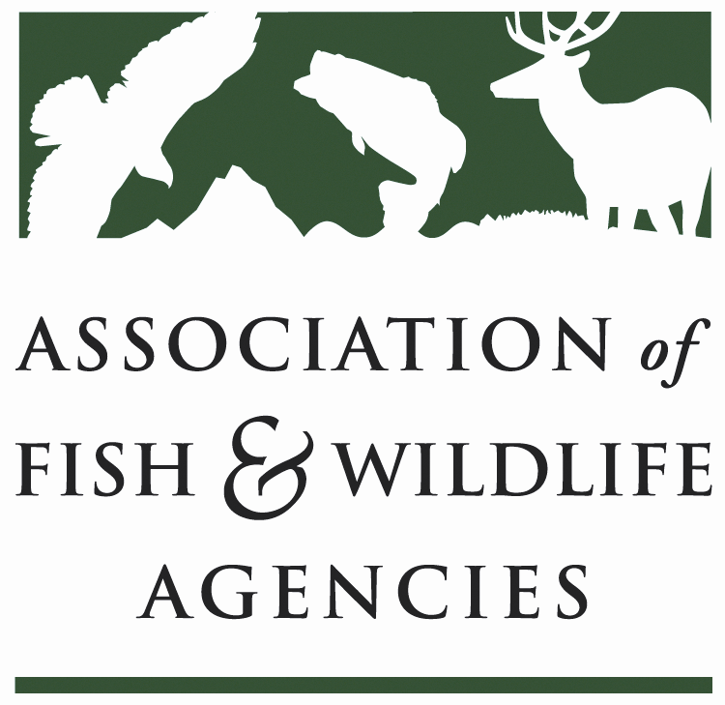

FISH AND WILDLIFE TRUST FUNDS COMMITTEE
Chair: Mark Tisa, MA
Vice Chair: Ted Will, GA

September 24, 2024

1:00 – 3:00 PM

​
- Call to Order, Introductions, Announcements, and Agenda Review – Mark Tisa, MA

The meeting was called to order at 1 PM.
- Approval of the March 2024 Meeting Minutes
The committee approved the meeting minutes from March 2024.

Scheduled Discussion Items

- 2027 National Survey Update – Jeff Davis, CO

Background
- National Survey is performed every five years
- Old census model became unaffordable (estimated at $22 million) and ‘new vision for national survey created by AFWA with following side boards:
- $7.5 million cap over five years
- High level, national, participation and economic data only
- Enable state ‘buy-up’ for state data
- 2022 survey considered success
- 15 states ‘bought-up’ for state level data

Recommendation 1: Main Survey
NSTWG Recommends NORC implement option #1:
- $7.495 million – meets budget cap
- Increase efficiency based on lessons learned from 2022 survey
- Increase number of completed interviews at same cost
- Addition of two or three new questions included

Recommendation 2: Coordination
NSTWG Recommends USFWS Continue to coordinate national survey
- Recommended reducing budget
- Develop workplan for addendum and reports with approval from NSTWG
- Better coordination with and approval of draft reports by NSTWG per RFP
- Make public data set available on USFWS web site for download (not done per RFP for 2022) – include instructions for use in all downloads
- Work with AFWA on formal, coordinated effort to solicit new questions (2-3 for National effort and potential future small surveys)

Recommendation 3: State Level Reports (15 states in 2022)
NSTWG Recommends promoting the expansion of state level reports (paid for by states):
- Investigate standardization of reports
- Develop and implement formal marketing / comms plan based on 2022 positive experience
- Share state data publicly on USFWS web site (requires permission from states)

Recommendation 4: Interim Surveys
Per instructions given to NSTWG, NORC is now able to perform interim, high-level surveys
- Note – need to determine timing/funding request for 2025 data
- Cost between $200,000 and $400,000
- AFWA continues to work with NORC to develop modules with subject experts on priority areas
- Proposal likely to be submitted in 2025

- Airguns Paying into Wildlife Restoration Fund – Chuck Sykes, AL

President Sykes gave a detailed update on the history and current status of negotiations and the potential for including airguns as taxable items.

During the Trust Fund Committee meeting at the 2023 North American Conference, a key action item emerged: AFWA was tasked with submitting a letter to the air gun industry, urging them to contribute excise tax to the Wildlife Restoration Fund in a manner consistent with the archery and firearms industries. Additionally, the Committee proposed that AFWA develop a position statement to be presented at the Annual Meeting in September 2023, stating that the air gun industry should pay excise tax into the Wildlife Restoration Fund in alignment with the archery and firearms industries.

Subsequently, at the 2023 AFWA Annual Meeting, RESOLUTION 2023-04-07 was drafted and passed, calling for an Amendment of the Pittman-Robertson Federal Aid in Wildlife Restoration Act to Include Airguns and Associated Ammunition.

After passing the Resolution, AFWA leadership (the Executive Director and the President) met with industry representatives during the SHOT Show—the meeting aimed to raise awareness among the airgun industry leaders.

As of now:

- Cautiously optimistic that we are making progress – it’s slow
- Airgun industry pays a 4-11% tariff on products – an average 10 million dollars a year over the past decade – to the USFWS migratory bird program
- Threefold
  - Voluntary – “not a viable option”
  - Open up PR for reauthorization
  - Do what the suppressor bill is doing.
- A couple of states have enacted fees.

- AFWA Knowledge Hub – Chet Van Dellen, Timons Group

AFWA has developed an initial concept, including requirements and designs, for the web-based “AFWA Knowledge Hub.” This concept will allow all fish and wildlife agencies to access a web interface embedded with “Playbooks” that are case studies and best practices that can be shared among agencies. The proposed solution will have capabilities that prioritize intuitive data sharing, organization of data, seamless collaboration, and a clean design for non-technical users. Additionally, the content on the Hub will be easy to update and require no code deployments or dedicated technical staff. In the proposed solution, fish and wildlife agencies will be able to:
  - Access the AFWA Knowledge Hub home page with an overview and a simple search mechanism to allow users to search by state, province, territory, or subject.
  - Potential subjects could include DEI, R3 grant matching, landscape conservation, shared stewardship, or other important subjects.
  - Navigate to the associated states’ available Playbooks organized alphabetically by subject by selecting a state, province, or territory from the home page.
  - Navigate to a list of Playbooks associated with the subject organized alphabetically by state by selecting a subject from the home page.
  - Manage the content and images for each agency.
  - The Hub will support linking out to full documents, where applicable, e.g., R3 plans for each state, etc.
Since the grant award, AFWA and their technology partner Timmons Group have developed an online Knowledge Hub shared-information portal for AFWA member agencies and their partners to upload, discover, and obtain Playbook articles on agency best practices, strategies, lessons learned, and pitfalls to avoid when undertaking new opportunities and challenges. This online portal is currently in a testing phase and is expected to be launched in a production environment at the end of this month (March 2024). AFWA and Timmons Group will continue to partner under this grant for the remainder of 2024 to provide onboarding, training, and Playbook content generation and management to ensure the Knowledge Hub portal provides as much value to AFWA members as possible.

- Update on FET Slippage through Internet Marketplace Facilitators – Dan Forster, ATA

Background
- Estimated 17 million dollars/year in lost revenue.
- Senator Crapo started a GAO study in 2023, completed in July 2024 (Annex 1)
- To ensure a good tax policy, you must move where that tax is collected up the chain.
Next Steps
- Currently have draft language of a bill; expect to get a bill dropped the first week of October.
  - We hope the bill is passed this legislative session but gives considerable footing for the 119th Congress.

- Wildlife and Sport Fish Restoration Update – Paul Rauch, OCI

The presentation is attached to this report. (Annex 2)

- New Business –Mark Tisa, MA

No new business

