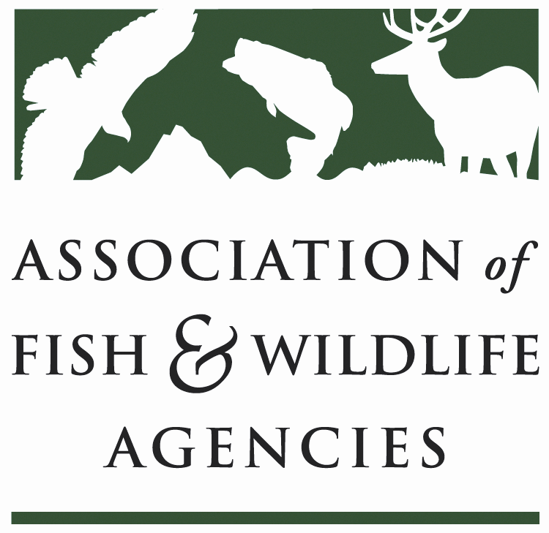

FISH AND WILDLIFE TRUST FUNDS COMMITTEE

March 10, 2025
1:15 – 3:15 PM

90th North American Wildlife and Natural Resources Conference
__________________________________________________________________________________

Chair: Mark Tisa, MA
Vice Chair: Ted Will, GA
​________________________________________________________________________________

Agenda

- Call to Order/Review Agenda/ Introductions- Mark Tisa, MA
- Approval of Minutes from the September 2024 Meeting
- 2027 National Survey Update – NORC
- Joint Federal/State Task Force on Federal Assistance Policy (JTF) Update- Mark Tisa, MA / Paul Rauch, OCI
- Update on FET Slippage through Internet Marketplace Facilitators – Dan Forster, ATA
- Office of Conservation Investment Update – Paul Rauch, OCI
- The Federal Aid Coordinators Working Group – Matthew Warriner, AR
- New Business – Mark Tisa, Chair
- Review of Action Items
- Wrap Up/Adjourn

