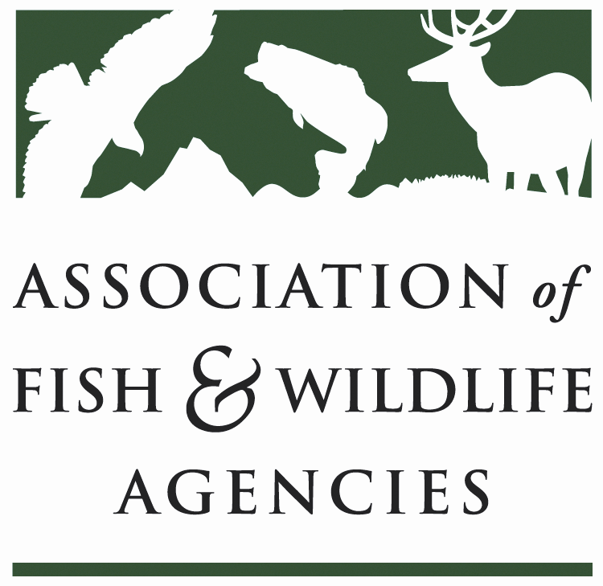

FISH AND WILDLIFE TRUST FUNDS COMMITTEE

September 24, 2024
1:00 – 3:00 PM

114th Association of Fish & Wildlife Agencies Annual Meeting
Madison, Wisconsin
__________________________________________________________________________________

Chair: Mark Tisa, MA
Vice Chair: Ted Will, GA
​________________________________________________________________________________

Agenda

- Call to Order/Review Agenda/ Introductions- Mark Tisa, MA
- Approval of Minutes from the March 2024 Meeting
- 2027 National Survey Update – Jeff Davis, CO
- Joint Federal/State Task Force on Federal Assistance Policy (JTF) Update- Mark Tisa, MA / Paul Rauch, OCI
- Airguns Paying into Wildlife Restoration Fund Update – Mark Tisa, MA
- AFWA Knowledge Hub – Chet Van Dellen, Timons Group
- Update on FET Slippage through Internet Marketplace Facilitators – Dan Forster, ATA

- Office of Conservation Investment Update – Paul Rauch, OCI
- The Federal Aid Coordinators Working Group – Matthew Warriner, AR
- New Business – Mark Tisa, Chair
- Review of Action Items
- Wrap Up/Adjourn

