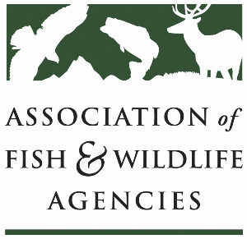

**OCEAN resources policy committee**

Chair: Nate Pamplin (WA)

Vice-Chair: Dave Golden (NJ)

Tuesday, September 24, 2024

10:00 AM – 11:45 AM

114th Association of Fish & Wildlife Agencies Annual Meeting

Madison, Wisconsin

**Agenda**

10:00 am Call to Order/Review Agenda/Approval of Minutes – *Nate Pamplin, WA*

10:05 am Introductions - *All*

10:10 am NOAA Update– *Heidi Lovett, NOAA*

10:30 am USFWS Update –*TBD*

10:40 am Roundtable Discussion on Pinniped Predation – *All*

11:00 am National Fish Habitat Partnership Update – *Ryan Roberts, AFWA*

11:20 am Government Affairs Update - *Ali Schwaab, AFWA*

11:40 am Wrap up and Adjourn – *Nate Pamplin, WA*