**BOILERPLATE LANGUAGE TO INCLUDE FALL FLIGHTS AND SOUTHERN WINGS IN SWAPS**

The Missouri Department of Conservation graciously offered the Fall Flights and Southern Wings teams to use the text from their [Comprehensive Conservation Strategy](https://mdc.mo.gov/sites/default/files/2022-04/2022-Missouri-CCS.pdf) to provide other states with ideas of how they may include Southern Wings, Fall Flights, and full annual cycle bird conservation in SWAPs. The text below has been modified by the Fall Flights and Southern Wings Teams for illustrative purposes. The Fall Flights and Southern Wings Teams as well as the Missouri Department of Conservation encourage you to incorporate any of the text below in your SWAP updates or modify to meet your needs. work on your SWAP. A template to include Southern Wings in SWAPs is also available - [Southern Wings Template for SWAPs](https://www.fishwildlife.org/download_file/view/5255/387). Southern Wings also has provided a [species spreadsheet](https://www.fishwildlife.org/download_file/view/3813/387) with information on annual cycle connections for priority species impacted by Southern Wings projects. Watch for an updated list that will include species impacted by Fall Flights projects as well.

**Table of Contents**

MULTI-STATE AND INTERNATIONAL COLLABORATIVES 1

PLANNING AT MULTIPLE SCALES 1

Migratory Bird Full Life-Cycle Conservation Partnerships 2

Neotropical Migrant Bird Conservation Partnerships – Southern Wings 2

Case Study Examples: 3

Waterfowl Conservation Partnerships – Fall Flights 4

Connections between the [REGION of CANADA] and [NAME OF STATE] 5

Case Study: Waterfowl Habitat for other species of migratory birds 9

Future Collaboration Supporting This Key Partnership 9

## MULTI-STATE AND INTERNATIONAL COLLABORATIVES

It is important to understand the value of [NAME Of STATE] resources and conservation initiatives in context of delivering upon regional, national, and international conservation success.

### PLANNING AT MULTIPLE SCALES

Conservation planning occurs at multiple scales and [NAME OF STATE] conservation planning is designed to contribute to ecological system restoration focused on landscapes that often extend beyond [NAME OF STATE] borders and meeting the needs of migratory species that have specific habitat requirements in ranges that can extend as far north as the Arctic and as far south as the tip of South America. The North American Bird Conservation Initiative establishes Migratory Bird Joint Ventures that establish regional bird conservation priorities. [NAME OF STATE] is part of [NUMBER OF] joint ventures ([LIST NAMES]) and the SWAP complements the regional priorities stepped down to the state level. [NAME OF STATE] is a partner in many regional planning and management initiatives including the [NAME OF FLYWAY], and priorities identified by the flyway are incorporated into the landscapes important for all birds. The [NAME OF STATE TEAM RESPONSIBLE FOR STATE BIRD PLAN] steps down regional landbird conservation plans to outline the state’s most threatened landbird species, including many neotropical migrants.

Beyond planning, management of our resources requires working beyond [NAME OF STATE] borders on a regular basis. Many of the priority landscapes in [NAME OF STATE] extend across [NAME OF STATE] border and most species of greatest conservation need (SGCNs) have ranges well outside the state, requiring partnerships with neighboring states and regional or international partners to accomplish needed actions to achieve shared goals. Watersheds and flyways often encompass all or parts of multiple states and require complex coordination among many partners and jurisdictions to improve conditions, regulate harvest and methods, and provide needed habitat. Recovery of declining species that have large ranges requires coordination throughout the species’ range and with partners and agencies with interest and jurisdiction. Much of this work may include efforts to protect and maintain migratory species’ habitat throughout their annual cycles, which is called full annual cycle conservation. Our focus is targeting management on key life history needs while species are in [NAME OF STATE]. These life history needs include providing breeding, migration, and non-breeding habitat, depending on the species. We then work through partnerships to accomplish larger scale landscape initiatives and to meet the full annual cycle needs of SGCNs that spend a portion of their annual cycle in [NAME OF STATE]. Conservation of migratory species is one area of [NAME OF STATE]’s commitment to cross-border conservation and is imperative to the improvement and long-term sustainability of [NAME OF STATE] natural communities and species. Some key examples of this work (i.e., neotropical migrant birds, shorebirds, waterfowl, and monarch butterfly) are included in this section to build understanding of the importance of supporting these key partnerships beyond [NAME OF STATE] borders.

### Migratory Bird Full Annual Cycle Conservation Partnerships

[PROPORTION, EG., One third] of [NAME OF STATE] breeding birds are migratory and spend up to eight months of the year beyond the borders of the United States, some traveling thousands of miles each way. In addition, [NAME OF STATE] plays a critical role for [NUMBER] of bird species that either migrate through [NAME OF STATE] or winter in [NAME OF STATE]. Considering recent research that quantified a net loss of 2.9 billion birds in the last 50 years (many of which are migrants; Rosenberg et al. 2019), we cannot afford to ignore the threats that many migratory birds face across their full life-cycle ranges.

### Neotropical Migratory Bird Conservation Partnerships – Southern Wings

When one considers the millions of migratory birds that breed across Canada and the United States redistributing into relatively small geographies within Mexico, Central America, South America, and the Caribbean during migration and the non-breeding seasaon, it puts in perspective the importance of this work.

Threats to these vital landscapes, ecosystems, and the birds that use them vary by country and region but include deforestation, commodity agriculture (palm oil), illegal logging, contaminants, and enforcement deficiencies on protected areas. Intense poverty across this region of the world adds to the dire need for support from international partners that have a shared interest in the protection and conservation of shared avifauna. Conservation efforts on migratory stopover sites and the non-breeding grounds work to curb these threats through acquisition and protection of lands used as migratory pathways and wintering sites; education of landowners on regenerative agricultural and ranching practices including shade-grown coffee farming; the creation and maintenance of native tree nurseries and reforestation efforts; and others.

The Association of Fish and Wildlife Agencies’ (AFWA) established [Southern Wings](https://www.fishwildlife.org/afwa-inspires/southern-wings) in 2009 to provide a mechanism for states to collaborate with partners to invest in the conservation of priority migratory birds across their full annual cycle. Since that time, over 41 states have contributed $4.2 million to conservation efforts on stopover sites and non-breeding grounds in Mexico, Central America, South America, and the Caribbean. Full annual cycle conservation efforts in Central and South American are critical for 100s of species of neotropical migrant birds, including these SGCNs, [LIST OF SPECIES].

[NAME OF STATE]’s priority SGCNs include species with conservation needs in [LIST COUNTRIES]. These countries encompass key corridors and geographies that [NAME OF STATE]’s priority species use as migratory corridors or overwintering habitat.

The conservation action on the ground depends on the needs of the species and the conservation landscape. It could include actions to slow or reverse continued deforestation through reforestation efforts and implementation of regenerative agroforestry systems with local landowners; secure protection of core migratory bird habitat through protected area creation and management; improve or reestablish shade- grown coffee practices that maintain or create migratory-bird habitat.

*[Note: You could insert a map here from* [*Cornell Lab of Ornithology's eBird website*](https://science.ebird.org/en/status-and-trends/abundance-maps) *to highlight a high priority species. Contact Deb Hahn if you need assistance.]*

#### Case Study Examples:

*[NOTE: We recommend including one or two case studies. We’ve provided two examples. You can modify to include work either done or planning to be done through your state’s investments in Southern Wings. A list of 2024-2025 Southern Wings projects can be found* [*here*](https://www.fishwildlife.org/application/files/6517/1206/8523/SWingsProjects_24_25_w_o_budgets.pdf) *to help you identify potential case study topics.]*

**Case Study: Restoration of Migratory Bird Habitat in Ecuador – Cerulean Warbler**

MDC has supported conservation efforts with partners American Bird Conservancy and local organization Fundación Jocotoco in Ecuador since 2015. Ecuador has the highest deforestation rate in South America over the last 50 years. The goals of projects in Ecuador are to slow the rate of deforestation, to work with landowners to improve land-use practices, and to create better habitat connectivity in the buffer zones of existing protected areas in the Chocó- Canandé BirdScape that cerulean warblers and 105 other neotropical migratory species use for nonbreeding habitat. Conservation efforts in Central America support cerulean warblers on both pre-breeding and post-breeding migrations, and work in Ecuador supports these birds through the boreal winter months (Figure 2.35). Missouri’s population of cerulean warblers breed in riparian-associated forest gaps largely near Ozark streams, including in five PGs (Missouri River Hills, Big Buffalo Creek, Mahan’s Creek, Huzzah and Shoal Creek Woodlands for Wildlife (SCWW), and Little Niangua River), Upper Niangua COA, Current River Hills Forest/Woodlands COA, and Little Black COA.

**Case Study: Pacific Shorebird and Wetland Bird Restoration**

Arizona Game and Fish Department, California Department of Fish and Wildlife, and the Pacific Flyway Council have supported Terra Peninsular and other partners since 2017. The project’s goal is to improve the efficiency of conservation and management for coastal wetlands, shorebirds, waterbirds, and waterfowl through the integration of data and prioritization of decision-making. The project impacts the conservation of between 3 and 21 SGCN species in AK, AR, CA, CO, ID, MT, NV, NM, OR, UT, WA, and WY including long-billed curlew, mountain plover, snowy plover, Pacific brant, lesser scaup, American white pelican, redhead, and more. Actions include conducting surveys for Pacific Brant, snowy plover, California least tern and other species; collaborating with the local hunting organizations to improve the sustainability of hunting; installing predator exclusion devices on beaches; and working with local communities to implement best management practices.

### Waterfowl Conservation Partnerships – Fall Flights

[NAME OF STATE] collaborates with other state and federal agencies and other conservation partners to achieve the NAWMP goals of:

1. Abundant and resilient waterfowl populations to support hunting and other uses without imperiling habitat
2. Wetland and related habitats sufficient to sustain waterfowl populations at desired levels, while providing places to recreate and ecological services that benefit society
3. Growing numbers of waterfowl hunters, other conservationists, and citizens who enjoy and actively support waterfowl and wetlands conservation

These goals acknowledge the important role wetlands and related habitats can play not only for waterfowl, but for providing ecological services, including habitat for other migratory bird species. Achieving these goals requires states to collaborate with one another and partners to pool resources to protect and conserve habitat in the regions most critical for waterfowl; this means directing resources to the breeding grounds in Canada. In turn, these investments benefit other species of migratory birds that share these habitats, especially shorebirds.

States, through AFWA, set a goal to collectively invest up to $10 million per year on the breeding grounds in Canada through the Fall Flights to help achieve their shared NAWMP goals. An AFWA Presidential Task Force set state funding goals based on waterfowl hunter and harvest data. In this program, states work closely with partners to leverage funding and to support conservation delivery. Every dollar invested by a state is matched by partner like Ducks Unlimited and Delta Waterfowl and then again by the North American Wetlands Conservation Act (NAWCA) and finally by Canadian partner contributions. The result is that each states’ contribution is multiplied at least four- to fivefold. Migratory Bird Joint Ventures provide the science used to identify priority landscapes and best conservation practices. Other partners, like Ducks Unlimited – Canada and Manitoba Habitat Conservancy are responsible for conservation delivery and focus on protection, management, and restoration of wetlands and associated habitats including grasslands, parklands, and boreal forest.

Realizing the immense benefit for migratory waterfowl and other migratory bird species, which use [NAME OF STATE] resources for part of their life cycle, [NAME OF STATE] has invested [DOLLAR AMOUNT] in Fall Flights and plan on continuing or increasing this investment.

#### Connections between the [REGION of CANADA] and [NAME OF STATE]

*[Contact Andy Raedeke (Andrew.raedeke@fallflights.com) or your Canadian partner liaison (e.g., Ducks Unlimited – Canada or Manitoba Habitat Conservancy) for assistance in locating the necessary data to complete the next two sections.]*

The connections between the [REGION OF CANADA] and [NAME OF STATE] wetlands are apparent when examining band recoveries of waterfowl harvested in [NAME OF STATE]. Nearly [NUMBER] percent of the waterfowl harvested in [NAME OF STATE] were banded in [REGION OF CANADA] (Figure 2.37). *[THE REMAINDER OF THE PARAGRAPH FOCUSES ON THE PRAIRIE POTHOLE REGION AND WOULD NEED TO BE REVISED IF YOUR STATE’S FALL FLIGHTS INVESTMENTS TARGET A DIFFERENT REGION IN CANADA]*. The highest densities of breeding ducks in North America occur in the PPR of Canada. As a result, the PPR is rated as the highest priority area for waterfowl conservation in North America. It is estimated that, dependent on habitat conditions, up to 70 percent of the continent’s waterfowl breed in this region. This area is particularly critical for mallard, northern shoveler, gadwall, northern pintail, blue-winged teal, American wigeon, canvasback, and redhead. Waterfowl populations of the PPR of Canada in 2018 were estimated at 15.7 million birds, representing 38 percent of the annual breeding population in North America. There are 18 species that frequent this region. Mallards, at 23 percent of the breeding duck population, are the most abundant species. This region also supports 60 percent of the breeding gadwall, over 48 percent of blue-winged teal, and at least 62 percent of redheads.

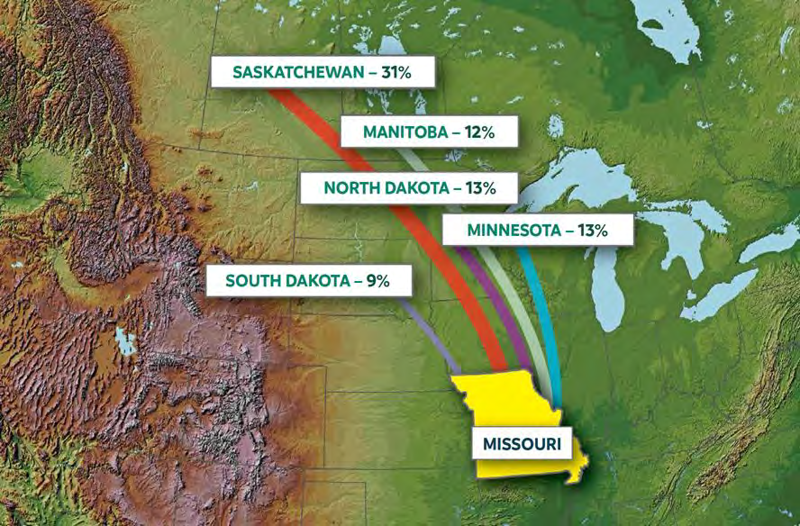

[EXAMPLE MAP – SOURCE DU-CANADA ANNUAL REPORT] – Nearly 80 percent of the waterfowl harvested in Missouri were banded in Saskatchewan, Manitoba, North Dakota, South Dakota, and Minnesota. Data from 1986– 2019. Note that this data is not corrected for banding effort.

The importance of [REGION OF CANADA] is not limited to waterfowl. This region plays host to [NUMBER] of different bird species, many of which rely on wetland habitats for breeding or for important rest stops during migration. The [NAME OF CANANDIAN JOINT VENTURE] has identified species that rely on these habitats for breeding, including [LIST OF SPECIES] – all of which are listed as species at risk in Canada. The [NAME OF CANADIAN JOINT VENTURE] also has identified [NUMBER] waterbird and shorebird priority species that breed in the Boreal or Arctic regions but rely on wetlands in the [NAME OF REGION IN CANADA] as important places to rest and replenish reserves during migration. The [NAME OF STATE] identifies [NUMBER] bird SGCNs. Of these, [NUMBER] are also listed as priority species in Bird Conservation Region [NUMBER], which is the [NAME OF BCR] of Canada.

#### A Focus on [NAME OF REGION IN CANADA]

[NAME OF STATE AGENCY focuses its Fall Flights resources on five high priority waterfowl areas located within the [NAME OF REGION IN CANADA] (Figure 2.38). [NAME OF STATE AGENCY] selected these priority areas because of their wetland density, risk and/or degree of habitat loss, and partnership opportunity. This targeted region serves as an important source for waterfowl that either migrate through or winter in [NAME OF STATE], as evidenced by the high proportion of band recoveries in [NAME OF STATE] of waterfowl banded in [NAME OF PROVINCE]. In addition to providing critical breeding and molting habitat for waterfowl, it is also an important stopover location for migrating waterbirds and shorebirds.

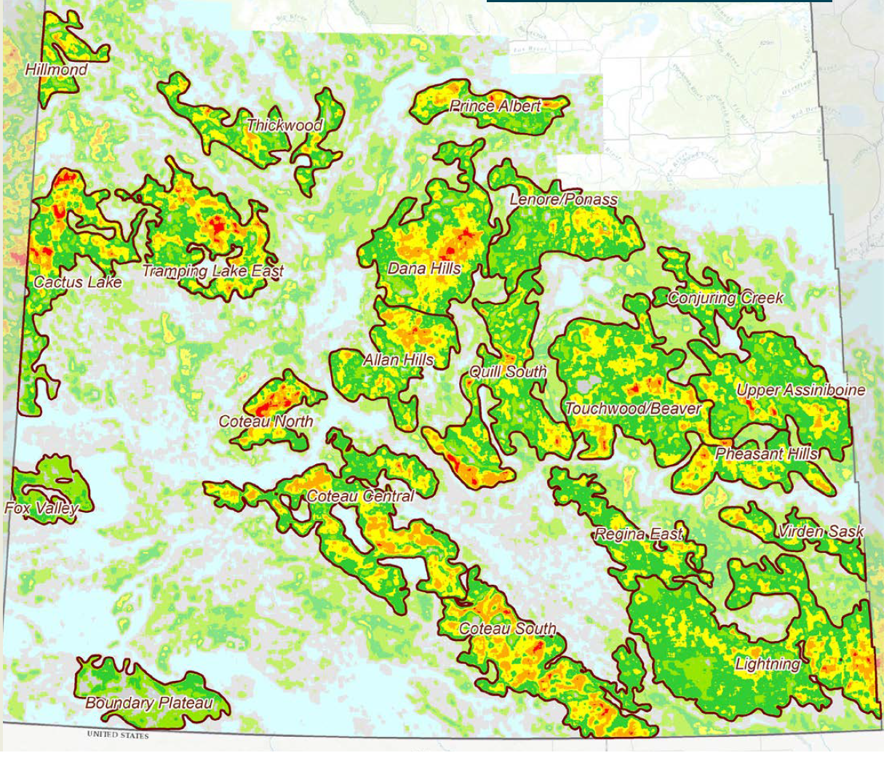

Figure 2.38 – [NAME OF STATE AGENCY] focuses its Fall Flights on five High Priority Waterfowl Areas in [NAME OR REGION IN CANADA], including [LIST NAMES OF PRIORITY AREASt]. *[NOTE: Maps like this can be found in the annual reports DU-Canada submits to your agency]*

These target areas are located in the [NAME OF ECOREGION] of [NAME OF PROVINCE]. The [NAME] eco-region includes [HABITAT TYPE] in the [DIRECTION (E.G., SOUTHERN)] portion of [NAME OF PROVINCE] and [HABITAT TYPE] further [DIRECTION] before reaching the [NAME OF NEXT LANDSCAPE TYPE, E.G., Aspen Parklands]. These habitats make these priority areas key to waterfowl production. [*THE NEXT SENTENCE WOULD APPLY IF INVESTING IN THE PPR]* Based on USFWS survey data, PPR and particularly these priority areas continue to stand out as the “best of the best” breeding habitats in North America, despite ongoing and historic habitat loss. The Prairie Pothole Habitat Joint Venture has noted these habitats also play an important role for grassland birds, shorebirds, and waterbirds.

[NAME OF STATE AGENCY] worked closely with [NAME OF CANADIAN PARTNER] to identify these locations based on science. DU- Canada developed a waterfowl distribution model to identify areas that have the highest duck pair densities. Direct programs are applied to areas that support a minimum long-term average of 50 pairs of breeding ducks ([LIST SPECIES]) per square mile. The priority areas far exceed this minimum criterion over most of the landscape (Figure 2.39). The [NAME OF CANADIAN JOINT VENTURE], employs a waterfowl production model to project the outcomes of conservation programs – measured in hatched nests, landscape conditions, and species-specific population characteristics.

Figure 2.39 – [NAME OF CANADIAN JOINT VENTURE] waterfowl Decision Support System map helps identify “hot spots” in which to direct efforts that will provide the greatest benefit to waterfowl.

#### Case Study: Waterfowl Habitat for other species of migratory birds

Please check back later. This section will be updated with examples.

#### Future Collaboration Supporting This Key Partnership

Conservation partners will continue to collaborate to help protect, conserve, and restore critical habitat in [NAME OF REGION IN CANADA] of Canada. This effort will ensure that waterfowl and other species of migratory birds that depend on these habitats at some point during their annual cycle and then migrate through or winter in [NAME OF STATE] will have sufficient habitat to meet their life history needs.

Landscape conditions and land use in the PPR have changed since [NAME OF STATE] first selected this focal region in [YEAR]. Next steps for [NAME OF STATE] will be to consider where best to direct future funds in the Canadian PPR. [NAME OF STATE AGENCY] will examine band derivation data for ducks harvested in Missouri, consider data from eBird Status and Trends and Audubon’s Migration Explorer for other species of migratory birds, and identify where the greatest potential threats to wetlands and associated wetland habitats are in the Canadian PPR. [NAME OF STATE] conservation partners will also consider goals and objectives associated with [NAME OF STATE WETLAND PLAN] and the [NAME OF STATE BIRD PLAN to ensure conservation efforts positively affect state priorities as well as influence larger flyway and population level goals.

Financial investments toward these efforts have been beneficial for wetland conservation and the many organisms that depend on abundant and diverse wetland habitats, including those species and habitats that support the tradition of waterfowl hunting. Ecological and social challenges exist for future conservation efforts. [NAME OF STATE] continuing commitment and leadership role in collaborative efforts like these are vital and have broader impacts than just within the state borders.