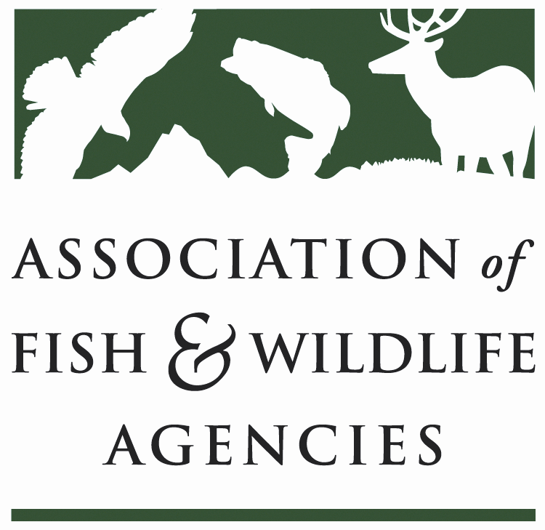

FISH AND WILDLIFE TRUST FUNDS COMMITTEE
Chair: J.D Strong (OK)

September 26th, 2023,
1:00 PM – 4:00 PM

​
- Call to Order, Introductions, Announcements, and Agenda Review – J.D Strong

The meeting was called to order at 1 PM.
- Approval of the March 2023 Meeting Minutes
The committee approved the meeting minutes from March 2023.

Scheduled Discussion Items
- 2022 National Survey Update –Emily, Alvarez, NORC

The first National Survey of Fishing, Hunting, and Wildlife-Associated Recreation was conducted in 1955. Before its inception, we knew many people spent time outdoors, we knew these outdoor activities impacted the economy, and we knew having measures of these would be beneficial to guide and manage conservation programs across the country. However, we had yet to consolidate ways to collect that data until the Association proposed a survey to address these gaps in understanding.
Now conducted every five years, the National Survey is one of the world's oldest, most comprehensive, and most respected recreation surveys.

2022 National Survey

- Data was collected over 4 waves of data collection:
- Screener Survey fielded January 15 to April 15, 2022
- 3 detailed wave questionnaires were fielded May 1, 2022, to March 31, 2023.

- Each survey was offered in 3 modes: phone, web, and paper.
- Interviews were conducted in both English and Spanish.
- In total, we interviewed 105,698 adults aged 16 and older.

2022 National Survey Findings

- Anglers - 15% of the U.S. population age 16 and older went recreational fishing in 2022.

Type of Activity | Participants |  | Days of Participation |  | Trips
 | Number | Percent | Number | Percent | Number | Percent
Fishing | 39,935,437 | 100 | 785,226,417 | 100 | 462,733,320 | 100
Freshwater | 35,069,217 | 88 | 559,005,615 | 71 | 359,051,599 | 78
Saltwater | 12,704,743 | 32 | 123,110,918 | 16 | 103,681,721 | 22
- Expenditures for Fishing for 2022

Expenditure Item | Expenditures |  | Spenders
 | Amount (Dollars) | Average per Angler (Dollars) | Number | % | Average per Spender (Dollars)
Total, All Items | $99,422,180,761 | $2,490 | 38,862,006 | 97 | $2,558
Total Trip-Related | 36,604,110,918 | 917 | 37,341,147 | 94 | 980
Fishing Equipment | 8,660,298,983 | 217 | 29,126,920 | 73 | 297
Auxiliary Equipment | 4,326,757,061 | 108 | 14,771,669 | 37 | 293
Special Equipment | 27,747,888,134 | 695 | 7,908,496 | 20 | 3,509
Other Expenditures | 22,083,125,666 | 553 | 29,268,567 | 73 | 754

- Hunters – 5.5% of the U.S. population age 16 and older went hunting in 2022.

Type of Activity | Participants |  | Days of Participation |  | Trips
 | Number | % | Number | % | Number | %
Hunting | 14,374,589 | 100 | 240,752,065 | 100 | 165,002,494 | 100
Big Game | 11,521,659 | 80 | 134,683,681 | 56 | 91,610,000 | 56
Small Game | 5,290,082 | 37 | 38,056,272 | 16 | 33,996,768 | 21
Migratory Birds | 2,812,364 | 20 | 22,861,271 | 9 | 19,786,340 | 12
Other Animals | 2,300,439 | 16 | 19,902,802 | 8 | 19,609,387 | 12

- Expenditures for Hunting for 2022

Expenditure Item | Expenditures |  | Spenders
 | Amount (Dollars) | Average per Hunter (Dollars) | Number | % | Average per Spender (Dollars)
Total, All Items | $45,221,096,403 | $3,146 | 13,854,558 | 96 | 3,264
Total Trip-Related | 12,322,736,006 | 857 | 12,191,391 | 85 | 1,011
Hunting Equipment | 7,903,537,189 | 550 | 10,555,584 | 73 | 749
Auxiliary Equipment | 3,947,958,433 | 275 | 8,440,300 | 59 | 468
Special Equipment | 7,742,558,419 | 539 | 3,351,210 | 23 | 2,310
Other Expenditures | 13,304,306,355 | 926 | 11,734,306 | 82 | 1,134

- Wildlife Watching - 57% of the U.S. population age 16 and older went wildlife watching in 2022.

- Expenditures for Wildlife Watching for 2022

Expenditure Item | Expenditures |  | Spenders
 | Amount (Dollars) | Average per Wildlife Watcher (Dollars) | Number | % Wildlife Watchers | Average per Spender (Dollars)
Total, All Items | $250,198,668,336 | 1,687 | 114,362,154 | 77 | 2,188
Total Trip-Related | 42,059,320,300 | 284 | 34,914,966 | 24 | 1,205
Hunting Equipment | 24,635,959,828 | 166 | 89,051,682 | 60 | 277
Auxiliary Equipment | 8,910,935,634 | 60 | 36,132,561 | 24 | 247
Special Equipment | 85,097,170,236 | 574 | 20,823,554 | 14 | 4,087
Other Expenditures | 89,495,282,339 | 604 | 72,486,119 | 49 | 1,235

- Participants in Target Shooting & Archery by Age Group in 2021

Age Group | Target Shooters |  | Archers
 | Number | Percent | Number | Percent
Total | 46,167,033 | 100 | 18,849,819 | 100
6 to 15 years | 4,820,346 | 10 | 4,198,084 | 22
16 to 17 years | 1,166,524 | 3 | 792,096 | 4
18 to 24 years | 4,175,301 | 9 | 1,947,345 | 10
25 to 34 years | 8,063,251 | 17 | 3,337,682 | 18
35 to 44 years | 7,583,088 | 16 | 2,932,189 | 16
45 to 54 years | 6,687,440 | 14 | 2,236,893 | 12
55 to 64 years | 6,938,313 | 15 | 1,970,654 | 10
65 years or older | 6,732,771 | 15 | 1,434,875 | 8

Full Presentation attached, Annex 1

- Airguns Paying into Wildlife Restoration Fund – J.D. Strong, OK

During the Trust Fund Committee meeting at the 2023 North American Conference, a key action item emerged: AFWA was tasked with submitting a letter to the air gun industry, urging them to contribute excise tax to the Wildlife Restoration Fund in a manner consistent with the archery and firearms industries. Additionally, the Committee proposed that AFWA develop a position statement to be presented at the Annual Meeting in September 2023, stating that the air gun industry should pay excise tax into the Wildlife Restoration Fund in alignment with the archery and firearms industries.

Subsequently, at the 2023 AFWA Annual Meeting, RESOLUTION 2023-04-07 was drafted and passed, calling for an Amendment of the Pittman-Robertson Federal Aid in Wildlife Restoration Act to Include Airguns and Associated Ammunition.

After passing the Resolution, AFWA will follow with a letter to the air gun industry encouraging excise tax payments.

- Update on FET Slippage through Internet Marketplace Facilitators – Dan Forster, ATA

The ATA and ASA have raised awareness that online marketplaces facilitate the sale of archery and sportfishing equipment into the United States by overseas manufacturers through these transactions, the traditional mechanism for excise tax collection (i.e., the U.S.-based manufacturer or importer) may be avoided.
AFWA came through last year, and the Trust Fund Committee members voted to move forward with the resolution titled “Urging corrective action to address federal excise tax slippage for imported archery and sportfishing equipment,” the State Directors voted on it during the business meeting. As a result, we managed to get some conversations started with Senator Crapo’s office. Senator Crapo initiated a Government Accountability study last year, and it’s still in process. GAO has been interviewing a lot of organizations and is making progress. When the study is complete, the ATA will analyze the results and connect with ATA members and Congress to find a solution that ensures foreign-based entities are paying the same taxes as companies in the United States.
A fix will take time because Congress must update legislation to ensure the FET collection process aligns with current global markets and consumer buying practices.

- Legislative Updates – David Lind, AFWA

Recovering America’s Wildlife Act -The Alliance for America’s Fish & Wildlife in coordination with steering committee members and various industry partners, has now contracted an economic impact analysis on the various costs associated with endangered species listings both incurred and avoided by making proactive investments. This will be a valuable campaign product to help make an economic argument for RAWA as we get into a busy fall legislative session in both chambers. We look forward to working with you all to compile good examples of proactive conservation that have prevented the need to list a species and any quantifiable economic gains.
FY24 Appropriations - As of Friday, September 22, 2023, a path forward to avoid a Federal Government shutdown was still unknown after a series of setbacks in the House as they worked to pass a short-term Continuing Resolution or CR. The only real movement was expected from the Senate, where they were trying to navigate a path forward for a minibus combining the Agriculture/FDA, Defense, and Transportation/HUD bills, however, that too now appears to have stalled. AS we go into the final week of the Federal fiscal year, a federal government shutdown is looking more likely. Meanwhile, we continue to meet with appropriators to advocate for our main priorities – State and Tribal Wildlife Grants, USGS Cooperative Research Units, USFWS Science Applications, and Migratory Bird Management. Given the difficult budget environment, we have tempered expectations of plus-ups for any of our priorities and have been advocating to at least hold the Senate appropriations numbers.
Bipartisan Safer Communities Act/Hunter Education Fix - When the Bipartisan Safer Communities Act (BSCA) was signed into law last year, Congress amended a comprehensive school funding program known as the Elementary and Secondary Schools Education Act (ESEA), which some state-level Departments of Education utilize to fund archery in schools, wilderness courses, archery programs, among others. When Congress modified the ESEA through the BSCA, they included language to prohibit using ESEA funds to train personnel in using a “dangerous weapon.” The intent of Congress in making this amendment to the ESEA was to prohibit ESEA funds from being used for training school resource officers and other security.
personnel.
Unfortunately, the U.S. Department of Education is taking the definition of “dangerous weapon” at face value rather than following the legislative intent of Congress, which is now threatening the future of school activities such as archery and hunter education, among many others. Whether ESEA funds will fund Hunter Education, National Archery in Schools Program (NASP), Scholastic Shooting Sports Programs, Wilderness Training, and Jr. ROTC Programs in a school or not…Congressional action is needed to preserve the ability of our nation’s schools to continue to offer these important programs, and they should be allowed to use ESEA funds if necessary.
Sen. Tester (D-MT) has introduced S. 2735, Defending Hunters' Education Act of 2023, co-sponsored by Sens. Murkowski, Casey, and Collins. Meanwhile, the House Education and Workforce Committee favorably reported H.R. 5110 with a unanimous vote for an amendment like a substitute that broadens the exception to cover Hunter Education and other programs, rather than just shooting sports, and makes the two bills identical. These bills address the legislative fix AFWA, and many other outdoor groups have requested to address this issue permanently.
E-Duck Stamp Legislation Passes Both Chambers, Reconciliation Needed - The Duck Stamp Modernization Act of 2023 (S. 788), which would eliminate the 45-day e-duck stamp expiry date and allow the e-duck stamp to be valid for the entire waterfowl season, passed the Senate by unanimous consent on July 27, while the House version (HR 2872) passed by voice on September 20.
BIL/IRA Implementation - The Association and Fish and Wildlife Agencies (AFWA) and the Theodore Roosevelt Conservation Partnership (TRCP) co-chair a coalition of several dozen hunting, fishing, and conservation organizations and businesses. This coalition helped pass the Bipartisan Infrastructure Law or Infrastructure Investment and Jobs Act of 2021 (BIL/IIJA) Public Law 117-58) and the Inflation Reduction Act of 2022 (IRA – Public Law 117-169), which both serve to strengthen established conservation and recreation programs and create new programs focused on infrastructure innovations that offer long-term benefits for climate resilience by utilizing natural systems.
Farm Bill Updates - As the 2018 Farm Bill approaches its September 30, 2023 expiration date, it has become clear a new Farm Bill will not be passed in time. A 2023 Farm Bill is not out of the question, as many of the programs will not face major disruption from the expiration until the end of the calendar year. Congress is hoping to get a bill passed by the end of December, otherwise an extension of the 2018 Farm Bill will be necessary.
Wildlife Disease Surveillance for Pandemic Prevention Act - A piece of legislation related to One Health that AFWA is prioritizing again in the 118th Congress is the Wildlife Disease Surveillance for Pandemic Prevention Act (WDSPPA) that was introduced at the end of last year by Rep. Porter (D-CA) after being developed in close coordination with the leadership of the AFWA Fish and Wildlife health Committee. Reintroduction we are told is imminent, but support from Republican original cosponsors is needed first. With the help of our state Directors, we have begun to reach out to potential Republican cosponsors to encourage support.
Build America/Buy American Guidance - The Office of Management and Budget (OMB) published final regulations in the Federal Register that provide new guidance for implementation of the Build America, Buy American Act (BABA), taking effect October 23. OMB intends to have issued a new M memorandum by then, replacing interim guidance. The new guidance expands definitions, including for construction materials (fiber optic and engineered wood), clarification of “manufactured products”, and added definitions for component and manufacturer. There is additional guidance on categorization of articles, materials, and supplies, as well as details on how federal agencies should implement the cost of components test.

Full briefing is attached to this report, Annex 2

- Wildlife and Sport Fish Restoration Update – Paul Rauch, WSFR/Colleen Scully, WSFR/Tom Decker, WSFR

The presentation is attached to this report. Annex 3

- Joint Federal/State Task Force on Federal Assistance Policy (JTF) Update- Paul Rauch, WSFR

- The Federal Aid Coordinators Working Group – Matthew Warner, AR

The presentation is attached to this report. Annex 4

- New Business – J.D. Strong, OK

No new business

The meeting adjourned at 3 PM

