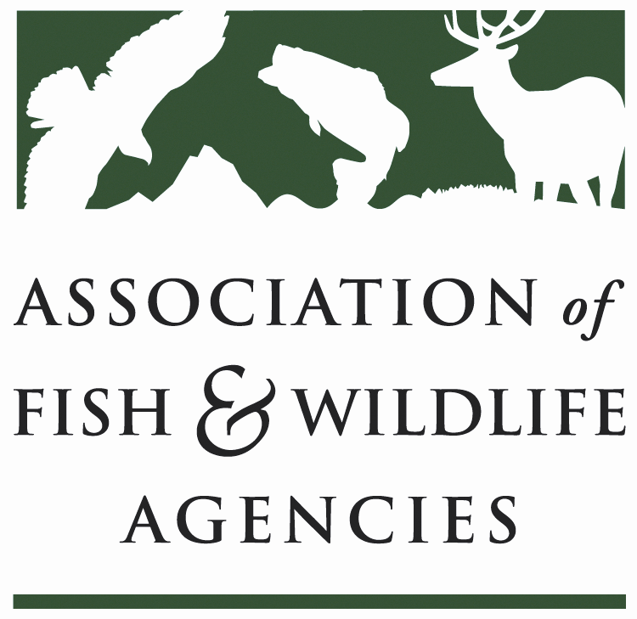

Wildlife diversity conservation & funding Committee
Chair: Carter Smith (Texas Parks & Wildlife Department)
Vice Chair: David Whitehurst (Virginia Department Game & Inland Fisheries)

Tuesday September 12, 2017
8:00 am to 12:00 pm

Association of Fish and Wildlife Agencies Annual Meeting
Room: Cottonwood A
Snowbird Resort | Sandy, Utah

Committee Charge Advocate for long-term dedicated funding and annual appropriations for the conservation of at-risk fish and wildlife, nature-based recreation and conservation education; support development, implementation and revision of State Wildlife Action Plans; build, support and coordinate the national Teaming With Wildlife coalition.

Agenda
08:00AM Call to Order/Review Agenda/Introductions-TBD

08:10AM Approval of Committee Report from the March 2017 Meeting-TBD

08:15AM Alliance for America’s Fish & Wildlife
- Update on Recovering America’s Wildlife Act-Jen Mock Schaefer, AFWA
- Update on branding, communications and advocacy campaign-Sean Saville, AFWA
- The role of partners-Naomi Edelson, NWF
- Report from Blue Ribbon Panel Communications Joint Working Group-Keith Norris, TWS; Jen Newmark, NDOW
- Blue Ribbon Panel Agency Relevancy & Transformation Working Group-Steve Williams, WMI

09:15AM State Wildlife Action Plans
- Report from the SWAP Review & Revision Guidance Working Group-Rex Sallabanks, IDGFD
- Presentation on Species of Greatest Conservation Need Tool-Abby Benson, USGS
- SWAP National Meeting-Mark Humpert, AFWA

10:00AM -BREAK-

10:15AM State & Tribal Wildlife Grants
- Legislative Update-Mark Humpert, AFWA
- Discuss need to continue advocacy- Rex Sallabanks, IDGFD, Keith Norris, TWS, Naomi Edelson, NWF
- 2018 SWG Fly-in-Mark Humpert, AFWA
- Criteria for competitive SWG-Mark Humpert, AFWA
- Wildlife & Sport Fish Restoration Program Report-Tim Smith, USFWS
11:00AM Other Reports
- Landscape Conservation Cooperatives-Elsa Haubold, USFWS
- National Survey on Hunting, Fishing and Wildlife-Associated Recreation-John Arway, PAF&BC
- Amphibian & Reptile Committee-Priya Nanjappa, AFWA
- Bird Conservation Committee-Judith Scarl, AFWA
- Wildlife Viewing & Nature Tourism Working Group-Shelly Plante, TPWD

11:40AM 2018 Committee Work Plan

12:00PM Adjourn

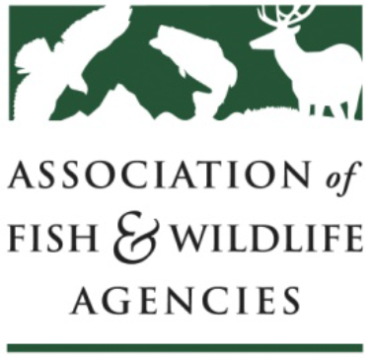
AFWA Committee Work Plan
Worksheet

Guidelines: Each AFWA Committee, Subcommittee and Workgroup is required to review their charge and develop a work plan at the AFWA Annual Meeting and submit to John Lord, Operations Director, jlord@fishwildlife.org by October 1. The purpose of the work plan is to improve communication and effectiveness of committee work and enable committee chairs and the Executive Committee to evaluate their status annually.

Committee Work Plan
Date:
Committee Name:

Chair: | Vice Chair: | Staff:
Committee Charge:

Changes to the Charge:

List Major Activities and Objectives Accomplished During the Last Year:
1.
2.
3.
4.
5.

List Activities and Objectives that Will be Accomplished in the Coming Year:
1.
2.
3.
4.
5.

Comments:

Workgroup Work Plan
Date:
Workgroup Name:

Chair: | Vice Chair: |  | Staff:
Workgroup Charge:

Changes to the Charge:

List Major Activities and Objectives Accomplished During the Last Year:
1.
2.
3.
4.
5.

List Activities and Objectives that will be Accomplished in the Coming Year:
1.
2.
3.
4.
5.

Describe any Changes you Anticipate to the Work Group:

List Workgroup Members:

Date Workgroup Formed: |  | Expected Termination Date:
Comments

Workgroup Work Plan
Date:
Workgroup Name:

Chair: | Vice Chair: |  | Staff:
Workgroup Charge:

Changes to the Charge:

List Major Activities and Objectives Accomplished During the Last Year:
1.
2.
3.
4.
5.

List Activities and Objectives that will be Accomplished in the Coming Year:
1.
2.
3.
4.
5.

Describe any Changes you Anticipate to the Work Group:

List Workgroup Members:

Date Workgroup Formed: |  | Expected Termination Date:
Comments

