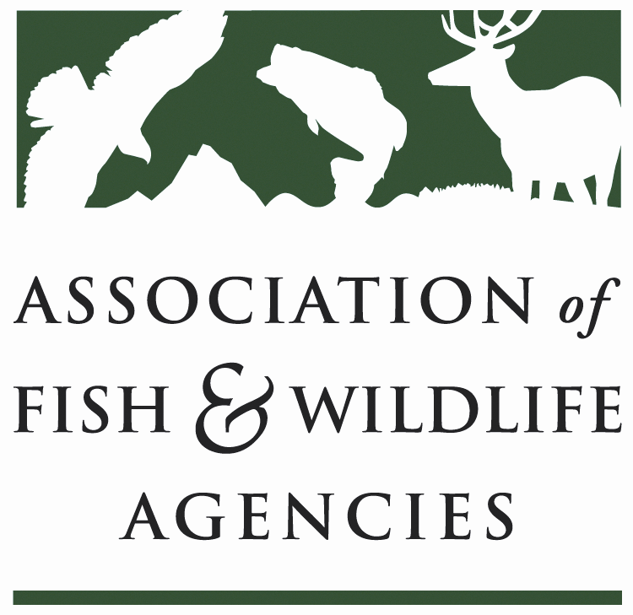

WILDLIFE RESOURCES POLICY COMMITTEE
Chair: Jim Douglas, (Nebraska)
Vice-Chair: Chuck Sykes (Alabama)

Friday March 10, 2017
8:00 AM – 10:00 AM

North American Wildlife & Natural Resources Conference
Room: Maple Ballroom / Davenport Grand Hotel
Spokane, WA

Committee Charge
To discuss and develop recommendations on Association positions related to federal laws, regulations and policies concerning habitat conservation, wildlife resources and related funding for such programs as well as wildlife management practices including those concerned with problem or nuisance wildlife, and emerging issues (e.g., commercial trade). The committee also stays abreast of threatened and endangered species wildlife issues, state legislation pertaining to wildlife management and wildlife diversity funding initiatives.

Agenda
08:00 AM Welcome, Introductions & Review Agenda (Jim Douglas, NGPC)

08:10 AM Discuss Committee Work Plan (Jim Douglas, NGPC)

08:25 AM Wildlife Services Report (Bill Clay, USDA/APHIS)

08:40 AM SUBCOMMITTEE/WORKING GROUP REPORTS

      - Amphibian & Reptile Subcommittee Report (Cathy Sparks, RIDEM)
      - Human/Wildlife Conflicts Working Group Report (Brian Wakeling, NDOW)
09:10 AM Multiagency MOU on Aircraft-Wildlife Strikes (Bill Clay, USDA/APHIS)

09:20 AM Update on Bear Diversionary Feeding Policy Statement (Jim Douglas, NGPC)

09:30 AM Registration of Kaput® Feral Hog Bait (John Bowers, GWRD)

09:40 AM Bat Conservation (Mylea Bayless, BCI)
- Update on the North American Bat Monitoring Program
- Bats & Wind Energy Conflicts
09:50 AM Update on Blue Ribbon Panel on Sustaining America’s Diverse Fish & Wildlife Resources (Mark Humpert, AFWA)

10:00 AM Adjourn

