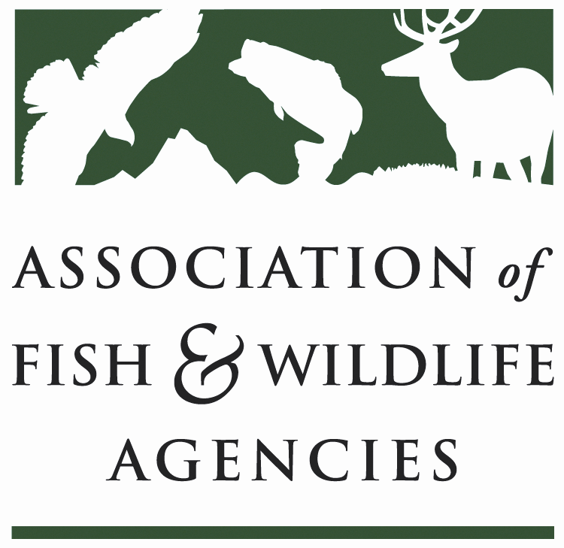

WILDLIFE RESOURCES POLICY COMMITTEE
Chair: Jim Douglas, (Nebraska)
Vice-Chair: Chuck Sykes (Alabama)
Wednesday September 14, 2016
10:00 AM – 12:00 PM
Association of Fish and Wildlife Agencies Annual Meeting
Room: Ballroom Salon K-Marriott Philadelphia Downtown
Philadelphia, PA

Committee Charge
To discuss and develop recommendations on Association positions related to federal laws, regulations and policies concerning habitat conservation, wildlife resources and related funding for such programs as well as wildlife management practices including those concerned with problem or nuisance wildlife, and emerging issues (e.g., commercial trade). The committee also stays abreast of threatened and endangered species wildlife issues, state legislation pertaining to wildlife management and wildlife diversity funding initiatives.

Agenda
10:00AM Welcome, Introductions & Review Agenda (Jim Douglas, NGPC)

10:10AM Discuss Committee Work Plan (Jim Douglas, NGPC)

10:30AM Wildlife Services Report (Bill Clay, USDA/APHIS)

10:45AM SUBCOMMITTEE/WORKING GROUP REPORTS

      - Amphibian & Reptile Subcommittee Report (Cathy Sparks, RIDEM)
      - Human/Wildlife Conflicts Working Group Report (Brian Wakeling, NDOW)
11:20AM Multiagency MOU on Aircraft-Wildlife Strikes (Bill Clay, USDA/APHIS)

11:30AM Update on Bear Diversionary Feeding Policy Statement (Jim Douglas, NGPC)

11:35AM Bat Conservation
- Update on White-nose Syndrome (Jeremy Coleman, USFWS)
- Update on Regional Bat Conservation Efforts (Mylea Bayless, Bat Conservation International)
11:45AM Update on Blue Ribbon Panel on Sustaining America’s Diverse Fish & Wildlife Resources (Mark Humpert, AFWA)

12: 00PM Adjourn

