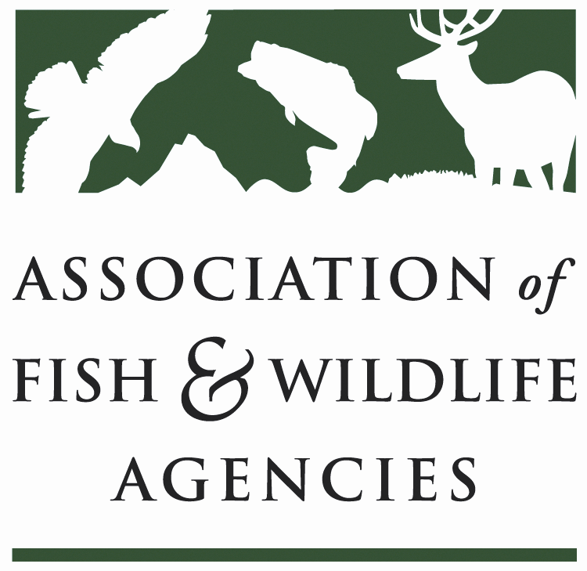

WILDLIFE RESOURCES POLICY COMMITTEE
Chair: Jim Douglas, (Nebraska)
Vice-Chair: Chuck Sykes (Alabama)

Wednesday September 13, 2017
10:00 AM – 12:00 PM

Association of Fish and Wildlife Agencies Annual Meeting
Room: Wasatch A
Snowbird Resort | Sandy, UT

Committee Charge
To discuss and develop recommendations on Association positions related to federal laws, regulations and policies concerning habitat conservation, wildlife resources and related funding for such programs as well as wildlife management practices including those concerned with problem or nuisance wildlife, and emerging issues (e.g., commercial trade). The committee also stays abreast of threatened and endangered species wildlife issues, state legislation pertaining to wildlife management and wildlife diversity funding initiatives.

Agenda
10:00 AM Welcome, Introductions & Review Agenda-Jim Douglas, NGPC

10:10 AM Wildlife Services Report-Bill Clay, USDA/APHIS

10:25 AM Multiagency MOU on Aircraft-Wildlife Strikes-Bill Clay, USDA/APHIS

10:30 AM Human/Wildlife Conflicts Working Group Report-Brian Wakeling, NDOW

10:45 AM Update on Bear Diversionary Feeding Position Statement-Jim Douglas, NGPC

11:00 AM Update on Registration of Kaput® Feral Hog Bait-John Bowers, GWRD

11:10 AM Update on the North American Bat Monitoring Program-Mylea Bayless, BCI

11:20 AM The Future of Landscape Conservation Cooperatives-Elsa Haubold, FWS

11:30 AM Update on the Alliance for America’s Fish and Wildlife-Sean Saville, AFWA

11:40AM Discuss/Develop Committee Work Plan-Jim Douglas, NGPC

12:00 PM Adjourn

