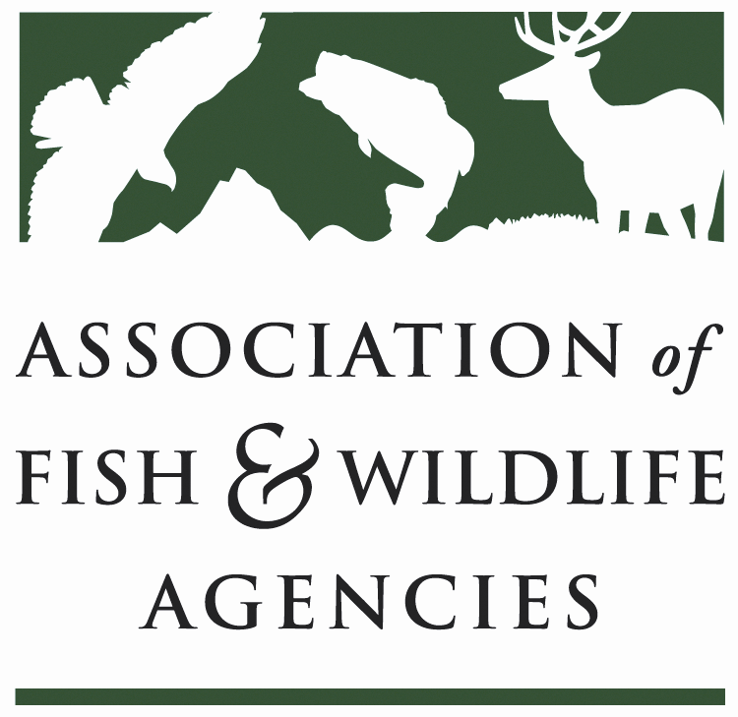

Energy & wildlife policy Committee
Chair: Paul Johansen (WV)
Vice-Chair: Keith Sexson (KS)

Tuesday, September 12, 2017
1:00 – 5:00pm

AFWA Annual Meeting
Maybird Room
Sandy, UT

Agenda

1:00 pm Call to Order – Chairman Paul Johansen, WV
Review and Approve Agenda
Introductions
Approval of Minutes from the March 9, 2017 Meeting

1:15 Committee Workplan and Energy Needs Assessment
Davia Palmeri, AFWA

1:25 State Roundtable
One representative per state agency highlights one legislative, policy, or management initiative or issue

1:45 Report from Bioenergy Working Group
Eric Zach, Working Group Chair

2:00 Alliance for America’s Fish and Wildlife
Sean Saville, AFWA

2:15 2018 National Conservation Need Proposal
Russell Norvell, Pacific Flyway Nongame Technical Committee

2:30 AFWA Legislative and Administration updates
AFWA Government Affairs Staff
-Energy package
-Hydropower legislation
-MBTA
-Administration

3:00 – 3:15 Coffee Break

3:15 Worldwide Standard for Automatic Bats & Birds Fatality Monitoring
Michal Przybycin, Empeko S.A.

3:30 Use of Ultrasonic Deterrents to Reduce Bat Mortality at Wind Plants
Brogan Morton, NRG Systems

3:45 Monarch butterflies and solar energy
Rob Davis, Fresh Energy

4:00 Report from American Wind Wildlife Institute
Ian Evans, AWWI

4:15 Report from U.S. Geological Survey’s Energy Programs
Mona Khalil, USGS

4:30 Report from Bat Conservation International
Mylea Bayless, BCI

4:45 Other business

4:55 Wrap-up Discussion & Action Items

5:00 Adjourn

