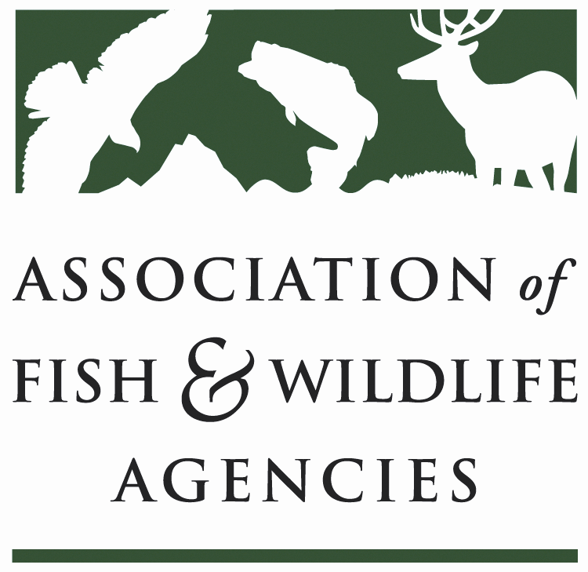

Energy & wildlife policy Committee
Chair: Paul Johansen (West Virginia)
Vice-Chair: Keith Sexson (Kansas)

Thursday, March 29, 2018
1:00 – 5:00pm

North American Wildlife and Natural Resources Conference
Room: Salon C
Hilton The Main | Norfolk, VA

Agenda

1:00 pm Call to Order – Chairman Paul Johansen, WV
Review and Approve Agenda, Introductions, Approval of Minutes from the September 2017 Meeting

1:15 State Roundtable
One representative per state agency highlights one legislative, policy, or management initiative or issue

1:30 Recovering America’s Wildlife Act & Alliance for America’s Fish and Wildlife
Sean Saville, AFWA

1:45 Update on Changes to Incidental Take (Migratory Bird Treaty Act)
Jerome Ford, USFWS

2:00 Update on Development and Mitigation Working Group-Ed Arnett, Teddy Roosevelt Conservation Partnership

2:15 Report from Bat Conservation International
Mylea Bayless, BCI

2:30 Update on Research, Strategies, and Solutions for Wind-Wildlife Challenges
Abby Arnold, AWWI

3:00 -Break-

3:15 Development of Conservation Measures for Impacts to Interior Forest Wildlife Associated with Natural Gas Pipelines in West Virginia
Cliff Brown, West Virginia Division of Natural Resources

3:45 Report on the America’s First Energy Plan-TBD

4:00 Report from the US Fish and Wildlife Service-Gary Fraser, FWS

4:15 Report from The Nature Conservancy-Brent Keith, TNC

4:30 Update on Hydropower Legislation & Other Legislative Issues
Devin DeMario, AFWA

4:45 Wrap-up Discussion & Action Items

5:00 Adjourn

