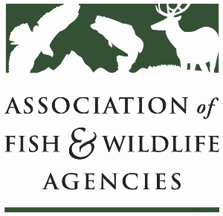

Ocean RESOURCES POLICY COMMITTEE
Chair: Nate Pamplin (WA)
Vice-Chair: Dave Golden (NJ)

Date: Tuesday, March 26, 2024
Time: 8:00 AM – 10:00 AM EDT
Amway Grand Plaza Hotel
89th North American Wildlife and Natural Resources Conference
Grand Rapids, MI

Agenda

8:00 am Call to Order/Review Agenda/Approval of Minutes – Nate Pamplin (WA)

8:05 am Introductions - All

8:10 am Government Affairs Update - Ali Schwaab, AFWA
- FY25 Budget
- Sport Fish Restoration and Boating Trust Fund
- USCG CON Registration issue
- Vessel fire safety rule
- Unmet drug needs survey- marine input needed

8:25 State Agencies’ Perspectives on ESA and MMPA Implementation – Roundtable
- State representatives will discuss how their agencies are faring with ESA and MMPA compliance. We ask attendees to come prepared to discuss topics such as incidental take permit status, take reduction team participation, fishing gear modifications/other technological advancements, and Section 6 recovery grants.

9:00 am Federal Partner Updates
- NOAA
  - Section 6 recovery grants
  - Status of marine mammal stock assessments
  - BOEM/NOAA right whale and offshore wind strategy
  - Fish passage updates
  - Funding opportunities
- FWS
  - Sport Fishing and Boating Partnership Council
  - Fish passage updates

9:15 am National Fish Habitat Partnership and National Fish Habitat Assessment Update – TBC

9:35 am State Management Responses to Shifting Species Distributions—Roundtable

- State representatives will discuss how their agencies are responding to shifting distributions of marine species, with a particular emphasis on changes in regulations.

9:55 pm Wrap up – Nate Pamplin (WA) / All

10:00 Adjourn

