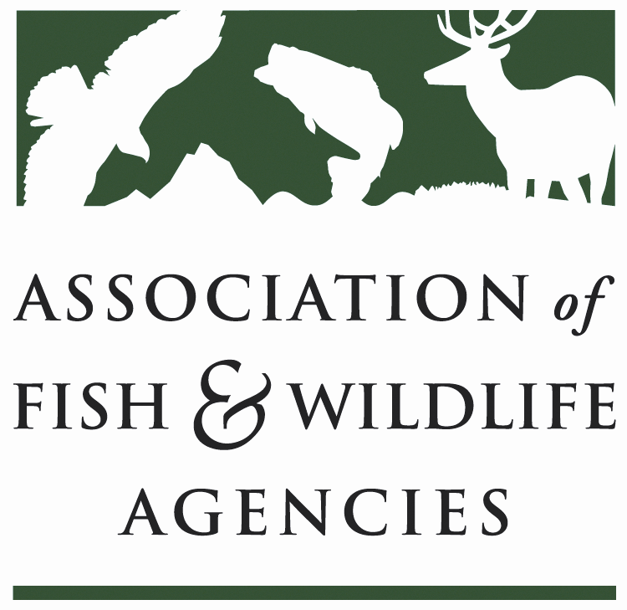

FISH AND WILDLIFE TRUST FUNDS COMMITTEE
_____________________________________________________

Chair: Mark Tisa, MA
Vice Chair: Ted Will, GA

March 28, 2024

10:00 AM – 12:00 PM

​________________________________________________________________________________

Draft Agenda

- Call to Order/Review Agenda/ Introductions- Mark Tisa, MA
- Approval of Minutes from the September 2023 Meeting
- 2022 National Survey Update – Brian Clark, KY
- Airguns Paying into Wildlife Restoration Fund – TBD
- Update on FET Slippage through Internet Marketplace Facilitators – Dan Forster, ATA

- Office of Conservation Investment Update – Paul Rauch, OCI
- Joint Federal/State Task Force on Federal Assistance Policy (JTF) Update- Mark Tisa, MA / Paul Rauch, OCI
- The Federal Aid Coordinators Working Group – Matthew Warriner, AR
- New Business – Mark Tisa, Chair
- Review of Action Items
- Wrap Up/Adjourn

