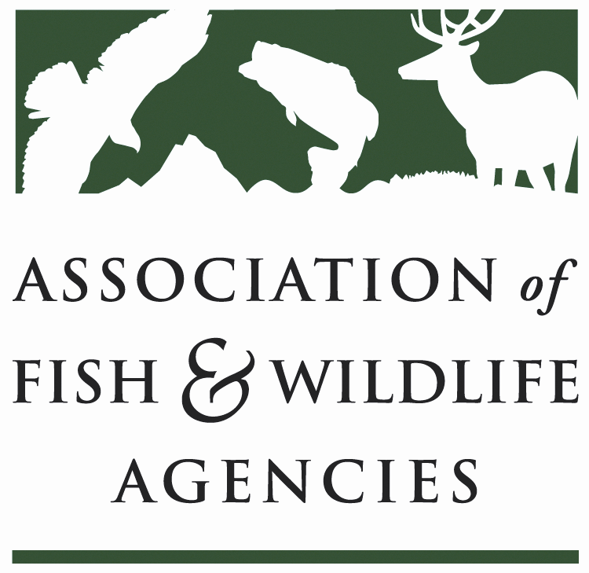

FISH AND WILDLIFE TRUST FUNDS COMMITTEE

Chair: J.D Strong (OK)

September 26th, 2023,
1:00 PM – 4:00 PM

​

Draft Agenda

- Call to Order/Review Agenda/ Introductions- J.D. Strong, OK
- Approval of Minutes from the March 2023 Meeting
- 2022 National Survey Update – Emily Alvarez, NORC
- Airguns Paying into Wildlife Restoration Fund – J.D. Strong, OK
- Update on FET Slippage through Internet Marketplace Facilitators – Dan Forster, ATA

- Legislative Updates – David Lind, AFWA

- Wildlife and Sport Fish Restoration Update – Paul Rauch, WSFR/ Tom Decker, WSFR
- Joint Federal/State Task Force on Federal Assistance Policy (JTF) Update- Paul Rauch, WSFR
- The Federal Aid Coordinators Working Group – Matthew Warriner, AR
- New Business – J.D. Strong, OK
- Review of Action Items
- Wrap Up/Adjourn

