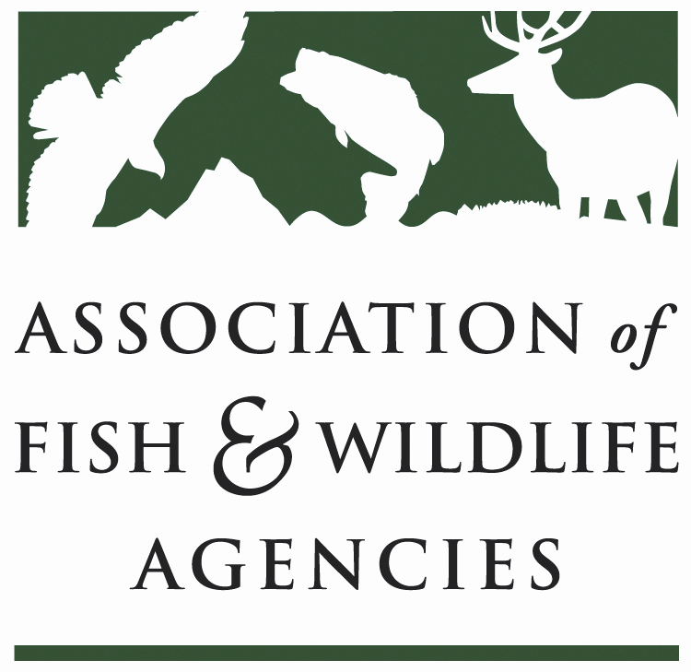

SUBCOMMITTEE ON WATER
Chair: Julie Carter (AZ)
Vice-Chair: Robert Caccese (PA)

Date: Monday, September 25, 2023
Time: 1:00 PM – 3:00 PM MDT

113th Association of Fish & Wildlife Agencies Annual Meeting
Calgary, Canada

Agenda

1:00 pm Call to Order/Review Agenda/Approval of Minutes – Julie Carter (AZ)

1:05 pm Introductions – All

1:10 pm Virtual Pre-Meeting Recap – Julie Carter (AZ)

1:30 pm National Fish Habitat Partnership Update

2:00 pm Government Affairs Update – Ali Schwaab, AFWA
- Community and Hydropower Improvement Act
- Rotenone
- Project Partnership Agreement (PPA) Reform
- WRDA 2024 Requests
- WOTUS Rule
- s404 Proposed Rule

2:20 pm Roundtable on SOW Work Plan – All

3:00 pm Wrap-Up Discussion and Adjourn – Julie Carter (AZ)

