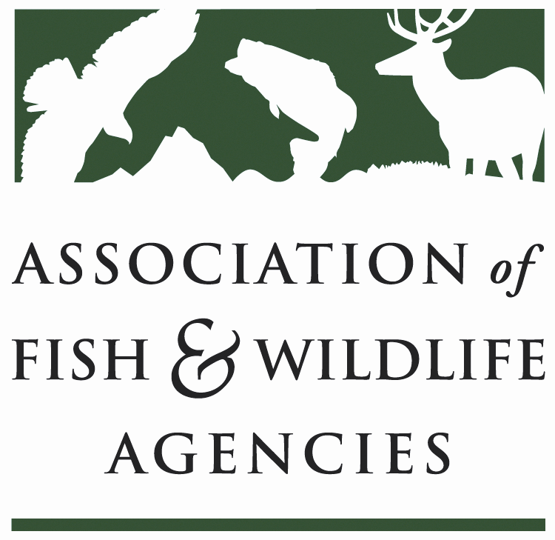

SUBCOMMITTEE ON WATER
Chair: Jason Olive (AR)
Vice-Chair: Robert Caccese (PA)

Tuesday, March 21, 2023
1:00PM CT – 3:00 PM CT

1:00 pm Call to Order/Introductions/Review Agenda – Jason Olive, AR
- Action: Approval of Draft Meeting Agenda/September 2022 minutes

1:10 pm Government Affairs Update David Lind, AFWA, Beth Calloway, ICWP

1:40 pm USGS Gap Analysis and Hydrography Update C. Estes, Life Member

1:50 pm IFC/AFS Instream Flow & Water Level Conservation C. Estes, Life Member
Training Center Planning Update

2:00 pm Public Trust Doctrine Resources Development C. Estes, Life Member

2:05 pm PFAS Discussion?

2:20 pm Jason Olive, AR

2:30 pm Jason Olive, AR

2:50 pm Action Items/Meeting Wrap/Adjourn Jason Olive, AR

Committee Charge:
Focus Areas and Goals:
- Identify, support, and communicate science, legal, policy and public involvement issues related to water that are of importance to fish and wildlife.
- Support and build on recommendations from AFWA Drought Forum.

Slides: https://www.instreamflowcouncil.org/download/virgilmoore_slides_flow2018- pdf/?wpdmdl=11389&ind=5ccff16ab72bd
Dialogue https://www.instreamflowcouncil.org/download/virgilmoore_dialogue_flow2018-pdf/?wpdmdl=11387&ind=5ccff167db4da

