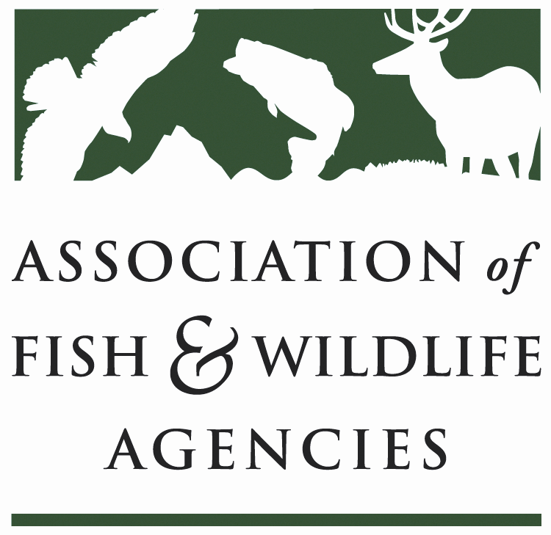

FISH AND WILDLIFE TRUST FUNDS COMMITTEE
Chair: Bryan Burhans (PA)
Vice-Chair: J.D Strong (OK)

March 23, 2023
1:00 PM – 3:00 PM

​

Bryan Burhans chaired the meeting.

- Call to Order, Introductions, Announcements, and Agenda Review – Bryan Burhans

The meeting was called to order at 1 PM.
- Approval of the March 2023 Meeting Minutes
The committee approved the meeting minutes from March 2023.

Scheduled Discussion Items
- 2022 National Survey Update –Emily, Alvarez, NORC

The first National Survey of Fishing, Hunting, and Wildlife-Associated Recreation was conducted in 1955. Before its inception, we knew many people spent time outdoors, we knew these outdoor activities impacted the economy, and we knew having measures of these would be beneficial to guide and manage conservation programs across the country. But we had yet to consolidate ways to collect that data until the Association proposed a survey to address these gaps in understanding.
Now conducted every five years, the National Survey is one of the world's oldest, most comprehensive, and most respected recreation surveys.

So what is even on the national survey? This is a high-level overview.

We measure participation rates and expenditures in fishing, hunting, and wildlife watching for adults aged 16 and over for 2022.
This includes participation in saltwater and freshwater fishing for residents in our 23 coastal states.
We also measure participation rates in fishing and hunting for children aged 6 to 15 for 2021. This data was collected on our screener survey fielded back in early 2022.
The fishing survey measures how many days each respondent has gone fishing, then in what state. For each state they fished in, we ask how many trips they took in that state and what they spent money on during those trips. This includes food, airfare, and even the ice they bought on those trips. Finally, we move on to other expenditures, such as equipment, books, and licenses.
The hunting survey follows that same cadence of total hunting days, trips and expenditures by state, and other types of expenditures.
The wildlife-watching survey has more burden on the respondents as wildlife-watching can come in so many forms. We consider this survey regarding "at home" and "away from home" wildlife watching. So, we ask about their around-the-home activities at the top, then collect the number of days watching wildlife away from home, the number of trips by state and trip expenditures by state, and other types of expenditures. The wildlife-watching survey also has questions about birding activities.
The survey data is used by agencies at both the state and federal level, industry, academics, non-profits, and the broader public in a myriad of ways, but the bottom line is that it contributes to the mission of the US Fish and Wildlife Service to conserve fish, wildlife, plants, and their habitats for generations to come.
The National Survey, and ALL surveys in general, have faced increasing challenges in recent years. Our industry needs help with rising data collection costs, we face a public that is increasingly distrusting polling and institutions, which is tanking response rates, and it's all costly to generate reasonable, reliable estimates.
This survey is long and detailed and could be more challenging. At this point in my life, it's tough to remember what I did yesterday, let alone what I did on a fishing trip two months ago.
A key constituent of this survey is our rural population. They are relatively easy to reach.
We also face non-response bias. Survey Non-response alone is not particularly troubling when the people not responding are random. But non-response can introduce significant errors in the estimates when the people refusing are systematically different from those who do take the survey. When designing this survey, we’ve been aware of the real risk that people who fish, hunt, or watch wildlife are more likely to respond to the survey than those who do not.
NORC was brought back in 2019 to help grapple with these challenges and chart a viable and sustainable path forward for the National Survey to continue for 2022 and well into the future. Working in close step with AFWA and the working group, we have come up with some solutions to do this:
We have reduced the burden on our respondents by significantly shortening the questionnaire.
For the first time in its history, respondents can now take the survey online, which helps make it more accessible and convenient to many respondents.
We've also provided a path for any state in the U.S. to opt-in to purchase state-level estimates. That was a new offering for the national survey this year.

In terms of the survey innovations:
- We’re using a blended sample design to control costs.
- Our sample sources provide better coverage in rural areas compared to the in-person interview approach used in previous survey iterations.
- We’ve taken significant steps to reduce non-response bias. NORC is using commercial data, license data, and small-area modeling to minimize any bias resulting from the potential that those who fish, hunt, or watch wildlife are more likely to respond to the survey than those who do not do those activities.
- Finally, we use advanced weighting techniques to ensure the survey represents adults regarding demographic characteristics such as age, race, gender, and education. The weights will also be designed to ensure the survey is representative of residents living in rural, suburban, and urban areas.

In the future, and if you take nothing else away from this presentation, please remember this: the 2022 National survey marks the start of a NEW TREND LINE due to all of the changes in methodology. It won’t be a good idea to make direct apples-to-apples comparisons between the previous iterations of the survey and this one. With all the updates, innovations, and improvements we’ve made, we are not able to make significant comparisons to previous trends as we won't know definitively if changes in the estimates are due to actual changes in behavior or the methodological updates we’ve made. Think of these data as the beginning of a NEW trend that can be continued in years to come with the sustainable survey model we’ve built.
For the 2022 survey. Data were collected over the course of 4 total waves- a household screener which rostered household members and their likelihood to participate in our three activities of interest. From that screener, respondents were selected to take one of the questionnaires- fishing, hunting, or wildlife-watching. They were then sent three follow-up surveys throughout the year to give us their participation and expenditures on that activity to date.
Respondents could take the survey online, with an interviewer over the phone, or on a paper and pencil questionnaire we mailed to their house. They also had the option of taking each survey in English or Spanish.
In the most recent wave alone, we completed more than 105,000 interviews. These come from several sample sources- roughly half are from probability-based lines, including members of NORC’s AmeriSpeak panel, a survey panel designed to be representative of the United States, and the other half from non-probability opt-in cases. Our statisticians will use a weighting approach designed by NORC called TrueNorth that combines the probability and opt-in respondents. TrueNorth is a proven method to obtain accurate estimates at a lower cost than if we had all probability cases. The approach mitigates potential bias introduced with the non-probability sample and helps reduce potential avidity bias.
State-level estimates to all states, and 15 have bought in. They will be receiving data for their state in addition to the national data.
The national report will be released in October. We'll present the results at the AFWA meeting in September. The Public Use Files will be released then as well.

- Industry/Agency Progress & Fish and Wildlife Business Summit -Jon Gassett, WMI

  - Business Summitt is not happening anymore.
  - WSFR database is almost final.
  - This year, we are focused on working with Southwick Associates, ATA, and ASA to look at FET slippage from import sales.
  - Mitch King continues as a contractor working on excise tax seminars/introductions to new manufacturers.

- Airguns Paying into Wildlife Restoration Fund – J.D. Strong, OK

J.D. - Some states call the air guns Air Bows, which are mislabeled. So, in some states, they are included in the archery season. For example, in OK, we tried to include the air guns into deer rifle season and passed the legislation for a $25 fee so they could contribute to wildlife conservation.
Is there more to do to include the air guns industries in paying excise tax?

Mitch asked how many air guns users paid the fee in OK – about 100. Mitch mentioned that he had worked with the industry previously on this issue, and they were not invested in making this part of legislation but rather ask states if they could charge a fee for the air gun users (like OK). But now we can go back and tell them it doesn’t work for the States and maybe start the conversations again. Air guns are becoming popular; therefore, the issue will expand.
J.D. suggested that the Association sends a letter to the air gun industry. Dan Forster suggested that the letter be drafted so the industry would respond to it.

The Committee moved that AFWA submit a letter to the air gun industry encouraging them to pay excise tax into the Wildlife Restoration Fund consistent with the archery and firearms industries. The Committee also moved that AFWA develop a position statement for the Annual Meeting in September 2023 stating that the air gun industry should pay excise tax into the Wildlife Restoration Fund consistent with the archery and firearms industries.

- Update on FET Slippage through Internet Marketplace Facilitators – Dan Forster, ATA

The ATA and ASA have raised awareness that online marketplaces facilitate the sale of archery, sportfishing equipment into the United States by overseas manufacturers through these transactions, the traditional mechanism for excise tax collection (i.e., the U.S.-based manufacturer or importer) may be avoided.
AFWA came through last year, and the Trust Fund Committee members voted to move forward with the resolution titled “Urging corrective action to address federal excise tax slippage for imported archery and sportfishing equipment,” and the State Directors voted on it during the business meeting. As a result, we managed to get some conversations started with Senator Crapo’s office. Senator Crapo initiated a Government Accountability study which was launched last year, and it’s still in the process.
GAO has contacted the USGWS, and they had a productive meeting. We are unsure how long it will take to solve this problem, but we hope for some legislative fix.

- Wildlife and Sport Fish Restoration Update – Paul Rauch, WSFR/Colleen Scully, WSFR/Tom Decker, WSFR

The presentation is attached to this report. Annex 1

- The Council to Advancing Hunting & Shooting Sports – Swanny Evans, CAHSS

The presentation is attached to this report. Annex 2

- The Federal Aid Coordinators Working Group – Matthew Warner, AR

The presentation is attached to this report. Annex 3

- New Business – Bryan Burhans, PA

The meeting adjourned at 3 PM

