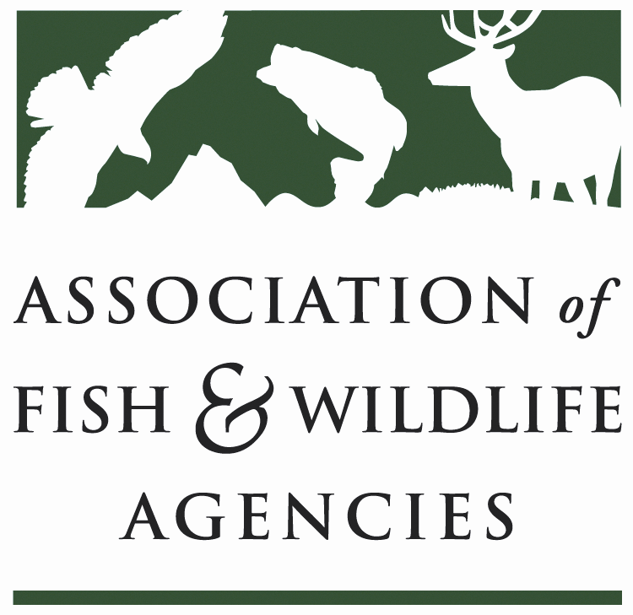

FISH AND WILDLIFE TRUST FUNDS COMMITTEE
Chair: Bryan Burhans (PA)
Vice-Chair: J.D Strong (OK)

March 23, 2023
1:00 PM – 3:00 PM

​

Agenda

- Call to Order/Review Agenda/ Introductions- Bryan Burhans
- Approval of Minutes from the 2022 AFWA Annual Meeting
- 2022 National Survey Update –NORC
- Legislative Updates/RAWA – AFWA
- Industry/Agency Progress & Fish and Wildlife Business Summit -TBD, WMI
- Update on FET Slippage through Internet Marketplace Facilitators – TBD

- Wildlife and Sport Fish Restoration Update – TBD, WSFR
- Joint Federal/State Task Force on Federal Assistance Policy (JTF) Update- TBD
- Break
- The Council to Advancing Hunting & Shooting Sports – TBD, CAHSS
- The Federal Aid Coordinators Working Group – Matthew Warriner, AR
- New Business – Bryan Burhans
- Review of Action Items
- Wrap Up/Adjourn

