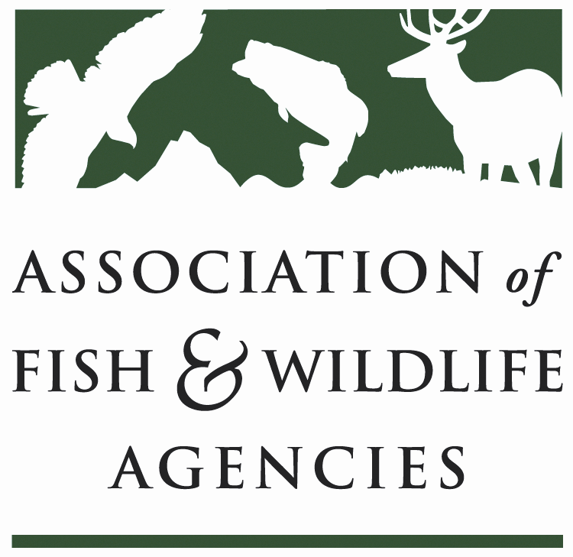

FISH AND WILDLIFE TRUST FUNDS COMMITTEE

Chair: Bryan Burhans (PA)
Vice-Chair: J.D Strong (OK)
March 16, 2022
1:00 PM – 4:00 PM

87th North American Wildlife and Natural Resources Conference
Spokane, WA

Bryan Burhans chaired the meeting. 31 virtual participants and 26 in-person attendance.

- Call to Order, Introductions, Announcements, and Agenda Review – Bryan Burhans

The meeting was called to order at 1:00 PM.

- Approval of the September 2021 Meeting Minutes

The committee approved the meeting minutes from September 2021.

Scheduled Discussion Items

- 2022 National Survey Update – David Sterrett, NORC

Update on 2022 National Survey of Fishing, Hunting and Wildlife-Associated Recreation (FHWAR) – David Sterrett, NORC
  - 4 waves – Surveys offered via web, phone & mail with the four-month reference period
    - Screener (Jan-April 2022) – Household Respondents respondent
    - FHW participants - Waves 1 – 3, May 1, September 1, January 1
    - Non-participants - Wave 3, January 1
  - This time around we will only provide National Level estimates, but we have collaborations with 15 states to provide state-level estimates
  - Data Collected (about 35,000) from Addressed Based sample and AmeriSpeak Sample
  - Initial results for the survey – Fall 2023 but the Final Report will be released in Spring 2024.

- Legislative Updates/RAWA – Kurt Thiede/Sean Saville, AFWA

Recovering America's Wildlife Act (H.R.2773/S.2372) Update
There has been a lot of good work and forward progress made recently as we identify the path to passage for the Recovering America’s Wildlife Act. We are very optimistic that this is the year we get this historic bill across the finish line! We currently stand at 166 bipartisan cosponsors in the House. This January the House Committee on Natural Resources (HNR) voted 29 to 15 to pass the Recovering America’s Wildlife Act (H.R.2773) out of committee. The bill hasn’t been officially discharged out of the House Natural Resources (HNR) committee yet, but we expect that to occur in advance of floor action this spring/summer. During the interim, the extra time allows for the opportunity to add cosponsors. Any assistance to that end is greatly appreciated. The House bill sponsors remain engaged and are discussing pay-for opportunities that may exist with leadership. The bill in the House currently does not identify a pay-for, and during the HNR markup in January, Congresswoman Dingell committed to working to find an offset prior to taking the bill to the floor.

In the Senate, we remain at 32 bipartisan cosponsors (16D-16R). On February 9, Sara Parker Pauley and Ron Regan, along with Congressional Sportsmen’s Foundation and National Wildlife Federation CEOs Jeff Crane and Collin O’Mara met with the Senate Co-Sponsors Sens. Roy Blunt and Martin Heinrich. They were very optimistic, engaged and looking forward to seeing the bill passed out of the Senate Environment and Public Works Committee (EPW) via mark-up in March or April (at the latest) so that it can reach the floor by summer. In addition, Senate EPW committee staff have been actively engaged, as has the AFWA ExCom, in discussing opportunities to find a path through their committee that addresses some of the issues raised during the December 2021 hearing while maintaining strong bipartisan support for the bill. Additional cosponsors in the Senate, especially Republicans, would be helpful in advance of a markup, so again any assistance in making touches to potential Senate supporters would be valuable and demonstrations of in-state support from partners is greatly appreciated.

There will be several forums during the North American where the bill and legislative trajectory will be discussed including a special virtual appearance by the bill’s congressional sponsors during the plenary and an exclusive conversation with state agency directors on Thursday the 17th in Spokane. Sean and Kurt will be on hand to give committee updates and answer questions throughout the conference as well.

Campaign resources can be found in the Alliance toolkit HERE and on the Alliance page of the AFWA site HERE. Don’t hesitate to reach out to Sean Saville at ssaville@fishwildlife.org; (202) 441-4214 with any questions or requests for information.

Bipartisan Infrastructure Package Passes Senate - On August 10, the Senate passed the bipartisan Infrastructure Investment and Jobs Act (HR 3684) by a vote of 69-30. While the fate of the legislation is uncertain, this would authorize historic funding for conservation, and critical programs would be reauthorized, including the Sport Fish Restoration and Boating Trust Fund and the Abandoned Mine Reclamation Fund. Funding includes $1 billion directly for hyroconnectivity / barrier removal programs at NOAA and USFWS, with $800 million set aside for a new competitive grant program for anadromous fish, the long-supported Wildlife Crossings Pilot Program would be established beginning with $60 million in FY22 and increasing to $80 million in FY26, $100 million would be authorized to the DOI and USDA for invasive species detection, prevention, and eradication, and $400 million for the DOI to provide grants to states, territories, and tribes for voluntary ecosystem restoration projects on private or public land.
FY22 Budget Resolution - On August 9, the Senate Budget Committee released an FY22 Budget Resolution Agreement Framework with reconciliation instructions directing 12 Senate committees to report legislation consistent with the $3.5 trillion topline figure agreed to in July. Reconciliation bills can change laws affecting mandatory spending and/or tax revenue, and in the Senate, they only require a simple majority for passage.
The Senate Committee on Agriculture, Nutrition, and Forestry received instruction of $135 billion for spending on "agriculture conservation, drought, and forestry programs to help reduce carbon emissions and prevent wildfires," among other things. Sen. Stabenow is reportedly pushing to nearly double conservation spending by providing $50 billion in additional funding for farm bill conservation programs over 10 years, potentially increasing baseline funding available in future farm bills.
The Committee on Energy and Natural Resources received an instruction of $198 billion, revised to include DOI funding. The last-minute inclusion of DOI programs in the budget resolution comes at the urging of AFWA via American Wildlife Conservation Partners (AWCP), 13 Western Democratic Senators, and House Natural Resources Democrats.
The Senate adopted the resolution on August 11; the House cut its recess short to pass the resolution on August 24. The resolution requires Committees to submit legislation to the Budget Committee by September 15. The recommendations will be packaged together by the Budget Committees upon reporting the legislation into an omnibus reconciliation bill.
Moderate Democrats in the House threatened to break the narrow Democratic majority by voting against the resolution unless the infrastructure vote came first. Democratic leadership agreed to hold the infrastructure vote no later than September 27, a few days before surface transportation authorizations are set to expire October 1
Reconciliation – House Natural Resources Committee Markup - The House Natural Resources markup began on September 2. As it currently stands, the HNR reconciliation bill includes major priorities for conservation and state agencies that have been years in the making. This includes $250 million for aquatic ecosystem restoration, $150 million for federal priority stream gages, $9.5 billion for coastal and great lakes restoration, $400 million for the Pacific salmon recovery fund, and $250 million for grants to states and tribes for marine hatcheries. $150 million is included for USFWS ESA recovery, with an amendment adopted in markup devoting $75 million of those funds for developing CCAs and CCAAs for candidate and other at-risk species. Specific language is included to implement the Fish and Wildlife Act and Fish and Wildlife Coordination Act, with $100 million for grasslands restoration and $10 million for mapping and assisting conservation and restoration of wildlife corridors.
FY22 Appropriations - On July 29, the House voted along party lines to pass a $620 million package of seven appropriations bills, including the Agriculture, Energy and Water Development, and Interior and Environment bills. The House Appropriations Committee has advanced all 12 of its bills using a split on nondefense and defense programs. The Agriculture and Interior-Environment bills provide for 12% and 20% year over year increases in discretionary spending, respectively. However, none of these bills are expected to pass as written in the evenly-divided Senate.
On July 27, the Senate Appropriations Committee advanced the FY22 Agriculture, Energy and Water, and Military Construction and Veterans Affairs spending bill, with the remaining nine bills planned to receive consideration before the end of September. Given the length of the recess and the impending September 30 deadline, a stopgap spending bill to avoid a partial government shutdown seems likely.
AFWA Pursuing Changes for Abandoned Mine Drainage Funding
While we were pleased to see reauthorization for the Abandoned Mine Land Reclamation Program included in the Infrastructure and Jobs Investment Act passed by the Senate, as well as an additional $11.3 billion authorized for the fund, we are actively pursuing amendments that would allow AML funds to be used on all Acid Mine Drainage projects and make funds eligible for states' set-aside accounts. Several state agencies in AMD states sent a letter to the House committees of jurisdiction requesting these amendments. Discussions continue regarding Senate outreach strategy, and we encourage states to reach out to their delegations supporting these changes.

- Update on FET Slippage through Internet Marketplace Facilitators – Dan Forester, ATA

Dan Forester gave an update on FET slippage, an issue that has been going on for a while. This issue is significant and growing. It also undermines the partnerships that manufacturers have. Our manufacturers pay those taxes because they know they benefit conservation. Our manufacturers are outcompeted by the foreign manufacturers who don’t pay this tax.
We have been working with the Trust Fund Collection Working Group, and as we learned from IRS, this will require legislative changes to fix this issue. ASA and ATA had some conversations on the Hill. We have a couple of cosponsors in the Senate in the Finance Committee as well as in the House, and we are currently working with the legislative council and the Treasure to see what that fix looks like on paper. Once those discussions are complete, we hope to get a bill introduced not very far in the future.

- Wildlife and Sport Fish Restoration Update – Paul Rauch/ Bob Curry, WSFR

- WSFR Administrative Charge
WSFR strives to meet its charge to administer, manage and oversee the Program through:
  - Efficient Administration
  - Management that enhances collaboration, trust, and engagement
  - Oversight that protects Program Integrity

Reading the Trust Fund Committee Charge it really aligns with WSFR program:
“The Committee is charged with promoting policies and procedures for the efficient and effective administration of federal assistance funds and improving system accountability. It also works with states, the U.S. Fish and Wildlife Service, federal collection agencies, and industry partners to ensure clear, fair, and effective application of laws and policies that govern the accumulation, investment, flow, and allocation of trust and related funds.” - from AFWA website.
With increased opportunities come big expectations.

Program | FY 2019 FWS Awarded | FY 2022 FWS Available
WSFR | $1.2 B | $1.5 B
MSCGP | $5.2 M | $13 M
BIG & CVA | $31.1 M | $35.5 M
SWG | $66.4 M | $72.6 M
Section 6 | $28.2 M | $24.1 M
Highlands | $8.2 M | $10 M
Coastal Wetlands | $21.6 M | $20.1 M
BIL | 0 | $100 M *
RAWA | 0 | $1.3 B **
TOTAL | $1.4 B | $3.1 B

The expectation for a collaborative approach to conservation, built on the best available science that drives outcomes relevant to all people, as expressed in Conserving and Restoring America the Beautiful, is reinforced by AFWA’s Resolution 2021-05-07 and Relevancy Road Map.

- Meeting Expectations Through Our Shared Vision
- Additional administrative funding to improve shared vision principles:
  - Grant Processing – Reduce grant processing timelines, continually seeking efficiencies
  - Training/Coordination – Add training events, increase capacity for tech support
  - Audits/Compliance – resolve findings in timely fashion, no more than 100 open audit findings
  - Communications – improved engagement with State and Industry communication needs
- Meeting Expectations Through Improved Grant Processing Efficiency
  - Re-baselined regional admin allocations while providing regions more flexibility in how they manage their individual budgets
  - HQ WSFR re-alignment and FASO efforts to strengthen all FWS Financial Assistance
  - Continual improvement of TRACS and GrantSolutions
- Meeting Expectations Through Improved Training/Coordination
  - Service's FA realignment reorganized some functions resulting in 0.5 FTE allocated to WSFR distance learning
  - Added Training Supervisor position to training team (To be announced soon)
  - Further evaluating our resourcing needs for increased capacity and technical assistance to States
- Meeting Expectations Through Improved Accountability Processes
Accountability initiative:
  - Additional proactive WSFR staff support for audits
  - 6-yr audit cycle
  - Annual Analysis of Audit Trends Report
- Meeting Expectations Annual Analysis of Audit Trends
Follow-Up on Previously Identified Areas of Concern:
  - Reconciling real property
  - Subaward monitoring
  - Volunteer in-kind match
  - Using excess State matching share (overmatch) to offset questioned costs from an audit

Next Steps:
  - Idle funds
  - Improper leave charges
  - Amortization of unfunded pension liability charged to Federal awards
  - Failure to provide sufficient support for grant costs

- Meeting Expectations Through Improved Engagement
  - Expanded Partner with a Payer opportunity - shifting from special initiative to permanent program
  - Service-wide overhaul of our FWS website – future WSFR page will be much more user friendly
  - Proactively seek opportunities for improving equity of FA by increasing and improving partnering and collaboration to increase engagement with, and service to, broader constituencies
    - FA workshop for nontraditional recipient organizations that serve or are from underrepresented communities planned for Summer 2022
- Meeting Expectations Through Improved Collaboration
  - Maintain/enhance our collaborative management approach through our leadership of and participation in vibrant and engaged JTF, FACWG, TRACS WG, and Policy SME teams, as well as proactive engagement with AFWA committees and in our preparation for the eventual passage of RAWA
- Recovering America’s Wildlife Act of 2021(RAWA)
  - Provides $1.3 billion annually to address the needs of the 12,000+ SGCN identified in State Wildlife Action Plans
  - Definition of SGCN: Fauna and (now) flora species that are of low population, declining, rare, or facing threats and in need of conservation attention as determined by each state/territory
  - Additional $97.5 Million annually to Tribal governments for fish and wildlife conservation through BIA
  - Aligns with and strongly supports principles of Conserving and Restoring America the Beautiful
  - WSFR launching a “RAWA Ready” initiative with AFWA

- RAWA Readiness Initiative Coordination
How:
  - Close coordination/collaboration with AFWA
  - Service/State Joint Execution Team
  - Likely focus areas include but are not limited to:
  - Competitive Innovation Grant Program
  - Reporting – Three-Year Workplan
  - Training
- RAWA Readiness Initiative Communication
How:
  - Seamless communication with key stakeholders
    - AFWA, Regional Associations
    - Joint Federal/State Task Force on Federal Assistance Policy (JTF)
    - Conservation organizations
  - Strategic engagement with Service programs
    - Science Applications, Ecological Services, Migratory Birds, Fisheries and Aquatic Conservation
  - Focused communications with target messages to key audiences
- RAWA Readiness Initiative Grants Delivery
How:
  - Prepare to act expeditiously in implementing a new grant program of such magnitude.
  - Numerous diverse components like:
    - Considering and deploying innovative/streamlined approaches for grant processing
    - Assessing and addressing workforce needs
    - Identifying areas for immediate guidance/policy consideration
    - Assessing audit accountability requirements and developing strategies to meet those needs
    - Creating structure for RAWA accomplishment reporting requirements
- RAWA Readiness Initiative Landscape-Scale Efforts
  - Service’s Science Applications and WSFR worked with AFWA to develop a framework to enhance landscape-scale and cross-boundary conservation through coordinated SWAPs
  - Promote landscape-scale efforts to conserve SGCNs, T&E species, and the natural processes and life cycles that sustain them
- Joint Execution Team (JET)
Establishment: JET will form immediately upon passage of RAWA and will meet as soon as practical after that
Purpose: Ensure a common understanding of responsibilities and coordination of effort during the first two years after the passage of RAWA
Membership: Co-chaired by the President of AFWA and the Director of the FWS or their designees. In addition to the co-chairs there will be six AFWA/State members and six FWS members
Team Charge: Work collaboratively to review the final bill language and identify areas of joint responsibility.
- TRACS Update
  - System working well/all designed elements fully functional
  - License Certification and Apportionment Module complete - including extensive testing / importing past allocations
  - Over 800 credentialed system users
  - Almost 2,500 Project Statements (grants) entered
  - Trainers hosted over 2,100 attendees on live webinars
  - Help Desk resolved over 762 requests for assistance
  - Working Group primarily focused on developing/issuing guidance
  - Development Roadmap is in place and will guide the next 12-18 months of work
  - Conservation Viewer Phase 1 underway – first version launch anticipated early FY2023
- WSFR Update
  - Funding
  - Wildlife Restoration & Hunter Education Advisory Team
    - Mission fulfilled - grant related questions for TarMark/PR Mod legislation answered
    - 25 advisories posted to the FA wiki at:
https://fawiki.fws.gov/pages/viewpage.action?pageId=117669889
  - Modernizing PR Implementation Team
    - Presented recommendations during Spring 2021 JTF meeting
    - With their assignment completed, Team was discharged following Spring 2021 JTF meeting
    - Recommendations were used to prepare WSFR Guidance published July 2021
  - 2022 National Survey
    - Interviews began in early January - continuing in waves throughout 2022 and early 2023
    - Results expected late spring 2023
    - Sixteen states have funded data collection for their state-level estimates
    - Freshwater/saltwater split information will be supplied for all Coastal States.
  - Policy - Known Regulatory Needs, Priorities for FY 2022-2023
    - 50 CFR 80
      - JTF-sponsored Federal/State SME Team – began work Sept 2021
      - Reviews/provides comments on proposed changes to 50 CFR 80 in areas aligning with:
        - 2 CFR 200
        - Tar Mark/PR Mod
        - Technical changes, clarifications, or enhancements
      - Anticipate drafts for State review/comment Spring 2022
      - Proposed rule will follow, offering additional opportunity for public comment
    - Clean Vessel Act (CVA)
  - TR Genius Prize Competitions
    - Encourage technological innovation with the potential to advance the mission of the Service in the following areas:
      - Preventing wildlife poaching and trafficking
      - Promoting wildlife conservation
      - Managing invasive species
      - Protecting endangered species
      - Managing nonlethal human-wildlife conflict
      - Reducing human-predator conflict
    - Prizes:
      - Up to $100,000 awarded in each of 6 competition categories
      - Deadline for Submissions: April 30, 2022

- WR / SFR Program FY 2022 Apportionments

Program | FY 2021  State Apportionments | FY 2022  State Apportionments | % Increase or Decrease | FY 2022  State Matching Funds | FY 2022  TOTAL Program
Wildlife Restoration | $678.9 M | $1.1 B | 64.3% INCREASE | $366 M | $1.5 B
Sport Fish Restoration | $414.3 M | $399.7 M | 3.5% DECREASE | $133 M | $532.7 M

WR/SFR Program FY2021 Cumulative Expenses WR/SFR Program FY2021Cumulative Headquarters Expenses
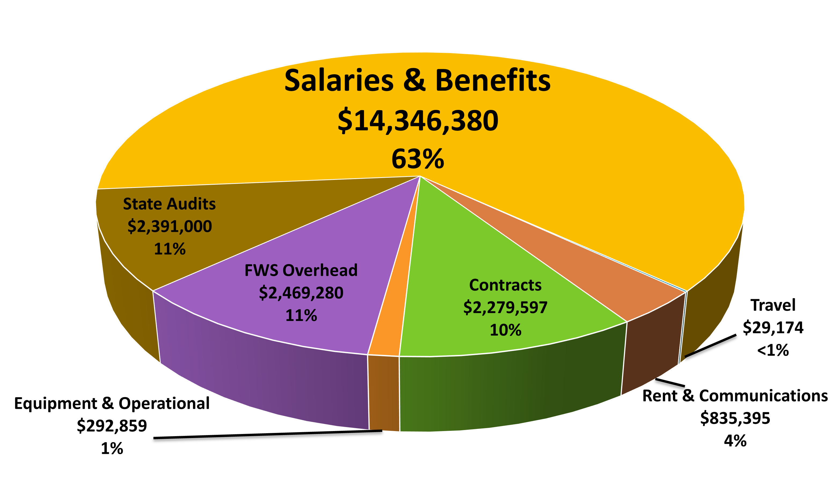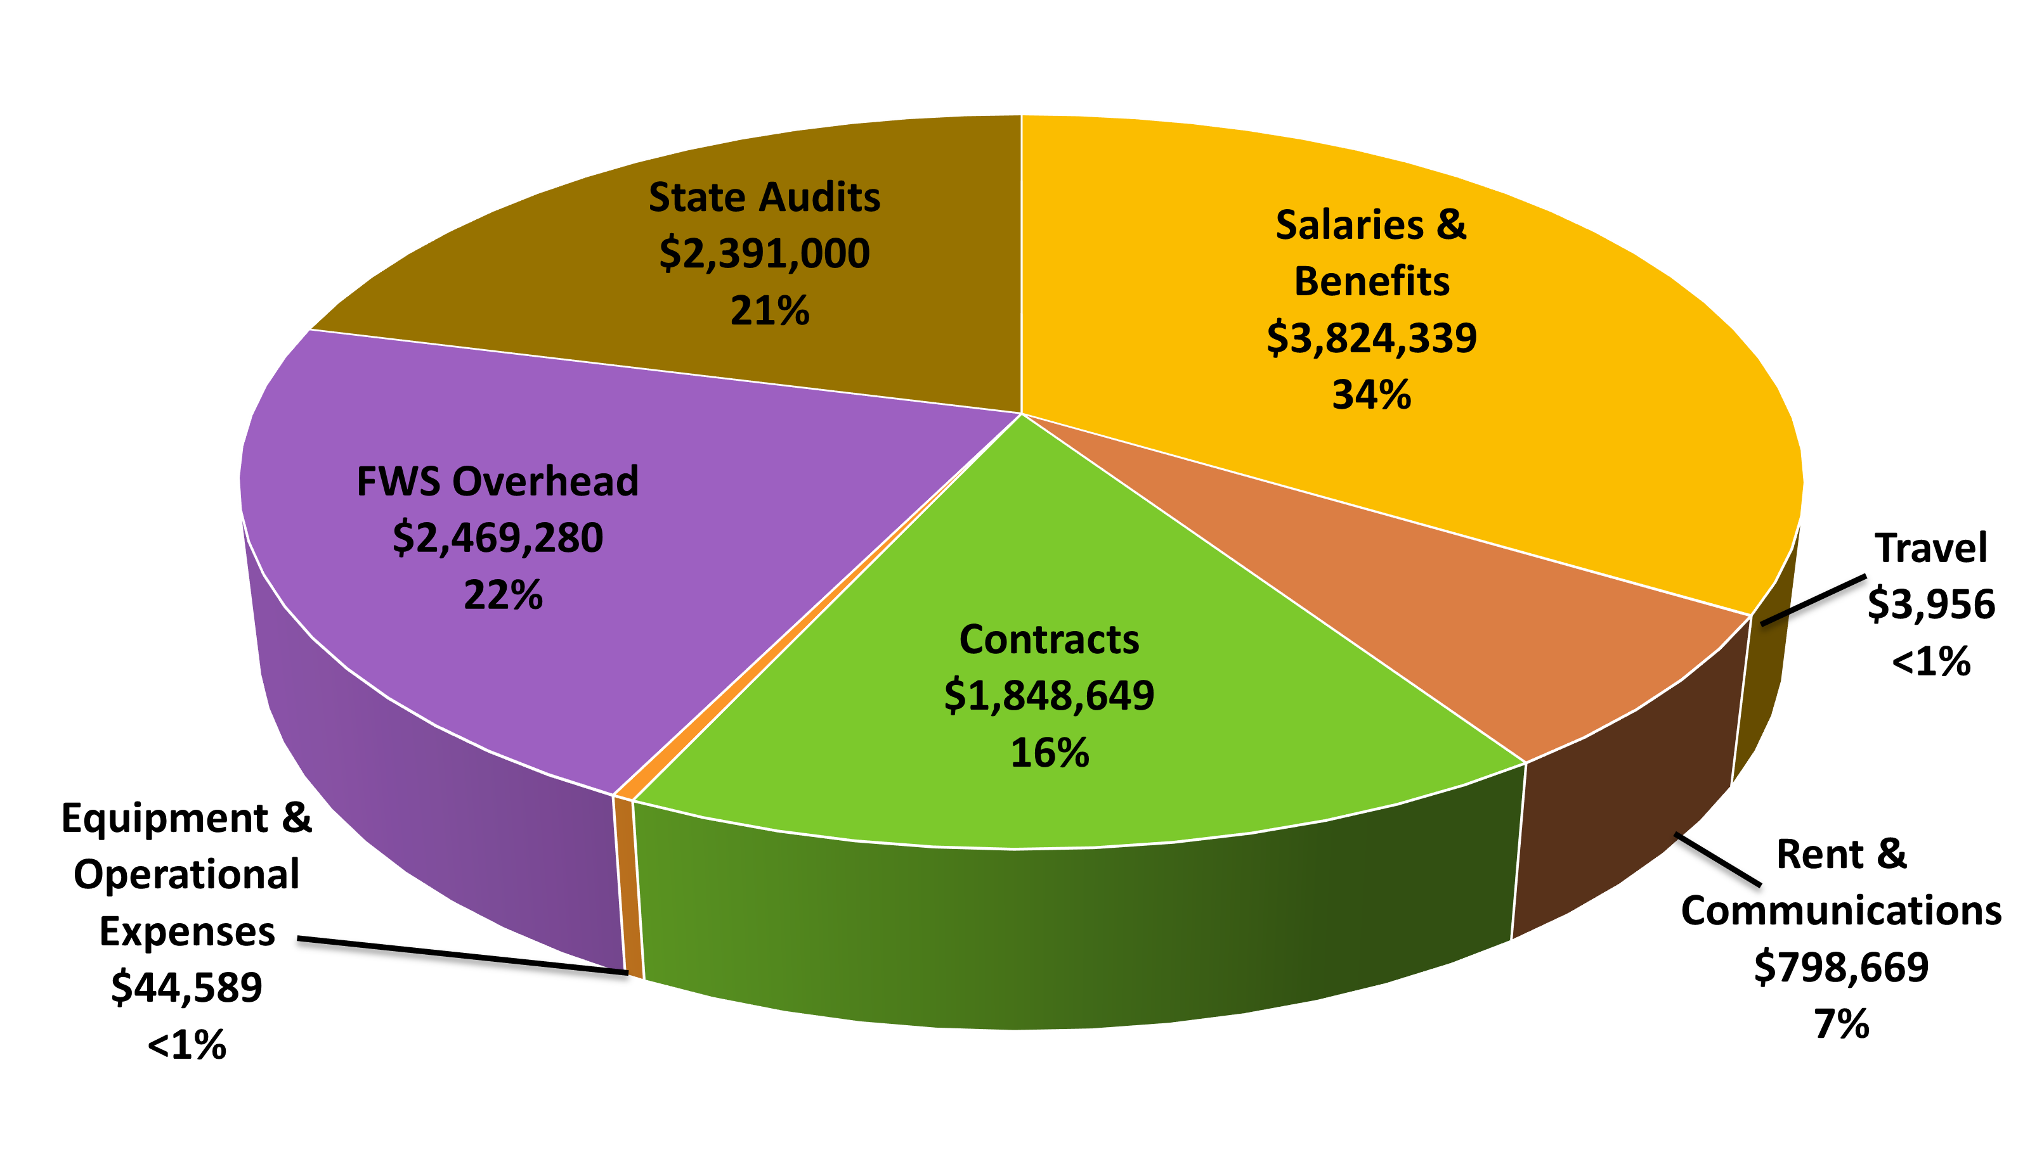

- State and Tribal Wildlife Grants Apportionments

Subprogram | 2019  Enacted | 2020  Enacted | 2021  Enacted | 2022  Enacted
SWG Formula | $54.0 M | $55.0 M | $59.0 M | $59.2 M
SWG Competitive | $6.4 M | $7.4 M | $7.4 M | $7.4 M
TWG Competitive | $4.2 M | $5.2 M | $6.0 M | $ 6.0 M
STWG Total | $64.6 M | $67.6 M | $72.4 M | $ 72.6 M

- Joint Federal/State Task Force on Federal Assistance Policy (JTF) Update- Paul Rauch, WSFR

The last JTF virtual meeting was held on December 1st. We had a couple of presentations.
We talked about subaccounts and safety margin review from Ryan Oyster. Got an explanation on why we have so many subaccounts in the WSFR program and why it is necessary if we are going to protect safety margins.
We also had a presentation and discussions about expanding some of the match opportunities.
We also had some updates on pre regulatory support team, RAWA and readiness efforts, TRACS, ID issue protocol process.
There were a few action items:
Going forward, we will be reporting on the Annual Audit report every year at the Fall JTF meeting
Continuing to share information on mitigation of carbon credit issues
We agreed on a regulatory issue for the Sub Part D that deals with license certification and multiyear licenses
We had a JTF position in TRAC Working Group that was vacant, and Lisa Holt will fill that position going forward

- The Council to Advancing Hunting and Shooting Sports – Swanny Evans, CAHSS

Swanny – The Council is finally fully staffed with 5 employees on board. We will continue to facilitate and provide all previous services; increase emphasis on new partnerships, e.g., new partners, marketing, diversity, training, research, and data, shooting sports;
2022-2024 Facilitation of National R3 Strategies (MSCGP Funded) –
- Community and Clearinghouse
- Summits and workshops
- Strategies/plans
- National/regional engagement
- Research and Data
- Training
- IWG -> TAG (The Assessment Group (TAG) and TAG Review Panel
- Outreach and communication
Two things to focus on:
- Last year, Southwick did a study about the Hunting License Index with 40 states to look at the change from 2019 to 2020. And we plan to continue to do this study.
United States (2019 -> 2020) -
  - Resident: 5.4%
  - Non-Resident: 1.5%
  - All: 4.9%
United States (2020 -> 2021)
- Resident: -4.0%
- Non-Resident: 12.9%
- All: -1.9%

 | United States | Regional Associations
 | United States | SEAFWA | NEAFWA | MAFWA | WAFWA
Resident | -4.0% | -2.5% | -3.6% | -3.8% | -5.4%
Non-Resident | 12.9% | 10.2% | 7.8% | 13.8% | 15.2%
All | -1.9% | -1.3% | -2.4% | -2.0% | -2.1%

- National R3 Symposium
  - May 2nd – 5th, Broken Arrow, OK
  - Partner with a Payer
  - R3minutes
  - R3 Training

- The Federal Aid Coordinators Working Group – Brenda Bowers, AK

- Grant Solutions/TRACS Efficiencies
The duplication of effort and inefficiencies within Grant Solutions and TRACS is still a significant concern for the FACWG. The FACs report an increased burden, a burden also impacting Wildlife and Sport Fish Restoration Program (WSFR) staff as well. It is paramount that actions be taken to improve the operational effectiveness of these two systems. We understand that the TRACS WG and WSFR are actively working to improve the effectiveness of these systems. The FACWG appreciates the diligence and commitment of the TRACS WG and WSFR and encourages the prioritization of improvements to these systems.
- TRACS
The FACWG continues to actively monitor the implementation of the TRACS enhancement. Some of our members also hold positions on the TRACS Working Group and are regularly engaged with the identification and resolution of issues and challenges. As TRACS issues and challenges are identified, the FACWG disseminates information to the federal aid coordinators (FAC) as needed. Some of our members actively participate on the TRACS WG, addressing specific issues like equipment needs, amendments, financial requirements in TRACS vs. Grants Solutions, etc. The FACWG remains committed to addressing concerns and issues with TRACS and will work collaboratively with the TRACS WG and the WSFR to develop solutions.
- NBCI Corrective Actions and CCI Update
The FACWG would like to acknowledge the National Bobwhite Conservation Initiative’s (NBCI) effort to implement measures addressing the Department of Interior, Office of Inspector General’s compliance concerns. NBCI was able to design a cost allocation methodology that WSFR found adequate. NBCI has made changes to its cost model to better conform to the “relative benefit” requirement by establishing a direct connection to specific state services.
The FACWG is appreciative of WSFR in considering the conservation benefits and program efficiencies that can be achieved when multiple States’ resources and partnership efforts are centrally coordinated and leveraged to address shared species’ management challenges spanning multiple geopolitical boundaries and requesting approval to establish a class of awards known as Collaborative Conservation Initiatives (CCIs).
- FACWG/WSFR Meetings and Invitational Travel
The FACWG appreciates the invitational travel offered by WSFR to help facilitate the attendance of the chair and vice-chair at the spring and fall JTF meetings and the FACWG members at the WSFR Chiefs/FACWG meetings. In-person meetings are vitally important to convey the perspective of FACs directly to the JTF and WSFR attendance at face-to-face meets is particularly important after the disconnect we have all felt as a result of the inability to meet during the Covid-19 pandemic.
- CAHSS Technical Advisory Committee
Vacant and still no direct involvement w/CAHSS. We request input from the TFC and CAHSS to determine if there is still a need to have a representative from the FACWG on the Technical Advisory Committee of the Council to Advance Hunting and Shooting Sports. We have been unaware of any committee activity since the fall of 2018.
- Communication Protocol
The Communication Protocol for relaying high-level information from WSFR to the States continues to facilitate communication and increase transparency. The FACWG strongly supports the continued use of this communication strategy for all WSFR-related policy-level communications.
The FACWG has continued to facilitate the flow of information between various federal and state groups by:
  - Holding monthly or bi-monthly FACWG TEAMS meetings to discuss matters of importance to Federal Aid Coordinators (FACs).
  - Corresponding via email amongst the FACWG regarding current topics of interest to FACs.
- Revisions to the FACWG bylaws regarding membership
The FACWG is in the process of revising the bylaws to clarify membership and the level of involvement of alternate members, to encourage alternates to actively participate in the FACWG at least one year prior to their membership, and minor revisions to modernize and improve consistency. We are advising the Trust Funds Committee of our intent to seek approval at the AFWA meeting.

- New Business

- Wrap Up/Adjourn

The meeting adjourned at 3:00 PM.

