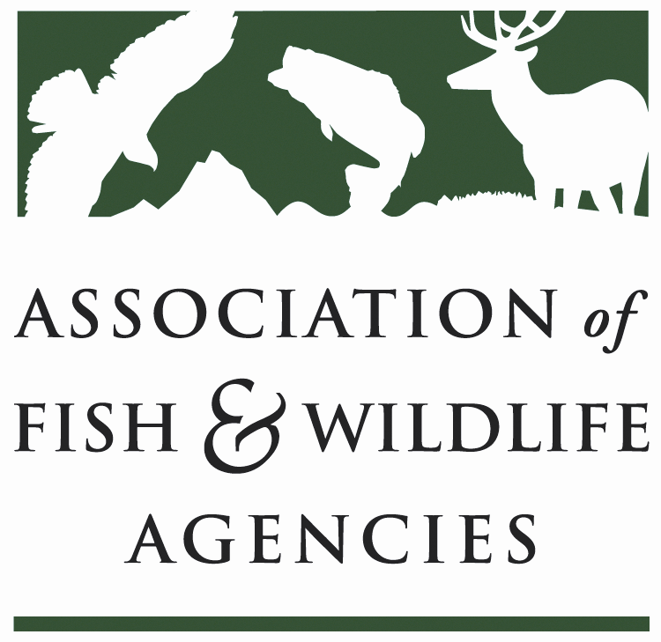

FISH AND WILDLIFE TRUST FUNDS COMMITTEE
Chair: Bryan Burhans (PA)
Vice-Chair: J.D Strong (OK)

September 20, 2022
9:00 AM – 12:00 PM

​112TH AFWA ANNUAL MEETING
Fort Worth, Texas

Bryan Burhans chaired the meeting. 49 participants in attendance.

- Call to Order, Introductions, Announcements, and Agenda Review – Bryan Burhans

The meeting was called to order at 10:00 AM.
- Approval of the March 2022 Meeting Minutes
The committee approved the meeting minutes from March 9, 2021.

Scheduled Discussion Items

- Wildlife and Sport Fish Restoration Update – Paul Rauch/ Bob Curry, WSFR

- What we had to do
  - Address program integrity - both perception and reality
  - Build partner trust
  - Improve communications
  - Increase accountability
  - Fix chronic funding/staff shortages
  - Address TRACS
- What We Choose to Do:
  - Develop a Strategic Communications Plan and establish a Communications Program,
    - Reorganized existing analysis and partnership functions
    - Combined them with Partner with a Payer and communications specialists
    - Created a Branch of Communications, Analysis, and Partnerships to expand and synergize communication capacity
  - Improve our customer interfaces,
    - Automate license certification into TRACS
    - Streamline performance reporting by using TRACS
    - Created Multiple Award Linking Tool in TRACS
    - Created Real Property Reporting Tools to receive waiver from paper reporting
  - Improve our customer interfaces,
    - Created data dashboard for apportionment and license data
  - Revamp the regional budget allocation process providing greater flexibility for Regional Managers’ workforce planning
  - Focus on RAWA ready
  - Update 50 CFR 80
- What we will do:
  - Continue to improve processes and customer service
    - Establish Collaborative Conservation Initiatives to promote partnership projects
    - Request a re-evaluation of GrantSolutions
    - Create workflow consistency and interoperability for improved efficiency
    - Propose a simplified small grant process
  - Expand and improve our communications efforts to promote relevancy and better support for WSFR
  - Broaden TRACS customer base
  - Advance TRACS as a source of information
- RAWA Readiness
Goal Statement: WSFR, AFWA, and States are prepared and well-positioned to fund and support high-quality fish and wildlife conservation projects as reflected in the following objectives:
  - minimize administrative challenges the first year RAWA is in effect (transition year)
  - obligate as close to 100% of the funds as possible by the end of the second year
  - ensure States have the tools, resources, and capacity to make significant expenditures by the end of the third year
- RAWA Readiness To Date - A Snapshot of Efforts
  - Provisional apportionments
  - Adding Plants to SWAPs Using a Minor Revision Process
  - Executive Leadership Team
  - Interim Guidance Team
  - Workforce Planning Efforts

- WR / SFR Program - FY 2022 Apportionments

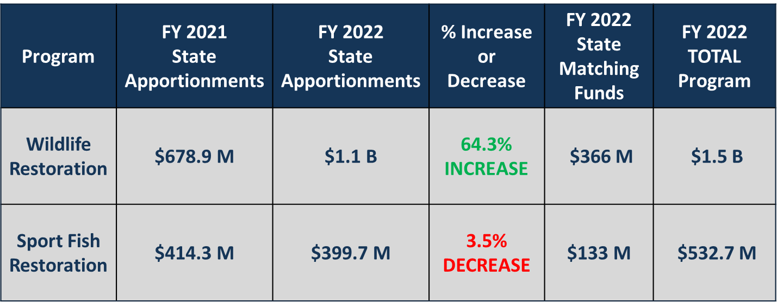
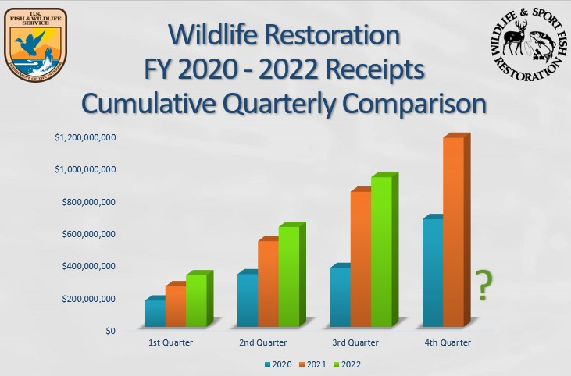

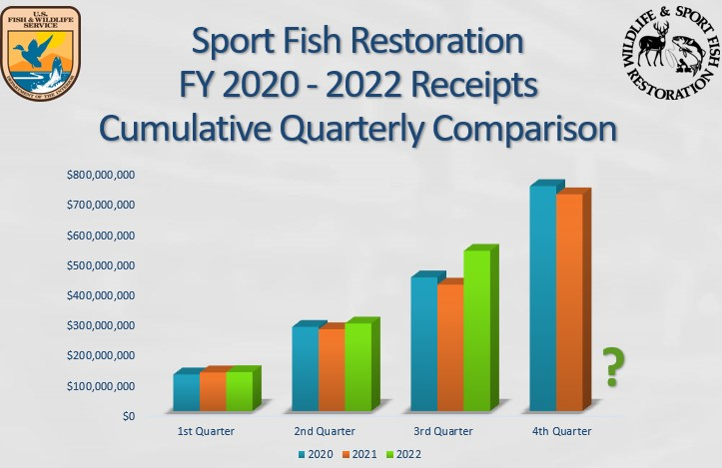
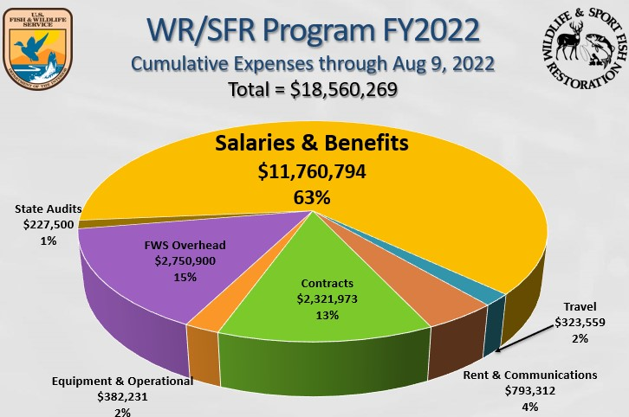
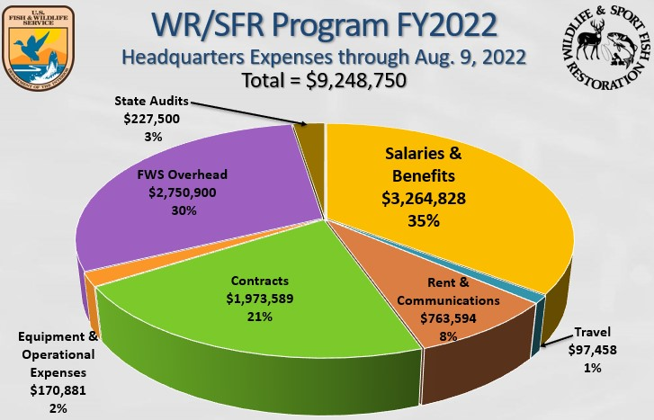

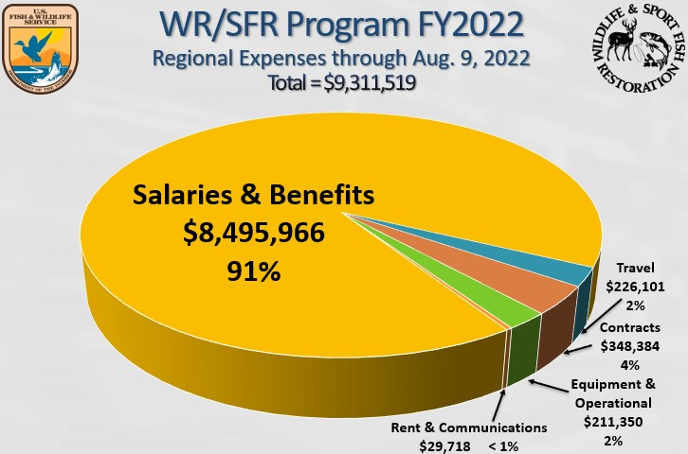

- State and Tribal Wildlife Grants Apportionments

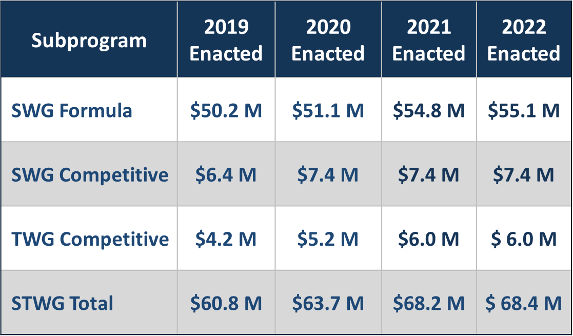
- WSFR Policy Update
  - 50 CFR 80 Regulatory Update
    - WSFR, JTF, Federal Aid Coordinators Working Group comment period completed - comments under review
    - JTF-sponsored 50 CFR 80 Pre-regulatory Support Team to assist in responding to comments - Target - late September
    - Review and comment period for States and other interested parties open - Target - November
    - Following the 2nd review and comment period, prepare a Proposed rule, available for 60-day public comment - Target - early Spring 2023
    - Final rule will follow - Target - early Summer 2023

- New rule to be available for FY 2024 projects
What will the new 50 CFR 80 rule do? - Build on collaborative work accomplished over the past several years like:
    - Addressing new eligible activities under the two laws passed in 2019
    - Using terms and language in the same or similar manner as in 2 CFR 200
    - Improving clarity and understanding of license certification
  - Clean Vessel Act Regulatory Update
    - Working with contractor support
    - Engaging with the States Organization for Boating Access, EPA, and others
    - Following the SOBA Symposium, agreed to weekly Open Forums (each Wednesday) to discuss identified topics
    - Rule drafting continues during this period
    - Target for draft rule review and comment period: early calendar year 2023
    - Proposed rule follows, then the final rule
    - New final rule target before next year’s CVA NOFO.
- Training Update
  - FY 2022 Accomplishments:
    - Training Team fully staffed: Training Team Supervisor selected - Ryan Oster; vacant WSFR trainer filled (Oct. expected start)
    - Emerged from COVID and resumed in-person training, along with continual virtual options – 680 staff trained
  - FY2023 and forward (WSFR Training Plan)
    - Resolve the remaining training backlog developed during COVID
    - Continue to prioritize training investment in State Federal Aid Coordinators and other similar positions
- Annual Analysis of Audit Trends
  - Follow-Up on Previously Identified Areas of Concern:
    - Reconciling real property
    - Guidance for reconciling and certifying land records
    - Prioritizing discrepancies between State and Service land records.
    - Best practices for managing and monitoring WSFR-funded real property
  - Next Steps:
    - Idle funds
    - Amortization of unfunded pension liability charged to Federal awards
    - Failure to provide sufficient support for grant costs
- TRACS Update
  - System working well/all designed elements fully functional
  - 909 credentialed system users
  - 1,875 Approved Project Statements (grants) entered
  - 2,271 TRACS training webinar attendees
  - States with most approved projects in TRACS: Alaska 118, Texas 117, Oregon 115, California 114
  - Development Team accomplishments: License Certification and Apportionment Module, Real Property Status Reporting Tool (live in Oct), Multi-award Linking Tool (MALT)
  - TRACS Working Group preparing to launch Communications Protocol to solicit comments on a suite of TRACS Matrix revisions for the November JTF meeting
- 2022 National Survey
  - Interviews began in early January - continuing in waves throughout 2022 and early 2023
  - Results expected June 2023
  - Sixteen states have funded data collection for their state-level estimates
  - Freshwater/saltwater split information will be supplied for all Coastal States.

- Joint Federal/State Task Force on Federal Assistance Policy (JTF) Update- Paul Rauch, WSFR

- Issue ID:
  - The JTF received a total of four issues from two states and the Northeast Wildlife Administrators Association Issues for issues to be addressed by the JTF. The issues were discussed at the Spring JTF meeting, and none were elevated for further action by the JTF. Responses were prepared for each issue, and letters signed by the JTF Co-chairs were distributed to the Alaska Department of Fish and Game, the Colorado Division of Parks and Wildlife, and the Northeast Wildlife Administrators Association. Copies of the response letters were forwarded to all JTF members on September 12, 2022.
- Survey and Assessment of the Standard Operating Procedure for the JTF Policy Development Process:
  - WSFR staff proposed draft language to the current Standard Operating Procedure for the Joint Federal/State Task Force on Federal Assistance Policy (JTF) Policy Development Process, published July 15, 2020, to allow for flexibility in assessments for adaptive management. JTF members reviewed the proposed new language, and no negative comments were received. The proposed revision has been finalized and will soon be reviewed by the JTF co-chairs.
- 50 CFR 80 Pre-Regulatory Review Process:
  - The WSFR, JTF, and Federal Aid Coordinators Working Group comment period is completed, and the comments are under review. JTF-sponsored 50 CFR 80 Pre-regulatory Support Team will assist in responding to comments. The target to complete the first review of comments is late September. The review and comment period for States and other interested parties is targeted to open in November. Following this second review and comment period, a Proposed rule will be prepared and made available for a 60-day public comment in early Spring 2023. The Final rule is anticipated to follow in early Summer 2023.
- Selection of Dates & Format for Fall 2022 JTF Meeting:
  - The Fall JTF meeting will be a VIRTUAL meeting. Two half-day afternoon sessions are scheduled: one on November 8 and the other on November 16.

- 2022 National Survey Update – Heather Sawyer, NORC
Heather Sawyer with NORC gave a presentation/updates on NORC work for the 2022 National Survey.

- The national survey collects:
  - Nationwide data on:
    - Participation and expenditures in fishing, hunting, and wildlife-associated recreation for the population ages 16 and over in 2022
    - Participation in fishing and hunting for 6 to 15-year-olds for 2021
    - Participation for saltwater and freshwater angling for residents of 23 coastal states
- Major objective: Comprehensive methodology to redesign the FHWAR
  - CHALLENGES
    - Sustainability
    - Steep respondent burden
    - Coverage error in rural areas
    - Nonresponse bias
- SOLUTIONS
    - Shorten the questionnaire
    - Reduce the respondent burden
    - Reduce costs
    - Address coverage errors in rural areas
    - Web option
    - Offer State Opt-In – 15 states currently participating
- INNOVATIONS
    - Blended sample design, including NORC’s AmeriSpeak panel and non-probability sample
    - Enhanced weighting

- Timeline
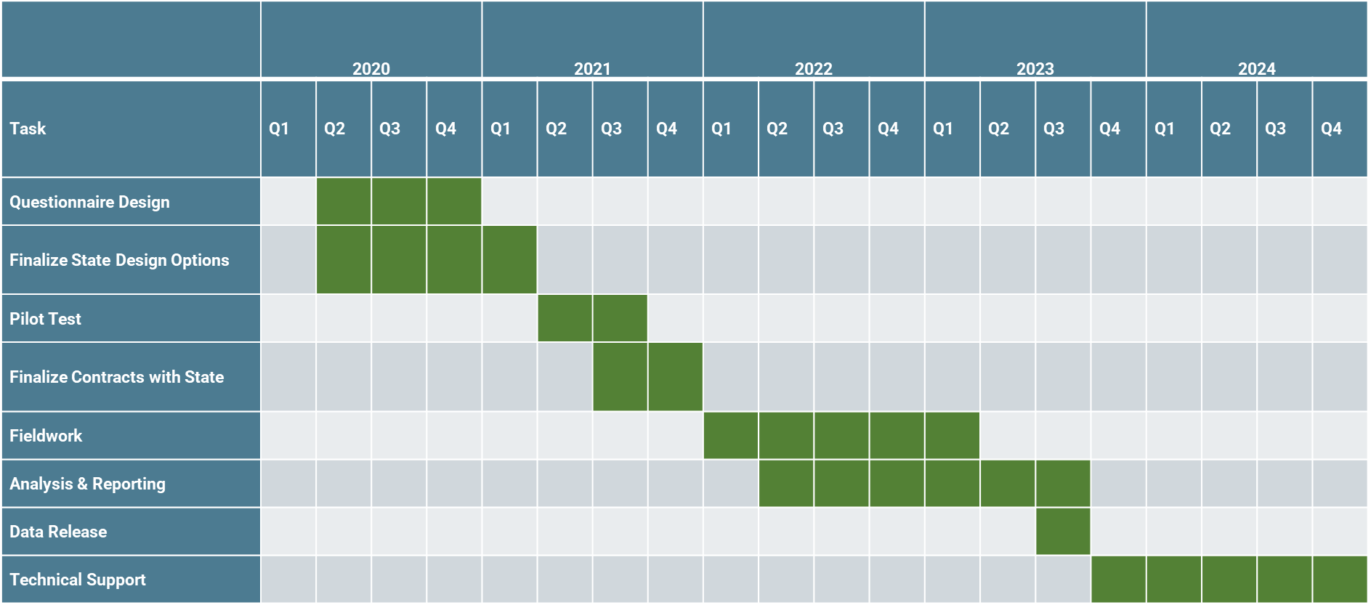

- Data Collection Overview
  - Data collection occurs over 4 waves
    - Screener data collection: January 2022 - April 2022.
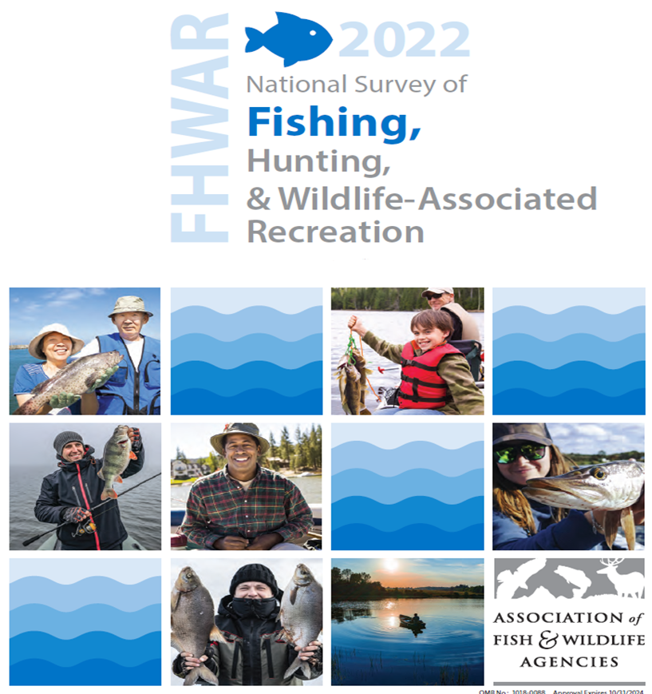
    - Wave 1 data collection: May 2022 - August 2022.
    - Wave 2 data collection: September 2022 - December 2022.
    - Wave 3 data collection: January 2023 – April 2023
  - Available in 3 modes:
    - Web
    - Phone
    - Mail (paper and pencil)
  - Respondents can choose from 2 Languages:
    - English
    - Spanish
  - The Screener Wave concluded at the end of April with approximately 40,000 completes.
  - Completes by Mode:
    - Web: 31,932
    - Phone: 2,232
    - Mail: 7,189
Wave 1 concluded at the end of August, with approximately 30,000 completed.
Completes followed the same pattern as the Screener, with Web being the most popular, Mail, and Phone. Each respondent received 1 of 3 possible detailed activity surveys: Fishing, Hunting, or Wildlife-Watching. Pictured below is an example mail Fishing survey.

- Industry/Agency Progress & Fish and Wildlife Business Summit - Jon Gassett, WMI

Jon Gassett gave an update on the Industry/Agency relations grants.
- Uses the grant to maintain and improve State and Federal relations with the industry.
- Industry Business Summit, Gassett and Steve Williams met with Ron Regan and Tony Wasley. Taking a different approach in the future.
  - Agree to target specific sectors or companies that need help with understanding WSFR’s Importance in the conservation
- On excise tax technical issues, we completed another round of reviews in cooperation with Southwick Associates. In this analysis, three products were examined using available information sources: 1) compound bows, 2)carbon arrows, and 3) fishing reels.
- Industry Database
  - Turnover in new companies keeps the database up to date even if companies vendors are entered in after a trade show

- FET Slippage Update – Dan Forster, ATA/Mike Leonard, ASA

The ATA and ASA have raised awareness that online marketplaces facilitate the sale of archery. Sportfishing equipment into the United States by overseas manufacturers, and through these transactions, the traditional mechanism for excise tax collection (i.e., the U.S.-based manufacturer or importer) may be avoided.
Dan asked the Trust Fund Committee members to vote to move forward with the resolution titled “URGING CORRECTIVE ACTION TO ADDRESS FEDERAL EXCISE TAX SLIPPAGE FOR IMPORTED ARCHERY AND SPORTFISHING EQUIPMENT”

Action Item: Motion to approve the resolution. - Approved

- The Council to Advancing Hunting & Shooting Sports – Swanny Evans, CAHSS

- Foundational R3 Training Videos
- Video series filmed in FL
- Launched a new website
  - Provide a foundational understanding of R3 - Why hunting and shooting sports are important, what is R3, what is the ORAM, best practices of R3, and Community Resources for R3
- Embedded in agency-wide staff training by states
- Clearing House
- 2,674 assets – 116% increase from 1/1/22
- 3,068 members – 3% increase from 1/1/22
- The Assessment Group (TAG) conducted an intensive review process
- Update coming
- MSGP product collections
- R3 Community
- Social network for R3 professionals
- Improvements coming across the board
- Events
- Building your R3 team
  - Released - Communication and marketing, GIS &R3 and Licensing
  - Coming soon - Law Enforcement, NGOs
- Real-time License Dashboard Project
- Concept is not new:
  - Recommendation 2: Compete the Hunting and Fishing Participation scorecard on an annual basis
  - Individual – states – real-time
- Significant interest and demand
- MSCGP
  - 11 partners, Southwick Associates and Pragmatim
- Relatively low lift for states:
  - Communicate with the vendor, No PII collected, Identify the master license list
- Special report on Hunting and Shooting Sports
- Partnered with the Outdoor Foundation
- Data from Physical Activity Council – 18,000 interviews with 6+ yo, supplemental survey to hit specifics
- 2021 participation
- Shooting Sports TV episodes
- Partnered with Into the Outdoors and OH Division of Wildlife
- Ad hoc committee
- Focus on shooting sports as safe and responsible activities for all
- Airs on PBS and ABC affiliates in mid-October
- Up to 4.8 million people in the viewing audience per episode
- R3 Baseline Survey
- The Assessment Group (TAG) identifies the need to establish R3 progress at this point in time
- Federal, Industry, Agency, and NGO
- Results will be used to:
  - Measure progress moving forward, identify gaps in R3 efforts, inform future iterations of the National Plan, inform future MSCGP priorities if requested, and provide information, if requested, on the report to Congress regarding PR Mod
- The National R3 Symposium will take place in Albuquerque, May 22-25, 2023

- New Business – Bryan Burhans
  - Integrating DEI in the Committee Work

The Committee members had discussions on DEI integration into the committee’s work. Some suggestions included:
- How to increase the diversity in the committee’s membership
- How to update the agenda/work plan to make it more inclusive
- Look at what currently exists and build on that

- The Federal Aid Coordinators Working Group – Matthew Warner

50 CFR 80 Pre-regulatory Review

FACWG members provided review and comment on the proposed revisions to 50 CFR 80. Members met with the WSFR Policy Team to better understand the proposal. Some of the comments were addressed during this meeting. All the comments submitted were minimal in nature and the FACWG was complimentary of the work done by the Pre-regulatory Team.

Grant Solutions/TRACS Efficiencies
The duplication of effort and inefficiencies within Grant Solutions and TRACS is still a significant concern for the FACWG. The FACs report an increased burden, a burden also impacting Wildlife and Sport Fish Restoration Program (WSFR) staff as well. It is paramount that actions continue to be taken to improve the operational effectiveness of these two systems. We understand that the TRACS WG and WSFR are actively working to improve the effectiveness of these systems. The FACWG appreciate the diligence and commitment of the TRACS WG and WSFR and encourages the prioritization of improvements to these systems.

TRACS
The FACWG continues to actively monitor the implementation of TRACS. Currently, the FACWG is working with WSFR to provide recommendations on land certification requirements and timelines. As other opportunities and challenges are identified, the FACWG will work jointly with WSFR and solicit input from the federal aid coordinators and disseminate information as needed. Some of our members actively participate in the TRACS WG, addressing specific issues like equipment needs, amendments, financial requirements in TRACS vs. Grants Solutions, etc. The FACWG will continue to work collaboratively with the TRACS WG and WSFR to develop solutions.

Collaborative Conservation Initiatives
The FACWG is appreciative of WSFR in considering the conservation benefits and program efficiencies that can be achieved when multiple States’ resources and partnership efforts are centrally coordinated and leveraged to address shared species’ management challenges spanning multiple geopolitical boundaries and requesting approval to establish a class of awards known as Collaborative Conservation Initiatives (CCI). The FACWG will continue to stay engaged on the establishment of CCIs and provide input.

FACWG/WSFR Meetings
The FACWG members met jointly with the WSFR chiefs and administration in April 2022, in Decatur, Georgia. Continuation of these in-person meetings are vitally important to convey the perspective of FACs to WSFR leadership. The FACWG chair and vice-chair participated virtually in the spring JTF meeting in 2022 and will be attending the fall meeting. Attendance at these meetings is also vitally important to convey the perspective of the FACs.
On the Horizon
The FACWG meets monthly to address WSFR-related topics important to the states and to work more closely with WSFR staff. These meetings provide the means for the FACWG to be better equipped to respond to emerging issues.
Some topics the FACWG will focus on in the near future include:
- RAWA and the FACWG
- NEPA categorical exclusions
- Land certification

- Wrap Up/Adjourn

The meeting adjourned at 2:00 PM

