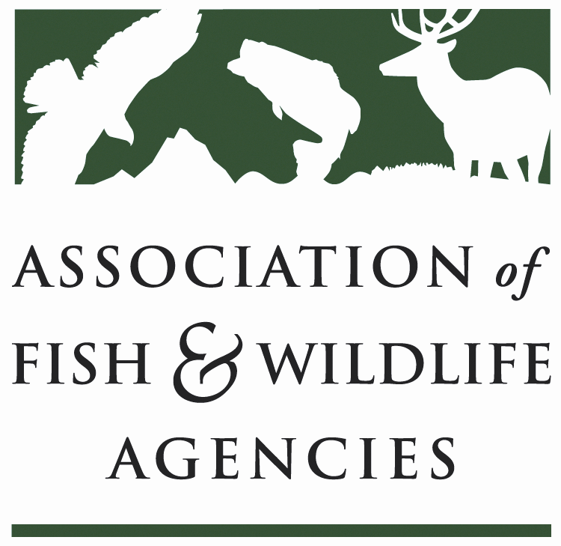

Energy & wildlife policy committee
Chair: Brad Loveless (KS)
Vice-Chair: Bob Sargent (GA)

Date: September 20, 2022
Time: 9:15 am - 12:15pm CST

112th AFWA Annual Meeting

Committee Charge: The energy and wildlife policy committee is focused on energy development and generation in North America and its impacts on fish and wildlife resources and their landscape habitats at the state, province, territory, region, and international levels.

Agenda

9:15 am Call to Order/ Approval of Minutes from March 2022 Meeting
Brad Loveless, KDWPT
- Jennifer Campbell – move to approve
- Angie Bruce- second

9:20 DEI Affirmation
Brad Loveless, KDWPT
- Supplement more diverse voices and new perspectives to the committee. Need to broaden perspective,
- As a body, we need to make sure we are letting other people talk; please encourage colleagues to add in
- Brad asks committee members to be cognizant of these issues and please share thoughts of things we can do better – this will be an ongoing conversation so we can get better with time

9:25 Review and discuss Committee Charge
Brad Loveless, KDWPT & Bob Sargent, GADNR
- Laura: focus on how to ameliorate these effects; we are focused on how to make things better, reduce impacts… add understanding impacts and ameliorate
- Meaghan makes some modifications, and we will circulate for feedback
- Update for the North American

9:30 State Roundtable
One representative per state agency highlights a couple of legislative and policy initiatives, issues, or success stories – please limit to 3 minutes per representative
- How legislatures are getting more involved in guiding energy development in states
- State role is super important
- Laura Zebehazy- TX- NREL doing proof of concept of large turbine in Lamar co., building 2 800-ft turbines, proof of concept is to build on-site with a temporary manufacturing building; adjacent to operational site, TX is involved with NEPA who is drafting a EA, no plans to do any bird/bat monitoring during life of project (40 yr)—the technology comes from oil/gas to be as big as they are; other issues they are worried about is offshore wind in Gulf of Mexico, engaged with BOEM, 2 lease areas one off Galveston and one off LA potentially as soon as next summer
  - Gary Frazer: Building on site because too big to transport? why did they not include natural resource monitoring? TX did recommend monitoring but no go
  - Brad: early on, development strictly followed wind maps, but as turbines get taller, wind is good higher so they can go anywhere.
- Karen Voltura- CO- covers SE region, oil and gas rules that were rewritten in 2020, good/bad news, new energy commissioner from the CPW; lots of orphan well plug/abandon so seeing a lot of operations do it because they don’t want to pay for it; starting to see mitigation money, protect resources not just offset, transmission legislation that didn’t go very far, 600 mile line from XCEL and some other lines that are going to affect solar siting, in SE region alone 9 GW alone, statewide, 10GW with probably half actually being built; tricolored bats do exist in the area; 100,000 acres evaluated with solar with biggest concern of fencing; PLUG: WAFWA is starting energy subcommittee to get new voices and get information from this committee to there and to be complimentary (Brad likes this)
  - Gary- can state influence the siting? No mostly because it is private land; Gary: from FWS, there are areas they could build to minimize effects, and the discussions are ongoing; Brad- when fed or state goes as far as they can, AFWA or WAFWA might be able to have a voice
- Sarah Reif – OR- reached a point to get additional transmission; currently quiet on wind/solar no rush like CO, but offshore is ramping up, critical period with BOEM as they are winnowing down lease areas; groundfish fisheries, fed delegation is calling for BOEM to work through this and state leg and gov are involved to make sure siting is appropriate, working with commercial fisherman to bring data, but getting data takes time and we are being pressed with urgency, reminiscent of hydrodams; want more of a pilot program which was a recommendation, so to extent of interest of offshore wind, please reach out; siting timing: about to enter legislative session to develop direct state Department of Energy to direct the round table; Question: Oregon doesn’t have a state wide energy plan and we continue to see project proposals, so what other states have a strategic energy plan?
  - Brad wants a survey to see if folks have a state energy plan, what works or doesn’t work?
- Brad Kansas: good siting and get involved early in process; legislative, wants strict siting protocols on wind but didn’t get close to passing b/c too onerous
- Ryan Scott- Alaska – lots going on, hydroelectric work south of Juneau- SE Alaska is building Hydro and building transmission lines to other smaller communities; if no hydro, using diesel, on gulf coast the community of Yakatak is looking at tidal generation; always looking at oil and gas especially in north slope especially with current issues of fossil fuel , more activity; lots of communities solving needs using small wind energy plants; west coast was hit by a hurricane on Sunday (we call it Fall 😊) but it has had a significant impact; Brad: hydro-projects and fish passage? We are pretty good about keeping this in mind including burrowing under lakes, ladders
- Tom Kirshing – SD – wind energy things have subsided, but do have a developer in NE part of the state who has been good to work with and are doing complete pre and post construction on sharptail grouse, using state wildlife grants for match, what impact does it have on grouse, so very excited to have a true pre/post construction monitoring; pump storage project to generate electricity along Missouri river, causing mayhem and currently at infancy of the project but operation not until 2035, biggest issue will be building a reservoir and it is all private land and it will be a fist-to-cuff conversation and we just haven’t dealt with things, will likely start seeing legislative session on the topic; Brad- Southeast folks might have some advice for you since they’ve been doing pump storage for a long time. Sarah Reif: Tribal engagement? We will, they are getting more and more engaged.
- Angie Bruce – WY – we just had a project come up on the ‘Miracle mile’ in pristine fish habitat. TBD on that project; Nuclear facility was chosen and sited very well on old coal mine, local community is a bit alarmed because of traffic increase is going right through pronghorn thus a wildlife crossing is wanted/needed and is a top priority project to get funded; lots of rare-earth mineral (uranium) exploration; 16 operational coal mines; Gateway West transmission line completion so can get more wind and solar out of the state resulting in 14 active wind farms and working 18-- there is a huge push on wind; our concerns are focused on big game as trends keep going down on Mule Deer, Executive Order on Migration corridors but less understanding on crucial winter range; year 4 on project finding minimal impacts on mule deer crucial winter range; $2.6 million dedicated by commissions for mule deer collaring = 8 herds which will have solar/wind development happening in their range; monthly meeting with state agencies about renewables (dept of ag, dept of environmental quality) to talk about what we know and coordinate efforts better; WY has state permit for solar and wind which is extremely helpful and in siting permit they have to address impacts of wildlife and also mandated a consultation with SFWA; if a company sites really well, we give rubber stamp just to send a strong message of good! Word has been spreading about this incentivization and people/consultant are talking the SFWA; proactivity is based on state permit; We have 2 executive orders – sage Grouse and Migration Corridors and we do the policy review on those but development restrictions go on the permit but we provide official recommendations.
- Jennifer Goff- FL- decommissioning site that provides warm water with manatees so working through warm water action plans; solar sites are running out and the pasture sites have been filled, so might have to start doing clearing so trying to figure out what that means for biodiversity.
- Scott Whitcomb- Michigan – denied a wind permit based on northern long-eared bats; leased 2 sites on former mining pond and gravel pit, some people are upset that public land is being leased even though they have leased TONS of public land to oil/gas
- Jim Farquhar - New York – lots going on with solar, terrestrial wind, and Atlantic offshore wind, still interest on eastern shores of Lake Erie and Ontario
- Nicole Nielson – Utah – new to the position and nice to hear that there are a lot of similar issues going on in my state.
- Craig Johnson – Alberta – oil is back and wind and solar is very busy
- Jennifer Sheehan – Arkansas – wind siting map with FWS ES office just like NC

10:00 Wind Wildlife Working Group update
Chris Berens, KS & Jessica Wilkinson, TNC
- Group has been around for several year
- Did survey and have been meeting monthly since North American
  - Asked for full time capacity and it was well received
  - WEG update – AFWA sent letter to FWS to asking for an addendum to update technology and science – Gary Frazer here to provide FWS update.
  - Industry and agency protocol – ACP and states are working on communications protocol documents that can be agreed upon between industry and state. Conversations are ongoing and making real progress.
  - State agency reviewer call – has been initiated and the first call, which was just meant to be a exploratory call to set a sense of what topics states want to talk about was attended by over 25 states who expressed high desire for this call- will continually quarterly starting in November – contact Meaghan Gade to get added to this call if interested
  - State agency – would love to get Canadian perspective!!

10:15 Solar Wildlife Working Group update
Bob Sargent, GADNR
- Proposed WG for last year in March and since formation, we have had bi-monthly meetings with 20-25 attendees
- We have survey results and have refined SWWG priorities: Top 3:
  - Develop a master, open-source BMP and guideline resource library
  - Develop a living document of science needs, priorities, and resources outlining available science
  - Develop a master, living document with standard pre and post construction monitoring protocols
- Juan Botero: DOE has taken close look at solar survey, siting database might have some resources on active mapping and projects so reach out to get some of those and see how we can work together – DOE is developing resources, project locations or what else? Bob – size of facilities?
- Needs of SWWG: Working Group Co-Chair; volunteers team members for top 3 priorties

10:30 US Fish and Wildlife Service Update
Gary Frazer, USFWS
- FWS is working with DOE to make a funding for a solar guideline development. How do we have robust stakeholder engagement. Using FACA is very time consuming, so can we have a different way
- FWS is in process of reinstating mitigation policies - do provide advisory role
- One big change- no longer reference ‘net conservation benefit’, looking for mitigation policies that is stable and durable, in process of OMB process hopefully by end of year
- Rule making on conservation banking – ESA section 10; NDAA directed a development of regulation – advanced notice in FR to get some feedback due next Monday
- HCPs- working with industry with a lot of bat / wind- most of bats are cave dwelling endangered because of White Nose and there is certainly chance wind might take – concern with too much time/energy on monitoring and driving mitigation toward not effective strategies—industry is poised to explode especially with IRA, so must ensure section 10 is not so onerous and more collaborative and improve as we move forward
- Addendum to WEG’s- FWS is happy to do it, first step is to put out FR notice about what is wanted; hoping to do this in timely fashion because we need solar guidelines.
- MBTA permitting update: proposed rule comes out? Eagle reg is moving to OMB soon or might be there? MBTA hasn’t even gone to OMB; Laura: there is a need/concern about state regs being in conflict with Fed so how do we deal with that? Gary – standing up a new regulatory program; Eric Kirshner with FWS to provide some context- timeline, eagle rule got clearance so moving to FR soon, eagle rule proposal late next week; MBTA rule has lagged behind is more likely Nov – Dec; states have been contacted to make sure they are not having unintended consequences
- Compensation policy – when into non equivalent measures (complementary)- does rule address circumstances nonequivalent and yes it does address that – does this take into account of 3rd party, conservation banks can take many different roles and FWS focus is to ensure there are clear objectives for success and effectiveness; conservation banks are the most important

10:45 USGS Update
Mona Khalil, USGS
- USGS dataset documenting unplugged orphaned oil and gas wells
- Ungulate migrations of western US – partnership with 11 states and tribes; supports corridor mapping team with technical assistance and map creation as well as cartographic assistance
  - New tools and understanding: Migration mapper 3.0, ungulates surf the green wave; variable effects of wind-energy development on seasonal habitat selection of pronghorn
  - Ungulate migration in a changing climate
- Optimizing wind energy siting and habitats for migrating whooping cranes
- USGS renewables – wildlife solutions initiatives – lead by Todd Katzner- cumulative and population impacts; looking for samples of carcasses for isotope analysis
- Solar PV – pollinator research eDNA as noninvasive tool; solar site database development with DOE; Solar on BLM lands in desert southwest- BACI study, plants and desert tortoise, habitat impacts; remote sensing indicators for monitoring ecosystem impacts (CA)
- Floating PV- looking at impacts of birds in collaboration with DOE
- Geothermal Energy – new mandate for USGS energy and Minerals mission areas to improve geothermal assessments, add low temperature resources, assess mineral + geothermal co-production; thermal energy storage; provide maps of new assessment products and risk maps for induced seismicity
  - Predict that Geothermal will become more apparent
- Sarah Reif: no longer collecting carcasses because of SPUD so service should hear that
  - Brad: Any other states with problems with getting SPUD permits? – post-construction monitoring – often problems associated with capacity issues
    - Gary will follow up with that and we need to continue that conversation
    - No problems in OH
    - Stu –CSP is not a relevant technology in US, solar expansion today is PV, CSP is not in the mix, and those two technologies are not the same so should not blend data

11:00 BREAK

11:05 Department of Energy Updates
Juan Botero, DOE
- Close to an update on selected projects for SolWEB – trying to make most informed decision to advance the science – hope for announcement in next month or so.
- Do have other active wildlife work-
  - Argonne Nat Lab – edge computing lab for real- time monitoring of avian activity
  - EPRI – developing unmanned aerial vehicle to identify carcasses as well as a lidar tech to determine fatality events
  - UCLA – uses genetic analysis technique to ID species from feather spots/carcasses; same dataset that Todd is using, over 5k feather spots
- Wildlife portfolio $50M in FY 2023, but wildlife is just a small part of the siting situation and DOE is actively investing in those components
- Will be investing a lot agrivoltaic

11:15 REWI update
Christina Marshall, REWI
- REWI: to facilitate timely and responsible development of wind and solar energy while protecting wildlife and wildlife habitat
- National Research Plan: wind has been developed and solar is happening now
- Solar State of the Science – in progress and out to peer review by end of the month
- Research Hub: information sharing center – it empowers decision makers, brings decades of research to your fingertips, online database of documents; you can add documents to it if you want – it is public but it prototype, so still working on QAQC. Please reach out with suggestions!
  - Currently just published papers, future hopefully will house webinars, white papers, ongoing projects
- Guide to Wind Energy & Wildlife – can serve as a “textbook” – online resource that goes as in depth as wanted
- 14th Wind Wildlife Research Meeting November 15-17, registration is open.

11:25 Wind and Solar Business Models 101 Presentation
Stu Webster & David Murray, ACP
- Will have access to slides
- PV is not the same as Concentrated PV and we should mix data
- Solar resource does not always track where solar facilities are built which is different from Wind- wind turbines are built where the wind resource is
- Market drivers of wind and solar
- Transmission injection capacity at a given point on the electrical system
- Brad: how do we promote open and early conversations?
- TNC tool “Site Renewables Right”

11:45 Discussion – SKIP FOR NOW

11:55 State Solar Spotlight Presentation
Jason Hight, Florida Fish and Wildlife Conservation Commission
- Side research projects with DOE – 150 projects in 45 counties and that is just with one developer
- FL regulatory landscape – strong state permitting, wetland not upland protective, able to impact a lot of solar development;
- Wildlife fencing – allows all wildlife including wild hogs which are causing a lot of issues not able to mow, maintain etc
- FPL Hammock Site
- Challenges and ongoing efforts – moving is largest costs, investigated native pollinators – less than 24 inches, they don’t have to mow; work with agriculture suppliers to establish supply; investigating bird boxes/perches
- Transitioning into sites that have good mix of wetlands and pines
- Gopher tortoise recipient site – $4k/tortoise for mitigation
- Next steps: best path forward for tortoises, HD ideas like public perception, continue to work with AFWA and AWWI, industry partners and local government

12:15 Wrap-up and Adjourn

- Brad: Thank you for the good, frank conversations that help move the needle!

