Rough Outline of Full Life-cycle Conservation Example Text for SWAPs

Context/Set the Stage for International Conservation Partnerships
Full life-cycle conservation
Bird declines and urgency for this work
Why full life-cycle conservation is important
Explain how Southern Wings works:
Intro to SW
Countries
General project information
International partners
Case Studies

Set the stage: States’ ecoregions extend beyond state borders; State conservation area boundaries and SGCN ranges are larger than states. States must work regionally, nationally, and internationally to accomplish conservation objectives for many habitats and species. To prevent migratory species from becoming endangered, and recover those already endangered, we must understand and address the totality of threats facing the species throughout their full life-cycle and x state’s role in supporting their populations. This is particularly important for neotropical migratory birds.
  - State Conservation Areas, Joint Ventures
    - Multi-State and International Collaboration: Initiatives and Priority Areas: This section explores X States geographic priorities and why focused collaborative effort within these landscapes/priority habitats is key to the conservation of the state’s invaluable natural resources. Improvement and sustainability of these resources at the state level is critical; however, it’s also important to understand the value of X states resources and conservation initiatives in context of delivering population-level conservation successes.
    - X states contributions to regional, national, and international conservation
      - The recovery and sustainability of state and/or regionally-endemic species: add state specific information on species that require international cooperation.
      - Critical stop-over and breeding habitat for migratory species (e.g., monarch butterfly, neotropical migrant birds, shorebirds, and waterfowl). add state specific information
      - River corridors: add state specific information
      - Migratory Bird Joint Ventures that establish regional bird conservation priorities. X state is part of X joint ventures
      - X state us a partner in regional planning and management initiatives including the Flyways, etc.
      - Beyond planning, management of state resources requires working beyond the borders on a regular basis. Many of the landscapes of state lands along the border extend across the border and most SGCN have ranges beyond the borders of X state, requiring partnerships with neighboring states and regional or international partners to accomplish needed actions to achieve shared goals. Watersheds and flyways often encompass all or parts of multiple states and require complex coordination among many partners and jurisdictions to improve conditions, regulate harvest and methods, and provide needed habitat. Recovery of declining species that have large ranges requires coordination with partners and agencies with interest and jurisdiction throughout the species’ range.
    - Full life-cycle conservation: Much of this work may include efforts to protect and maintain migratory species habitat throughout their annual cycles, which is called full life-cycle conservation. Full life-cycle conservation of migratory species is one area of X states commitment to cross-border conservation and is imperative to the improvement and long-term sustainability of X states natural communities and species. Some key examples of this work (i.e., Neotropical migrant birds, waterfowl, and monarch butterfly) are included in this section to build understanding of the importance of supporting these partnerships beyond X states borders.
Bird declines and urgency: In light of recent research that quantified a net loss of 2.9 billion birds in the last 50 years (many of which are migrants; Rosenberg et al. 2019), we cannot afford to ignore the threats that many migratory birds face across their full life-cycle ranges.
Why full life-cycle conservation is important
- X percent of x states breeding birds are neotropical migratory birds and spend up to eight months of the year beyond the borders of the U.S., some traveling thousands of miles each way.
- When one considers the millions of migratory birds (entire continental popoulations) that breed across Canada and the U.S. wintering in a relatively small geographies within Mexico, Central America, South America, and the Caribbean during migration and the nonbreeding season, it puts into perspective the importance of this work.
- Threats to these vital landscapes, ecosystems, and the birds that use them vary by country and region but include deforestation, commodity agriculture (palm oil), illegal logging, contaminants, and insufficient enforcement on protected areas, among others. Intense poverty across this region of the world adds to the dire need for support from international partners that have a shared interest in the protection and conservation of shared avifauna. Conservation efforts on migratory stop-over sites and the nonbreeding grounds work to curb these threats through acquisition and protection of lands used as migratory pathways and nonbreeding sites; education of landowners on regenerative agricultural and ranching practices including shade-grown coffee farming; the creation and maintenance of native tree nurseries and reforestation efforts; and other actions.
- Neotropical Migrant Bird Conservation Partnerships across the Hemisphere are critical.
- Add a map from Cornell Lab of Ornithology’s eBird website for a high priority species. Contact Deb Hahn if you need assistance. https://ebird.org/science/status-and-trends/abundance-maps

Example for cerulean warbler and Missouri
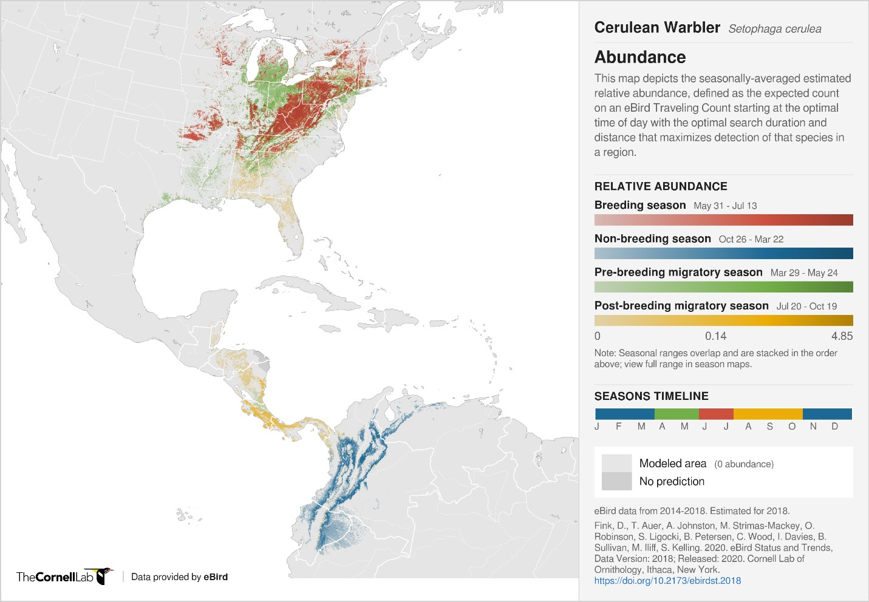
Figure 2.35 – Cerulean Warbler eBird abundance map. Ceruleans migrate through Central America and overwinter in northwestern South America, including Ecuador where Southern Wings projects work on reforestation with landowners to maintain and restore vital habitat (Buehler et al. 2020).

Spring migratory route
Fall migratory route
Ecuador Project Sites
Gale Verhague ©Dreamstime

Additional information on status and trends can be found here. https://ebird.org/science/status-and-trends/
Southern Wings
- Introduction to Southern Wings: The Association of Fish and Wildlife Agencies’ (AFWA) endorsed and began implementing Southern Wings in 2009 after the concept was presented to AFWA by the state fish and wildlife agencies. Southern Wings facilitates state fish and wildlife agency participation in the conservation of priority migratory birds across their full life-cycle. Since that time, 39 states have contributed over $3.2 million to conservation efforts on stop-over sites and wintering grounds in Mexico, Central America, South America, and the Caribbean. In 2006, Partners in Flight overlaid weighted nonbreeding ranges of 42 priority bird species that breed in every state to identify the most impactful areas for conservation efforts on stop-over sites and the wintering grounds. Add your state map here (https://www.partnersinflight.org/wp-content/uploads/2018/08/State_Prov_Breeding_Links_to_Wintering_Maps.pptx). You can find out more about this maps and migratory connectivity here (https://partnersinflight.org/resources/pif-technical-series-04-making-connections-appendices/).

  - Southern Wings focal countries for full life-cycle conservation of X state-breeding SGCN include X, Y and Z. These countries encompass key corridors and geographies that X state-breeding migratory birds use as migratory corridors or overwintering habitat. Southern Wings projects within these countries include a variety of grasslands, wetlands and coasts, and tropical forested habitats, including low- to highland rainforest, mangroves, and cloud forest, among others. A list of current project is available here (https://www.fishwildlife.org/afwa-inspires/southern-wings).
  - Southern Wings Project Goals: Overall goals vary by project but include: slowing or reversing continued deforestation through reforestation efforts and implementation of regenerative agroforestry systems with local landowners; securing protection of core migratory bird habitat through protected area creation and management; improving or reestablishing shade-grown coffee practices that maintain or create migratory-bird foraging habitat; working with local communities to build sustainable conservation capacity and ownership; among others.

  - Species these efforts support (tailor to X state)
    - Full life-cycle conservation efforts in Mexico, Central and South America support over 150 species of Neotropical migrants that migrate through or overwinter in these rich habitats, including these SGCN that are also included in the X state SWAP as our most-threatened species: List species. Could also list other less threatened species that are SGCNs.
  - International partners: Hemispheric full life-cycle neotropical bird conservation partners involved in Southern Wings as of now include, but are not limited to: American Bird Conservancy, National Audubon Society, Bird Conservancy of the Rockies, SELVA: Investigación para la Conservación en el Neotropico (Colombia), Fundacion para el EcoDesarollo y La Conservacion (FUNDAECO; Guatemala), El Jaguar Private Wildlife Refuge (Nicaragua), Red de las Reservas Silvestres Privadas de Nicaragua, La Asociación de Investigación para el Desarrollo Ecológico y Socio Económico (Honduras), Fundación Jocotoco (Ecuador), and Pronatura Noreste (Mexico).
Case Studies: We recommend 1 or 2 case studies if they exist. Below are some examples.
Case Study: Conserving North America’s Grasslands
Arizona Game and Fish Department, New Mexico Game & Fish Department, Montana Fish, Wildlife & Parks and Colorado Parks and Wildlife have partnered with Bird Conservancy of the Rockies to help facilitate conservation of grassland bird species in the western U.S., through the protection and conservation of the Chihuahuan Desert grasslands in Mexico. The Sustainable Grazing Network (SGN) is an important program developed by Bird Conservancy of the Rockies and IMC Vida Silvestre to engage ranchers in conserving and restoring their grasslands and implementing sustainable practices. Monitoring bird populations and gathering data have also been an important facet of Bird Conservancy of the Rockies and IMC Vida Silvestre’s efforts. By gathering data and making decisions based on it, Bird Conservancy of the Rockies is prioritizing and developing frameworks of action. Bird monitoring also helps to engage landowners in better understanding how their management affects wildlife. As of 2020, 308,000 acres have been enrolled in the Sustainable Grazing Network since 2013, with more than 90,000 enhanced and 5,000 acres restored.
Case Study: Pacific Shorebird and Wetland Bird Restoration
Arizona Game and Fish Department, California Department of Fish and Wildlife, and the Pacific Flyway Council have supported Terra Peninsular and other partners since 2017. The projects goal is to improve the efficiency of conservation and management for coastal wetlands, shorebirds, waterbirds, and waterfowl through the integration of data and prioritization of decision-making. The project impacts the conservation of between 3 and 21 SGCN species in AK, AR, CA, CO, ID, MT, NV, NM, OR, UT, WA, and WY including long-billed curlew, mountain plover, snowy plover, Pacific brant, lesser scaup, American white pelican, redhead, and more. Actions include conducting surveys for Pacific Brant, snowy plover, California least tern and other species; collaborating with the local hunting organizations to improve the sustainability of hunting; installing predator exclusion devices on beaches; and working with local communities to get them the legal status to control disturbance and implement best management practices.
Case Study: Restoration of Migratory Bird Habitat in Ecuador - Cerulean Warbler and Other
Missouri Department of Conservation is the sole state agency supporting conservation efforts with partners American Bird Conservancy and local Fundación Jocotoco in Ecuador since 2015. Ecuador has the highest deforestation rate in South America over the last 50 years. The goal of projects in Ecuador are to slow the rate of deforestation and work with landowners to improve land-use practices and create better habitat connectivity in the buffer zones of existing protected areas in the Chocó-Canandé BirdScape that Cerulean Warblers and 105 other Neotropical migrant species use for overwintering habitat. Conservation efforts in Central America support Cerulean Warblers on both spring and fall migrations and work in Ecuador supports these birds through the winter months. Missouri’s population of Cerulean Warblers breed in riparian-associated forest gaps largely near Ozark streams, including in five Priority Geographies: Missouri River Hills, Big Buffalo Creek, Mahan’s Creek, Huzzah and Shoal Creek Woodlands, and Little Niangua River; Upper Niangua COA, Current River Hills Forest/Woodlands COA, and Little Black COA, among others.
Case Study: Migratory Bird Wintering Grounds Conservation in Nicaragua and Honduras - Wood Thrush and Others
Along with key conservation partners American Bird Conservancy, El Jaguar Private Wildlife Refuge (Nicaragua), Red de las Reservas Silvestres Privadas de Nicaragua, and La Asociación de Investigación para el Desarrollo Ecológico y Socio Económico (Honduras), and others, Missouri supports habitat conservation projects in Nicaragua and Honduras that provide benefits for a broad suite of Neotropical migrants. The most common threat in this region are land-use practices not compatible with forest preservation. These include human migration to the area which has led to encroachment of indigenous lands which are largely intact habitats. Increased human presence has led to habitat fragmentation via creation of homesteads, land grabs, and deforestation associated with these impacts.
Project goals include slowing rates of deforestation in Honduras and Nicaragua by working landowners and communities to adopt land-use practices compatible with forest preservation. Project successes include native plant and tree nurseries; regenerative land-use workshops for local landowners; and landowner agreement sign-ups outlining commitments to reduce the impact of cattle ranching through silvopasture techniques, tree planting, and the creation of feed banks and rotational grazing systems; among others. Wood Thrush breed across Missouri forests but are most abundant across contiguous Ozark forests (Figure 2.36) including five Priority Geographies: Missouri River Hills, Big Buffalo Creek, Mahan’s Creek, Huzzah and Shoal Creek Woodlands, and Little Niangua River; and several Missouri Forest/Woodlands COAs.

