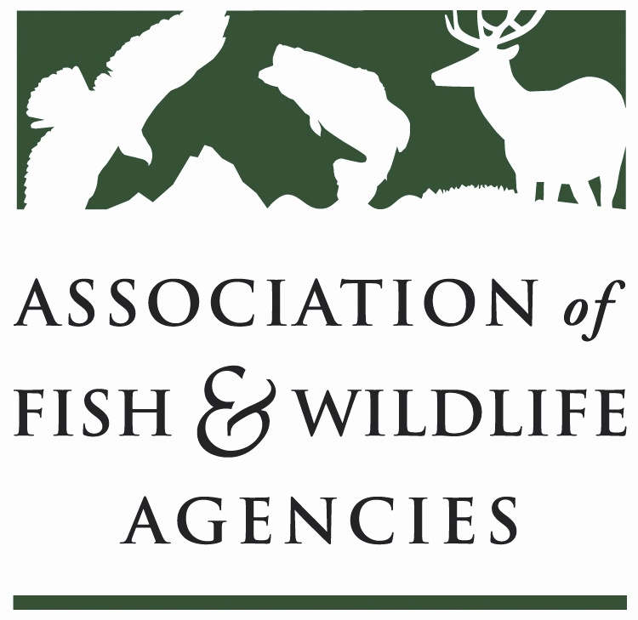

GRASSLANDS WORKING GROUP
Chair: Bill White, Missouri Department of Conservation
Vice-Chair: Greg Link, North Dakota Game and Fish Department

Thursday, March 10, 2022
7:00-9:00 a.m. PT
Virtual

87th North American Fish and Wildlife Conference Virtual Meeting

Agenda

7: 00 a.m. Call to Order/Review Agenda

7: 05 a.m. Introductions

7:15 a.m. Report from Tammy VerCauteren –Central Flyway Grassland Roadmap Update

7: 45 a.m. Report from Greg Link on North Dakota Meadowlark Initiative

7: 55 a.m. Report from Jim Giocomo – Mississippi Flyway Grassland Roadmap

8:10 a.m. North American Grassland Conservation Act

8:25 a.m. Discuss New Working Group Chair

8:30 a.m. Next Steps on Another NCN - Greg Link

8:35 Other updates (5 min. each)

8:45 a.m. Action items

9:00 a.m. Adjourn

