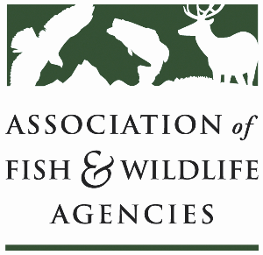
Invasive Committee
Chair: Eric Sutton (FL)
Vice-Chair: Kim Bogenschutz (IO)

Date: March 10, 2022
Time: 2:00 pm-5:00 pm ET

87th North American Wildlife and Natural Resources Conference
Virtual
Agenda
2:00 pm Call to Order/Introductions (Kim Bogenschutz)

2:05 pm Review of Agenda/Committee Change & Committee Updates (Kim
Bogenschutz)

2:15 pm Recovering America’s Wildlife Update (Sean Saville)

2:25 pm Government Affairs Updates (Devin DeMario)

2:40 pm Internet Trade of Invasive Species (TBD)

3:00 pm Online Enforcement and Education on Washington’s Plant Health
Quarantines (Tristan Carette-Meyers)

3:25 pm Break

3:35 pm Feral Hog Working Group Update (TBD)

3:55 pm Federal and Partner Updates (TBD)
USFWS –
USGS –
USDA/APHIS - TBD
ANS Task Force – Kim Bogenschutz
Wildlife Forever -

4:35 pm Federal, State, Tribal & Partner Roundtable

4:55 pm Wrap Up and Next Steps

