2019 Multistate Conservation Grant Program

Survey and Gap Analysis of North American Grassland Habitat Conservation Efforts: FINAL SUMMARY

American Bird Conservancy

CO-PIs-- Jim Giocomo, Oaks and Prairies Joint Venture/American Bird Conservancy; Bill White, Missouri Department of Conservation; Greg Link, North Dakota Fish and Game; Arvind Panjabi, Bird Conservancy of the Rockies

Lead Applicant’s Contact Information: Merrie S. Morrison
P.O. Box 249
4249 Loudoun Ave.
The Plains, VA 20198-2237
mmorr@abcbirds.org
(540) 253-5780

Project Goals and Objectives
Under the direction of and in cooperation with AFWA’s Grassland Bird Working Group, American Bird Conservancy hired Dr. Amanda Haverland to survey and analyze all state, Federal, NGO and other large scale (e.g., statewide or ecoregion) grassland conservation programs on private and public lands as part of a Gap analysis of existing grassland conservation programs.

Co-PIs built two teams to organize two Grassland Conservation Flyway meetings. Jim Giocomo and Arvind Panjabi, working with Tammy VerCauteren (Executive Director of Bird Conservancy of the Rockies), have built a planning team and facilitated the Central Flyway Summit in August 2020 (see websites below). Bill White and Jim Giocomo, working with Jane Fitzgerald (Central Hardwoods Joint Venture Coordinator), collaborated with local partners to facilitate the Mississippi Flyway Summit in January 2021. Both Summit groups continue to plan for implementation of grassland conservation actions identified in the summits.

- Gap Analysis
  - Compile information on state, Federal, NGO and other large-scale grassland conservation programs that address wildlife habitat needs through a web based survey, and conduct follow-up phone surveys.

Measureable objectives for this project include number of individual surveys completed and amount of spatial data contributed to the webmap (https://arcg.is/XTT4i).
Over the course of this project, we sent the survey to over 250 people in over 90 organizations in the United States and Canada. Participation varied by flyway, with participants from all 14 US states and 1 Canadian Province in the Mississippi Flyway region, all 10 states, 3 provinces in the Central Flyway, 2 (of 7) states, and 1 province in the Pacific Flyway, and 12 (of 18) states and 0 provinces in the Atlantic Flyway.
Analysis and basic summary statistics are available in a preliminary storymap (https://arcg.is/1ba895) for use by the Grassland Work Group of the Bird Conservation Committee to plan further strategies for addressing grassland conservation efforts.

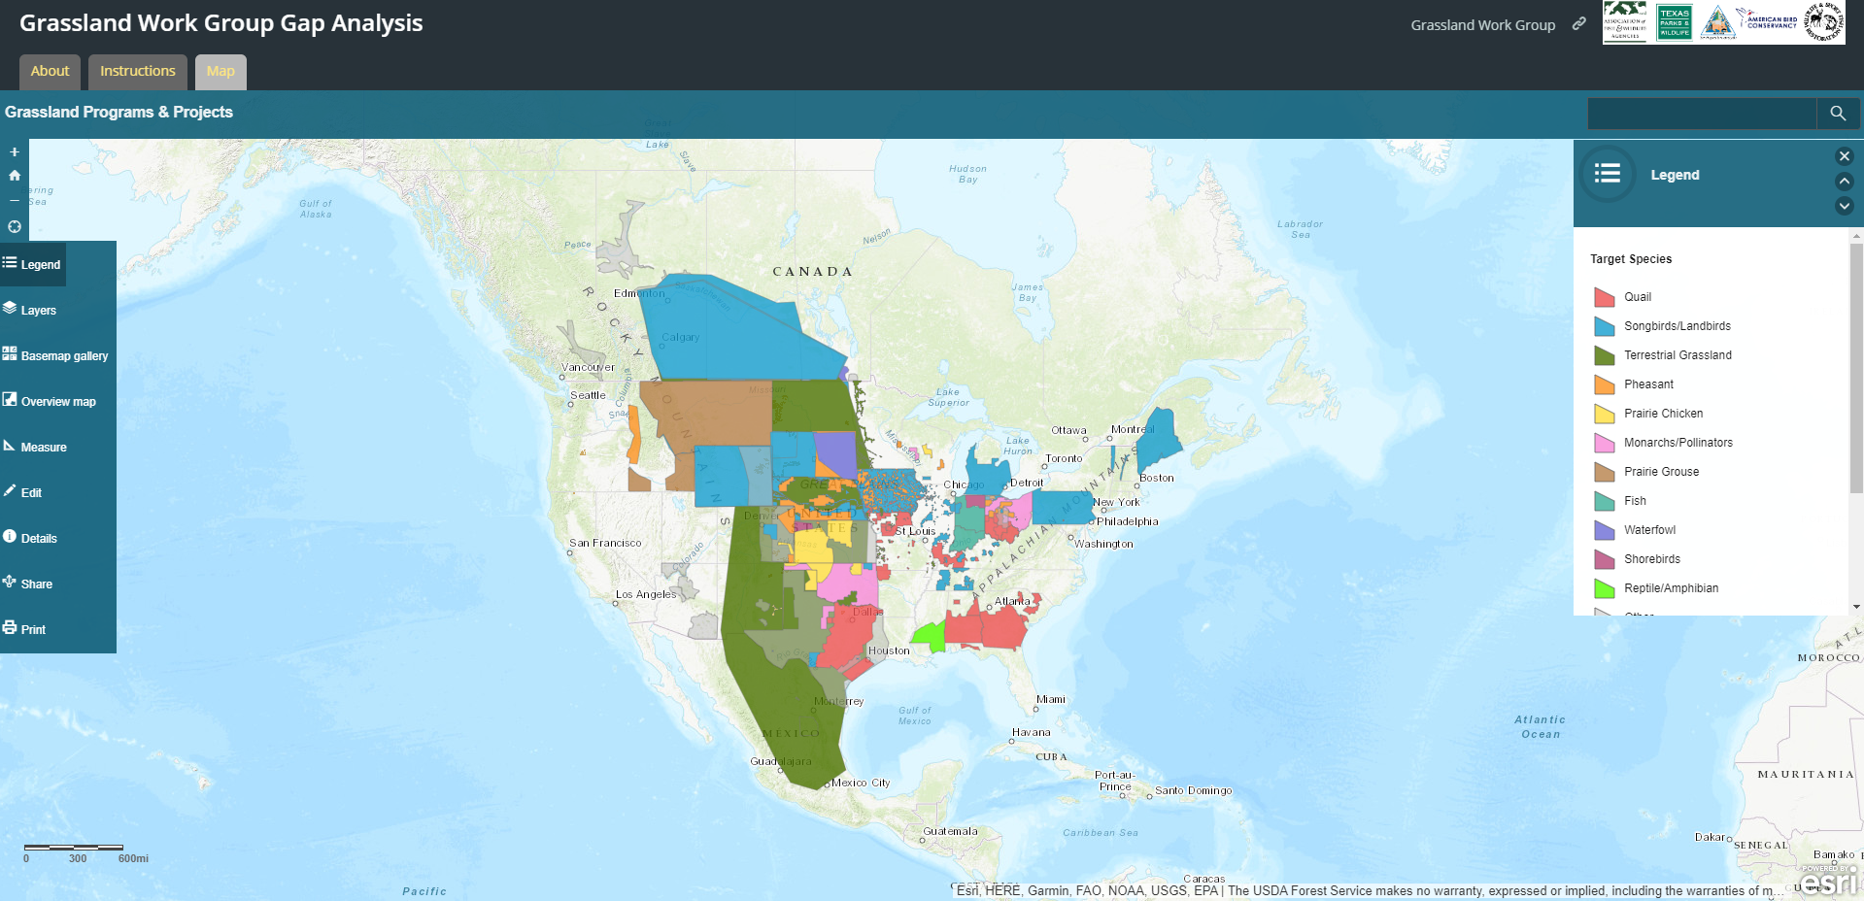

  - Compile grassland conservation priorities identified in state (wildlife action plans), regional (e.g. Joint Venture), national and international grassland conservation plans.

Conservation priorities for priority birds and other wildlife species have been compiled in a database for each state in the US by gleaning information from individual State Wildlife Action Plan documents. We are currently comparing this data with the bird species assessment scores in the Avian Conservation Assessment Database (http://pif.birdconservancy.org/ACAD/). Lists of state identified priority grassland species are compiled at the Flyway level and can be found near the end of our storymap (https://arcg.is/1ba895).

  - Evaluate survey data to determine gaps in North American grassland habitat conservation efforts based on survey and mapping data.

This process is ongoing in the Grassland Work Group of the Bird Conservation Committee as the mapping tool and state wildlife action plan database are completed. We are also working within other AFWA committees, like the private lands working group of the Agricultural Conservation Committee.

  - Develop recommendations, an action plan, and potential funding sources for a unified approach to address identified gaps and move the needle forward on North American grassland conservation.

This process is ongoing. The mapping tool and state wildlife action plan database drafts are being used to support the ongoing efforts to prioritize conservation actions through the Central and Mississippi flyway region summits (see below).

  - Compile a report that contains the above and present to AFWA leadership through the Grassland Bird Work Group of the Bird Conservation Committee.

A summary of the survey results was presented in the Bird Conservation Committee meeting as well as discussed in greater detail in the Grassland Work Group meeting at the March 2021 86th North American Wildlife and Natural Resources Conference and in the virtual meeting of AFWA in September 2021.

- Unified framework for grassland conservation
  - Help to organize partner-hosted grassland conservation workshops in the Mississippi and Central flyways.

In fall/winter 2020-2021, virtual meetings for both the Mississippi Flyway Grassland Roadmap and the Central Flyway Grassland Roadmap Summit were conducted with over 350 total participants in various stages of each of the multiple-day meetings. Both have websites including archived videos of the presentations that were part of each meeting.

Information about the Mississippi Flyway Grasslands Roadmap Summit, held in January 2021, can be found at: http://www.msflywaygrasslandssummit.com/

Information about the Central Flyway Grasslands Roadmap Summit, held in August 2020, can be found at: http://www.grasslandsroadmap.org

  - Bring together thought leaders from federal, state, NGO, foundations, industry and Joint Ventures to identify what strategies and actions within the 5 priority themes identified by the North American Bird Conservation Initiative will contribute to a unified framework for grassland conservation in the Central and Mississippi flyways.

In the Central Flyway Region various additional Forums continue working to bring together constituencies (https://www.grasslandsroadmap.org/forums). In April 2021, one workshop brought together a diverse group of state representatives from across the Central Grasslands to co-learn about state strategies for addressing conservation goals, supporting landowners, and building collaborations on-the-ground that are positively impacting grassland ecosystems and rural communities. In this forum, representatives from state wildlife agencies discussed; how to pursue connections to Recovering America’s Wildlife Act (RAWA), and plan for approaches to match Federal funding, such as collaborating with Joint Ventures; Contribute to the Program Mapping and Gap Analysis; and Ensure that language in the Roadmap and future initiatives elevates the need for monitoring, and encourages the application of science through decision-support tools.

Information about the Mississippi Flyway Grasslands Roadmap Summit, held in January 2021, can be found at: http://www.msflywaygrasslandssummit.com/

Information about the Central Flyway Grasslands Roadmap Summit, held in August 2020, can be found at: http://www.grasslandsroadmap.org

  - Ensure significant state level participation through direct travel support.

Representatives from the state wildlife agencies in the 10 states of the Central Flyway and the 14 states of the Mississippi flyway participated in their respective Flyway Summits.
Printed Products Included
- Gap Analysis Summary March 2021
- Documents from the Central Grasslands Summit efforts
  - Central Grasslands Roadmap Long Form 4-2-21
  - Central Grasslands Roadmap Exec Summary 01MAR2021
  - States and Roadmap Inventory and Workshop Summary
- Mississippi Flyway Grasslands Roadmap Final March_2021

Acknowledgements
We gratefully acknowledge the support from the State and Federal Wildlife Agencies, The Association of Fish & Wildlife Agencies, and Wildlife & Sport Fish Restoration Program. We also would like to thank all the agency and NGO staff who took the time to take the survey and contribute data to this project.

