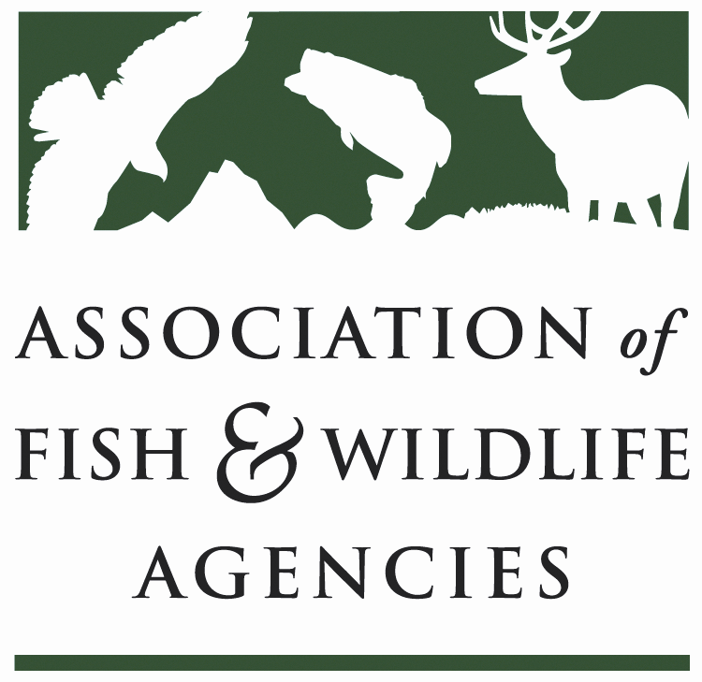

EQIP/CSP Joint Working Group
Co-Chair: Mark Gudlin (TN)
Co-Chair: Derek Wiley (TX)

Date: Thursday, September 9, 2021
Time: 10:00am – 1:00pm ET

Association of Fish & Wildlife Agencies 111th Annual Meeting
Virtual Meeting
Providence, RI

Agenda

10:00 am Call to Order; Review Agenda Mark Gudlin (TN); Derek Wiley (TX)

10:05 EQIP/CSP Implementation Roundtable
- Conservation Incentive Contracts
- High Priority Contracts
- CSAF Sign-Up
- 10% spending
- Other

11:00 Working Lands for Wildlife Update
- Western Frameworks
- Eastern Projects
  - Northern Bobwhite
  - Other

11:45 CART

12:50 pm WG Chair and Other Business

1:00 pm Adjourn

