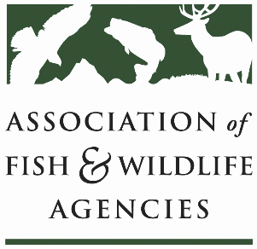

Conservation Reserve PRogram WOrking Group
Chair: Todd Bogenschutz (IA)
Vice-Chair: Sal Palazzolo (ID)

Date: Wednesday, September 8, 2021
Time: 1:00 – 4:00 pm ET

111th AFWA Annual Meeting
Agenda
1:00 Call to Order, Agenda Review, Minutes
1:10 FSA Update and Discussion
- General 56, Continuous 55, Grasslands 203, and SHIPP 401 Signups
- Emergency Haying and Grazing
- SAFE Revisions
- FY22 Planned Signups and Program Changes
- Status Reviews
- Training and Outreach
- Other
2:00 State Roundtable
2:30 Break
2:40 2023 Farm Bill Platform
3:00 Research Presentations and Discussions
- CRP Climate Change Mitigation Assessment Initiative
3:45 Wrap up
4:00 Adjourn

