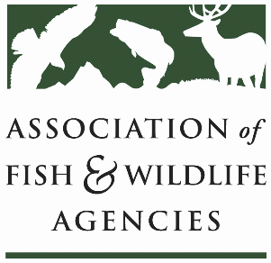

Agricultural Conservation Committee
Chair: Jim Douglas (NE)
Vice-Chair: Kevin Robling (SD)

Date: Friday, September 10, 2021
Time: 1:00 pm - 4:00 pm ET

111TH AFWA ANNUAL MEETING
Agenda
1:00 PM Call to Order, Agenda Review, Approval of Minutes Jim Douglas (NE); Kevin Robling (SD)
1:10 Panel on Voluntary Carbon Markets: State of Voluntary Carbon Markets, USDA’s Role, and Implications for Private Lands Conservation
2:00 Diversity, Equity and Inclusion
- USDA Outreach Strategy
Ronald Harris, NRCS Outreach and Partnerships Division
- Incorporating DEI considerations into ACC Work Plan
David Buggs (TX); Jen Newmark (NV)

2:40 Break

2:45 Working Group Reports
- CRP Todd Bogenschutz (IA)
- EQIP/CSP Mark Gudlin (TN)
- Easements David Breithaupt (LA)
- Public Access Sal Palazzolo (ID)
- Private Lands Ray Aberle (CO)
- RCPP Eric Zach (NE)
- Bioenergy Eric Zach (NE)
- Forestry Lisa Potter (MO)
3:30 Agency and Partner Updates

3:55 Wrap up discussion and adjourn

