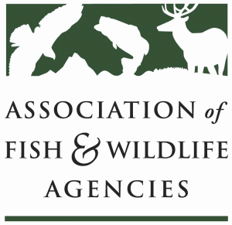

Adapative Leadership Working Group
Chair: Ann Forstchen (FL)

Friday, September 11, 2020
TIME: 10:00 pm to 12:00 pm
Association of Fish and Wildlife Agencies Annual Virtual Meeting

Working group Members: Ann Forstchen, Charlie Sperry, Michelle Doerr, Lynn Quattro,
Linda Kelly, Scott Anderson, Deb Schlafmann, Gina Jackson

Working Group Charge: to develop ideas to increase adaptive leadership (AL) capacity for AFWA members
and others in the conservation community. This includes:
- assessing the leadership development needs of AFWA members;
- cataloguing the leadership programs currently available that embrace adaptive leadership concepts;
- developing options for meeting the adaptive leadership development needs; and
- identifying ways to build greater capacity for teaching adaptive leadership skills (e.g., train the trainer).

Agenda
10:00 - 10:15 Call to Order, Welcome and Introductions, Review Agenda

10:15 – 10:30 Review Working Group Charge

10:30- 10:45 Review and clarifications of actions to date (see summary of work doc)

10:45 – 11:00 Review NCLI Standards document

11:00 -11:30 Discussion: developing adaptive leadership skills in a pandemic – what opportunities are there?

11:30 – 11:50 Future discussion, actions of the ALWG

11:50 - 12:00 Summary of Action Items and Wrap-Up

12:00 Adjourn

