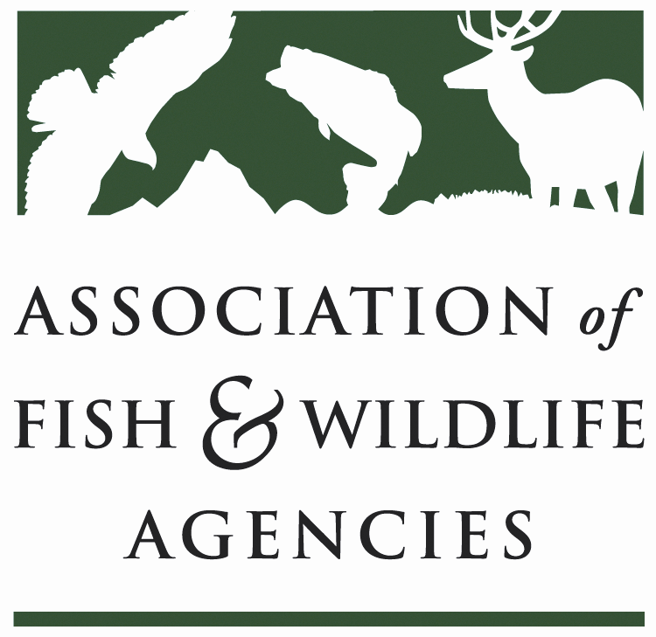

LAW ENFORCEMENT COMMITTEE
Chair: Alvin Taylor (South Carolina)
Vice-Chair: Curtis Brown (Florida)

AFWA Annual Meeting
Snowbird Resort
Sandy, UT

Sunday, Sept. 10, 2017
8:00am-5:00pm
Offsite
Agenda

8:00-10:00 am Depart hotel and travel to Antelope Island State Park

9:30-10:00 am Coffee & donuts

10:00-12:00pm Leadership training – Paul Butler

12:00-1:00pm Catered Lunch

1:00-3:00pm Leadership training – Paul Butler

3:00-4:00pm Utah Division of Wildlife Resources AIS Program – Lt. Scott Dalebout

4:00-5:00pm History / Overview of Antelope Island State Park

BBQ Dinner – Fielding Garr Ranch

Depart back to conference site

Monday, Sept. 11, 2017
8:00am-5:00pm
Room: Rendezvous A
Agenda

8:00-12:00 pm AFWA Law Enforcement Business Meeting

- Regional Reps Role
- AFWA Intelligence Summit Overview – Curtis Brown / Bob Thompson
- Wildlife Diversity Conservation and Funding Committee Update – Brian Nesvick
- International Wildlife Crimestoppers (IWC) Update
- Electronic Tagging Discussion

12:00-1:00pm Lunch on your own

1:00-3:00pm Plenary Session

3:00-5:00pm Interstate Wildlife Violator Compact Meeting

Tuesday, Sept. 12, 2017
8:00am-5:00pm
Room: Rendezvous A

Agenda

8:00-12:00 pm AFWA / NACLEC Law Enforcement Meeting

- Elections
- NACLEC Academy Update
- AFWA / NACLEC Bylaws
- Mutual Goals set at National Chiefs Meeting
- Award for Kevin Jones (Kansas)

12:00-1:00pm Lunch on your own

1:00-5:00pm AFWA / NACLEC Law Enforcement Meeting (cont’d)

- States to report on updates, trends, concerns, and hot topics in their area

