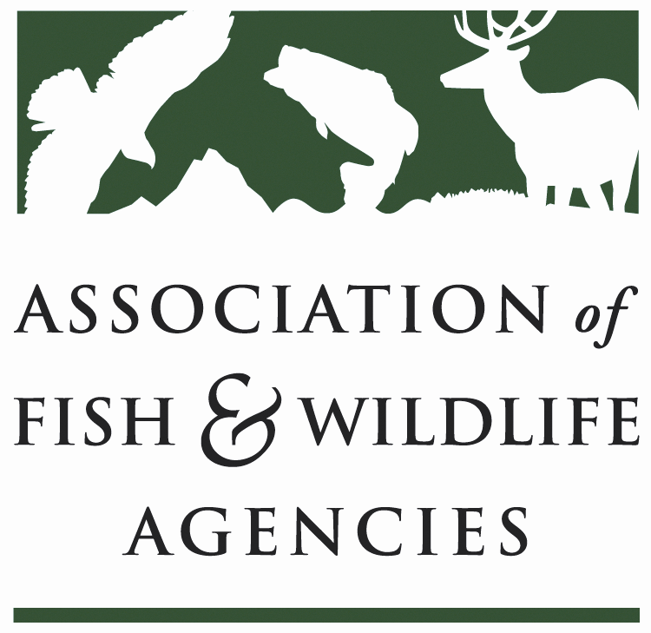

85th North American Wildlife and Natural Resources Conference
Omaha, Nebraska
https://wildlifemanagement.institute/conference

Sustainable Use of Wildlife Committee
Thursday, March 12th
8:00 a.m. – 12:00 p.m.
Committee Charge:
Advocate the North American Model of Fish and Wildlife Conservation and promote the sustainable use of fish and wildlife resources at the international level.

Chair: Terry Steinwand Vice-Chair: Dave Kay

Subcommittees and Working Groups:
U.S. Furbearer Conservation Technical Working Group

Agenda
- Agenda review, adjustments, and opening comments (Terry Steinwand, Dave Kay)
- Approval of Minutes from the previous meeting (Steinwand)
- Update on Multi-state Conservation Grants (Tom Decker, Zach Lowe, Bryant White)
- Sportsmen’s Alliance (Luke Houghton)
- Safari Club International (Jeremy Clare)
- Bobcat Non-detriment finding renewal in 2020/CITES/IUCN (Deb Hahn)
- Conservation Leaders for Tomorrow Program (Zach Lowe, Dave Windsor)
- Trapping Matters Workshops and Fur Schools in 2019 and 2020 (Tom Decker)
- Joint Management Committee Meeting for the Agreement on International Humane Trapping Standards 2020 (Dave Kay, Tom Deliberto)
- Best Management Practices for Trapping: Progress, Plans and Outreach (Bryant White)
- Agreement on International Humane Trapping Standards in Canada (Dave Kay)
- Other topics potentially affecting Sustainable Wildlife Use (Terry Steinwand)

