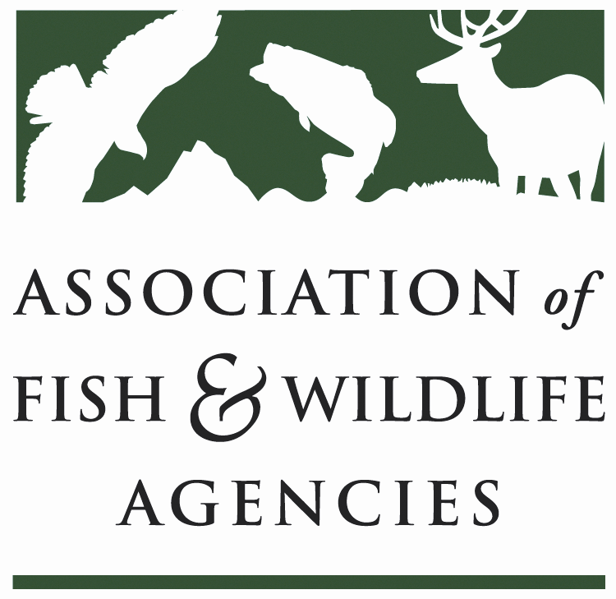

Leadership and Professional Development Committee

Committee Charge: Related to this strategic priority of the Association, the Leadership and Professional Development Committee plays a primary role in guiding actions of the Association that develops tools and programs to help AFWA members develop new generations of conservation leadership who are prepared to address current and future conservation needs in their state, region, across the US, and Canadian Provinces. The Committee charge is to:
- Provide oversight and direction to the AFWA Management Assistance Team (MAT) Work with MAT to provide guidance from Organizations regarding identified issues and concerns about the [current and future] work force so that MAT is most effectively targeting the most important leadership development and agency management needs of state fish and wildlife agencies and AFWA members.

- Create and foster leadership development activities that may be used by AFWA Member Organizations - Facilitate development, guidance, support, and ongoing continued improvement of a Leadership Development Initiative, based on identified Organization needs, to provide training and consulting services to AFWA Member Organizations that will help them best address leadership development. Facilitate and lead development of a Leadership Institute that provides exceptional training and networking opportunities for the next generation of conservation organizations’ top-leaders.

- Communicate with AFWA members on trends related to current workforce issues, leadership development, and professional development – Communicate with AFWA Members and disseminate state-of-the-art knowledge on workforce trends and issues, latest information, and “Best and Improved Practices” in leadership development. Provide resources so members may share their knowledge and experiences and a forum to share member experiences.

- Coordinate with the National Conservation Leadership Institute Board of Directors –Work with the National Conservation Leadership Board of Directors and Director to facilitate state fish and wildlife agencies and other AFWA Member Organizations involvement in the National Conservation Leadership Institute and provide continuity in leadership development programming.

