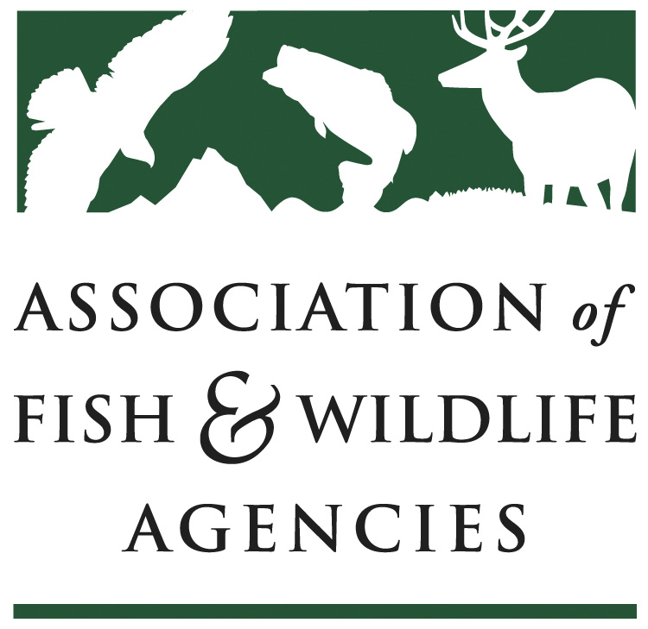

Leadership and Professional Development] Committee Report
Chair: Dave Golden (NJ)
Meeting of September 25, 2019
Intercontinental; Governors IV
St. Paul, MN

Committee Charge
(Post the committee’s charge)

Meeting convened during (10am – 12pm), chaired by Dave Golden. 27 participants in attendance, including 10 current Committee members:

Scheduled Discussion Items
Dave Golden opened the meeting with introductions and confirmed committee members; encouraged all participants to actively participate.
- Motion to accept last meeting minutes; so moved by Jim Devos, 2nd by Lynn Quatro
- Reviewed LPD Committee Charge and involved participants in the broadening of the charge to include all AFWA members. Karen accepted Dave’s motion to accept the current changes with the caveat we learn the correct language for AFWA membership and seconded by Lynn Quattro
  - Further Discussion – clarified LPD’s role re: NCLI; to communicate to the NCLI Board involvement level of AFWA Members
  - Voted on new charter language, all were in favor
- Doug Austen (AFS) voiced interest re: how MAT and other AFWA members/Partners collaborate in providing leadership development; Dave requested we hold discussion to the Products & Services rather than the “Charge”
- Bettina Fiery reviewed MAT products & services offered to States in 2019
  - Linda (MN)- inquired about some of the types of state-based training
  - Chris (AR) – inquired how to implement training
- Bettina also Discussed an upcoming needs assessment to sent to LPD Committee Members and other AFWA Members prior to the N. American and report back to the Committee at the N. American
  - Inquiry re: another Train-the-Trainer in the future; Yes, sometime in 2020
- Gina provided an update on NCLI Cohort 13 & upcoming Cohort 14
  - Three new industries for this cohort
  - Pilot Coaches Training offered in Denver (Sept. 2 – Sept. 5); due to the success, this Coaches’ training will be offered annually to a greater population
  - Shared update from the Alumni Mtg (over 40 attended); 3 break-out sessions (more discussion later from Charlie Sperry):
  - More robust Alumni Portal, and Resource Library
  - Enhancing communication strategy via social media, and e-newsletter: On the Balcony
- Charlie Sperry (MT) – provided an update from the Alumni Meeting’s:
  - Meeting continuing education needs of alumni
  - Individual versus Global challenges and how to best implement
  - Sate & Regional Leadership Development Programming to augment NCLI participation
    - Alumni Members committed to address the lack of organizational leadership re: attrition of NCLI Alumni in agencies, and only one person/year (at best) able to attend
    - Challenges: (1) Quality Control
(2) Branding Issues
(3) Maintaining the integrity of NCLI; how to be more complimentary rather than competitive
(4) Staff capacity (Agency & MAT); development & sustainability
- Establishing a clearing house of resources; operating procedure
- Communication mechanism w/alumni & NCLI Board
- Dave raised the same question re: NCLI-like training at the state/regional level to the committee
  - Jim Devos offered the option of multiple NCLI campuses; standard curriculum with a model to follow
  - Chris (AR) – talked about several leadership development programs in which employees can attend; finding lack of succession planning with high level positions open and no one eligible to apply
  - Ann (FL) –implementing leadership development programs based upon modified Adaptive Leadership re: FL-based issues. Feel this program expands capacity without minimizing people attending NCLI
  - Dave (NJ) & Scott (NC) –agree attending NCLI would not have the same impact after attending these state-based programs
  - Lynn (SC) – Looking at a modified program similar to what FL is offering which would not preclude participants from attending NCLI; recommends both programs be developed rather than an “either/or” approach
  - Martha Williams (MT) – What keeps my up at night as a director is how we have not developed depth in our agency in a leadership capacity
    - Agrees we must address this lack of capacity leadership
    - Clearly hearing a need for greater capacity but seeks greater collaboration & coordination of efforts with other agencies (WMI, AFS)
- Heather (SD) discussed the benefits of having multiple leadership development programs as an aspect of greater employee engagement and succession planning
- Dave summarized themes and recommends: MAT incorporate these themes into the upcoming needs assessment/survey (include: Complimentary programs to NCLI or adaptive leadership programs that could be replacements)
- Scott (NC) – seeking clarity on our vision: what will we look like in 20 years? Not sure where to quantify this vision: NCLI or LPD Committee?
- Jim (AZ) – recommends cohort program of some substance rather than ala carte option to gain greater bonding/teambuilding among cohort members
- Linda (MN)- shared the significance at looking at this as a culture shift, with a need for greater awareness around funding and the sustainability of making leadership development an agency priority

- Leadership Development Central Clearing House (Ann) – Learn from agencies with established leadership development programs, where would the repository lie; what is the capacity of MAT
  - Could this discussion be rolled into the Working Group (Dave)? Yes, Ann feels we could visit the R3 portal and use as a model

Progress and Opportunities
Progress achieved in developing a Working Group of NCLI Alumni to first (develop a vision), address leadership development and then a mechanism to communicate with NCLI Board
Work Group Charge: Explore ideas for expanding Adaptive Leadership programing at state, regional, and national levels.
- Motion to approve workgroup by Charlie Sperry, 2nd by Ann Forstchen
- Charlie Sperry agreed to Chair; members of the committee marked their interest on the sign-in sheet

Threats and Emerging Issues Identified
Potential competitive nature of some states’ leadership development programs with NCLI

New Opportunities Identified
Greater collaboration among AFWA Members and conservation partners

Action Items
- Finalize LPD Committee Charter – Disseminate draft revision to Committee Members
- MAT Needs Assessment to Committee & AFWA Members – send draft survey to Dave with input from Chris Smith (WMI)
- Develop Working Group – Provide list of names to Charlie and send to NCLI Alumni for additional interest and come to N. American with recommendation
  - Working Group Members (ascertained by LPD Roster): Michelle Doerr, Bettina Fiery, Ann Forstchen, Lynn Quattro, Linda Kelly, Scott Anderson, Deb Schlafmann

Submitted by: Dave Golden

