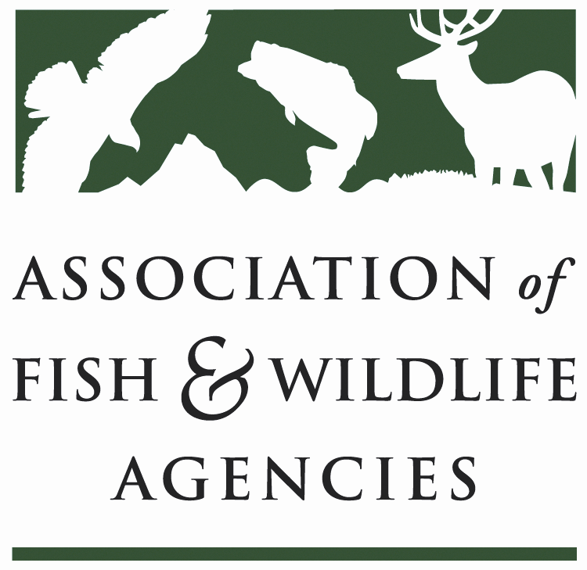

Leadership and Professional Development Committee
Chair: Dave Golden (NJ)
Vice-Chair: Karen Waldrop (KY)

Date: Wednesday, September 25
Time: 10am – 12pm

Association of Fish & Wildlife Agencies 109th Annual Meeting
TBD / Intercontinental Saint Paul Riverfront Hotel
St. Paul, MN

Agenda

10:00 am Call to Order/Review Agenda

10:05 Introductions

10:10 Approval of Minutes for the 84th North American Wildlife and Natural Resources Meeting

10:15 Review Committee Charge

10:30 Input into AFWA’s 2020 Strategic Plan

10:45 Report from MAT staff

11:00 Discussion on new products and services for state agencies

11:30 State Roundtable
One representative per state agency highlights leadership initiatives or issues

11:55 Wrap-up Discussion

12:00 Adjourn

