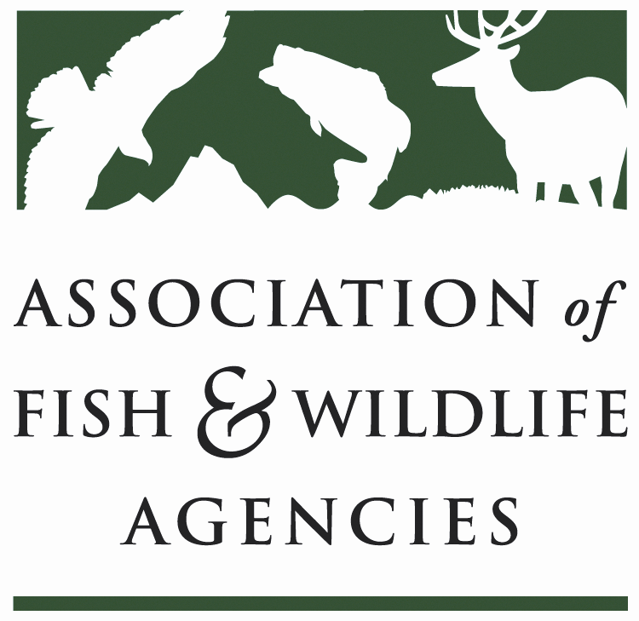

Project WILD Sub-Committee
Chair: Rusty Garrison (GA)
Vice-Chair: Name (State)

Date: Thursday March 7, 2018
Time: 11:00-12:00

North American Wildlife and Natural Resources Conference
Room: Director’s Row E/ Sheraton Denver
Denver, CO

Agenda

11:00 am Call to Order/Review Agenda

11:05 Introductions

11:10 Approval of Minutes for the 2018 AFWA Annual Meeting

11:15 Report from Project WILD Staff

11:25 Colorado Project WILD

11:35 Discussion on R3/Relevancy

11:55 Wrap-up/Next Steps

12:00 Adjourn

