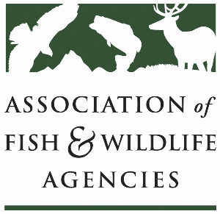

AFWA Feral & free-ranging cat Work group
Co-Chair: Sara Schweitzer (North Carolina Wildlife Resources Commission)
Co-Chair: Colin Gillin (Oregon Department of Fish & Wildlife)

North American Wildlife and Natural Resources Conference
Hilton Norfolk The Main, Norfolk, Virginia

Thursday, March 29, 2018
8:00 – 10:00 a.m., Meeting Room: Fusion

Agenda

8:00 am Call to Order/Review Agenda (Sara Schweitzer, NCWRC; Colin Gillin, ODFW)

8:05 Introductions

8:10 Review and Approval of Minutes – 2017 meeting

8:15 Report from Legal Sub-Committee (see “State Wildlife Law Project – summary of development and plans for integration” attached)

8:45 Report from Survey Development Group –
For September 2018, Chris Serenari & Ashley Gramza – work on analyses and interpretations of results

- BMP chapters (proposed chapters from discussions at March 2018 meeting)
  - Prevention (of dumping of cats; of free-ranging TNR colonies, etc.)
  - Mgt. of feral and free-ranging cats on state lands
  - Working with partners to support TNC (trap-neuter-confine) – Pat Klein
  - Disease (?) control – diseases and public health – Colin Gillin, Sara Schweitzer
  - Optimizing contribution of research relating to feral cat impacts
  - Human Dimensions – Ashley Gramza, Chris Serenari
  - Legal language; regulatory messages; model language – Lane Kisonak
  - Legal issues – Lane Kisonak; Carol Banbury; Grant Sizemore
- By June 1 August 20th, submit anything on each topic/chapter
- At Tampa, September, AFWA, present rough draft of BMP. Comments by Nov. 01, 2018

9:10 Discussion – Reports and Surveys’ findings

- Web site development (promotes prevention of impacts to cats and to wildlife) (e.g., Feral Cat C. of Oregon) – Colin will contact possible web designers
  - Highlight safe, happy, confined cats (see Am. Bird Conservancy’s web page)
  - Highlight successful cat sanctuaries, rehab centers that support cats indoors
  - Highlight products like fence roller, tubes, catios, etc.
- Develop events with breweries to show cats indoors products, show nongame wildlife that are typically killed by cats (live specimens), book marks with killed wildlife facts
- Need powerful message – support life message

9:40 Wrap-up Discussion and Next Steps

10:00 Adjourn

