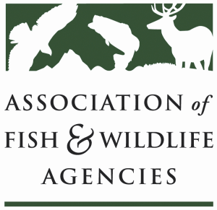

BIRD conservation Committee PART I
Chair: Gordon Myers, NC Wildlife Resources Commission
Vice-Chair: Tony Wilkinson, NY State Department of Environmental Conservation

6 March 2019
1:00 pm-5:00 pm

North American Wildlife and Natural Resources Conference
Denver, CO
DRAFT AGENDA v12Feb19

Agenda

1:00 Welcome/Introductions/ Announcements

1:15 US Fish & Wildlife Service Migratory Bird Program Updates
Ken Richkus, Division Chief, Division of Migratory Bird Management

1:45 Canadian Wildlife Service Update
Silke Neve, Director of Monitoring, Assessment and Information Division

2:15 Migratory Bird Incidental Take: Best Management Practices and Model Regulatory Language
Judith Scarl, Bird Conservation Program Manager, AFWA/NABCI Coordinator
Lane Kisonak, Staff Attorney, AFWA OR Erik Schneider, Policy Analyst, Audubon

2:45 North American Bird Conservation Initiative (NABCI) Updates
Judith Scarl, Bird Conservation Program Manager, AFWA/NABCI Coordinator

3:05-3:15 BREAK

3:15 NABCI State of the Birds 2019: State Agency Contributions to Bird Conservation
Tom Moorman, Chief Scientist, Ducks Unlimited/Ken Rosenberg, Cornell Lab of Ornithology

3:30 Bird Conservation in the 116th Congress: Migratory Bird Conservation Funding Briefing
Jennifer Cipolletti, Director of Conservation Advocacy, American Bird Conservancy

3:40 2018 NAWMP Plan Release
Jerome Ford, Assistant Director for Migratory Birds, USFWS
Silke Neve, Director of Monitoring, Assessment and Information Division, CWS

3:50 New Avian Knowledge Network Capacities and Next Steps
John Alexander, Executive Director, Klamath Bird Observatory

4:00 Alliance for America’s Fish and Wildlife/Recovering America’s Wildlife Act
Sean Saville, Blue Ribbon Panel Campaign Manager, AFWA

4:15 Legislative Updates
Jen Mock Schaeffer, Government Affairs Director, AFWA

4:25 Southern Wings Progress Updates
Deb Hahn, International Relations Director, AFWA

4:40 Additional Discussion, Closing Items

5:00 Adjourn

