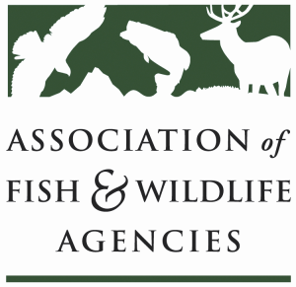

BIRD CONSERVATION COMMITTEE PART II
Chair: Gordon Myers, NC Wildlife Resources Commission
Vice-Chair: Tony Wilkinson, NY State Department of Environmental Conservation

8 March 2019
8:30-10:30 am

North American Wildlife and Natural Resources Conference
Denver, CO
DRAFT AGENDA v12Feb2019

8:30 Welcome, Introductions, Announcements

Bird-Fish Conflicts Working Group Report
David Cobb, Wildlife Management Division Chief, NC Wildlife Resources Commission

PIF/Shorebird/Waterbird Working Group Report
Sara Schweitzer, Wildlife Diversity Coordinator, NC Wildlife Resources Commission

Feral and Free-Ranging Cat Work Group Report
Sara Schweitzer, Wildlife Diversity Biologist, NC Wildlife Resources Commission

Resident Game Bird (RGB) Working Group Report
Karen Waldrop, Deputy Commissioner, KY Department of Fish and Wildlife
Migratory Shore and Upland Game Bird Working Group (MSUGBWG) Report
Alicia Hardin, Wildlife Division Administrator, Nebraska Game and Parks Commission

Waterfowl Working Group Report
Jeff ver Steeg, Assistant Director, Colorado Parks and Wildlife

Harvest Information Program Working Group Report
Ross Melinchuk, Vice President of Conservation, National Wild Turkey Federation

10:00 Discussion follow-up from BCCI

10:20 Additional Items, Closing

10:30 Adjourn

