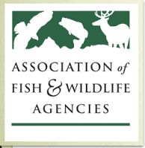

AFWA Science and Research Committee
Human Dimensions and Social Science Subcommittee

Subcommittee Contact Information:
Chair: Ann B. Forstchen, Human Dimensions Coordinator, Florida Fish and Wildlife Conservation Commission Ann.Forstchen@myFWC.com 727-502-4765
AFWA Staff: Dr. Jonathan Mawdsley, Science Advisor, Association of Fish and Wildlife Agencies, jmawdsley@fishwildlife.org 202-997-6628

Charge to subcommittee:
- Provide a forum for discussion of human dimensions and social science research and applications in state, federal and provincial wildlife and natural resource agencies and partners.
- Advise the membership and leadership of the Association regarding human dimensions and social science research and applications.
Agenda
Introductions
Discussion of current human dimensions activities within agencies (states and partners)
Human Dimensions and Species Distribution Modeling
Human Dimensions and Chronic Wasting Disease

