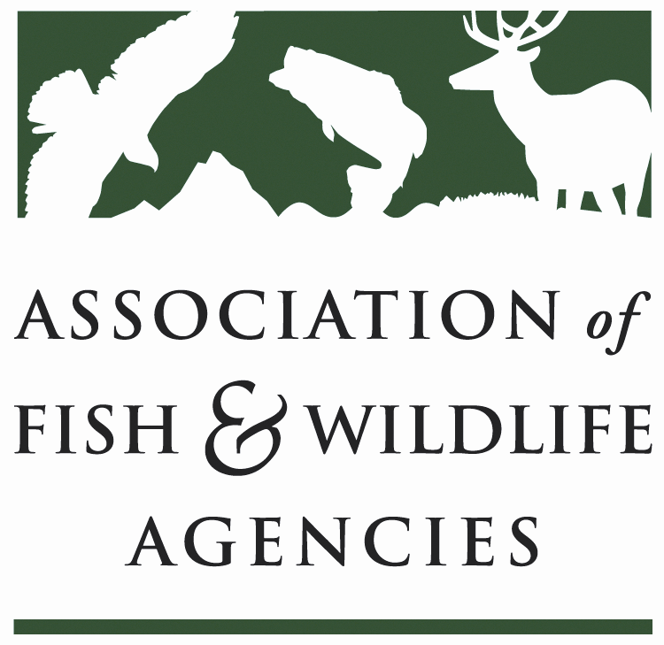

Human Wildlife conflict Working Group
Chair: Brian Wakeling (Nevada)
Vice-Chair: vacant

Wednesday, March 6, 2019
3:00 PM – 5:00 PM

84th Annual North American Wildlife and Natural Resources Conference
Sheraton Denver Downtown
Denver, Colorado

Agenda

- Call to Order/Review Agenda (Chairman Wakeling)

- Introductions

- Approval of Minutes for the meeting of the HWCWG from the AFWA Annual Meeting

- Report on progress toward the development of peer reviewed publications on human-wildlife conflicts (Bryant White)

- Deer in Populated Areas

- Urban Coyotes

- Discussion on - - -
  - Other topics of interest
  - Vice-Chair appointment?

- State/Federal/Tribal/Provincial Roundtable
One representative per agency highlights a couple of human wildlife conflict issues
- Wrap-up Discussion and Assignments for Next Meeting

- Adjourn

